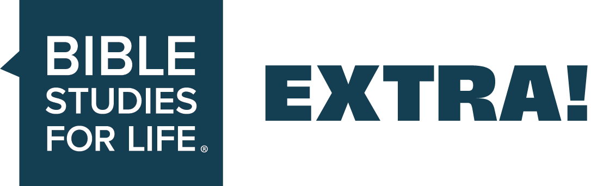
EXTRA Ideas for Adults // Seize the Day—
A Mission Outside Your Comfort Zone
EXTRA supports the group plans in the Bible Studies for Life leader guides.

Date: May 17, 2026
Session Title: A Mission Outside Your Comfort Zone
The Point: The gospel crosses cultures—and so should we.
Podcast—Bible Studies for Life: Adults
_____________________________________________________________________________

Additional Teaching Options

Optional teaching ideas that incorporate current news, cultural trends, and real-world illustrations to help your group engage more deeply and view today’s issues through a clear biblical lens.

Getting Stated
Read after discussing Getting Started—Question 1:
Wade and Sharon Sigrest have served as missionaries in the Philippines for twenty years, though they weren’t always missionaries.
Early in their marriage, Wade told Sharon that he felt called to missions. As they traveled for military duty and served those they came into contact with, Sharon thought they were already doing enough. But after doing door-to-door evangelism with their church in 1998, she reconsidered. Sharon listened to her pastor share the gospel with a woman, who responded that she’d been waiting for someone to tell [it] to her. The Sigrests have been serving in the Philippines since, sharing the gospel and meeting the needs of the people they meet.
God may not call you to serve Him overseas, but He often does call us out of our comfort zone to be His hands and feet in the world. We may be called to donate to a missions cause instead of eating out for a bit. We may be called to sacrifice a lazy weekend to serve at a church outreach event. Though being called out of our comfort zone can be intimidating, we can be secure knowing God will walk with us where He calls us.
To read more about this article, visit IMB.org or WMU.com and search “missionaries reflect on two decades in the Philippines.”
Get Into the Study (Option for Adult Leader Guide)
In advance, play a video clip showing another culture (in a positive light). Then ask Question #1.

Study the Bible
Read after discussing Study the Bible—Question 2:
Obstacles faced with cultural boundaries—Slovenia gaming
When sharing the gospel with people of different backgrounds or ethnicities, it’s important to be mindful of any cultural differences that could be a barrier to receiving the good news of Jesus. IMB missionaries Daniel and Heather Bates found the perfect inroads to gospel sharing in Slovenia: board games.
Though Slovenia is a culturally Roman Catholic country, most young adults privately claim atheism. Evangelical Protestant churches are seen as “cult-like,” and those who visit risk ostracization from their families and friends. But if they have a reason to be at a Protestant church, like a game night, there’s no stigma. Attending these game nights and staying in touch with gaming groups during the week allow the Bates to build relationships within the community without risking ostracization. Thanks to gaming, these young adults are doing more than just hanging out. They’re getting to hear the gospel.
Before learning of the large gaming community in their area, the Bates had a difficult time building relationships without being seen as “other.” Finding common ground is a great way to overcome cultural barriers when sharing the gospel.
To read more about this article, visit IMB.org and search “Slovenia’s gaming culture.”

Additional Questions

Optional, thoughtfully crafted questions designed to warm up group conversation and guide engagement throughout each Bible passage—helping your group think critically, connect personally, and process Scripture through a clear biblical lens.
Icebreakers
- When have you been asked to do something way out of your comfort zone and how did you respond?
- What’s the farthest distance you’ve gone from the place where you were born?
- What foreign culture interests you the most?
Acts 8:26-29. Be willing to go where God sends you—even when crossing cultural boundaries.
- What do you learn from this passage about the Holy Spirit’s involvement in evangelism?
- What does Philip’s quick obedience tell you about his personal faith and dependence on God?
- What opportunities do believers often miss by being reluctant to cross cultural boundaries?
Acts 8:30-35. Be ready to share Jesus.
- How can you better prepare yourself to explain the Scriptures to others?
- How do you find answers when you don’t understand Scripture or spiritual things?
- How can believers be ready to share Christ’s gospel when opportunities arise?
Acts 8:36-38. Be prepared to help others to take the next step.
- What’s the significance of baptism in the life of the believer?
- What are some misconceptions about baptism today?
- How can involvement in the church help a new believer to take the next steps?
The week’s writer for Extra is Emily Duncan. Emily is a Southern California native who lives in west Georgia with her husband and daughter. God saved her from Wicca when she was sixteen while at a youth retreat. Emily’s a member of Midway Church in Villa Rica and mentors young women as they transition from high school to college.
[Linked material and sources serve as background illustration only and does not imply endorsement beyond our biblical application.]

