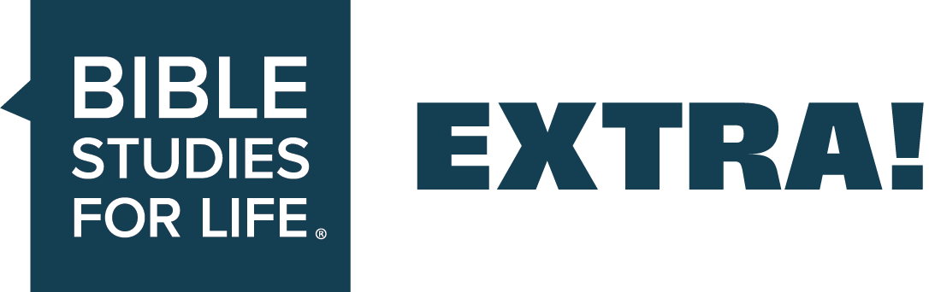
EXTRA Ideas for Adults // Seize the Day—
A Mission Met With Courage
EXTRA supports the group plans in the Bible Studies for Life leader guides.

Date: May 3, 2026
Session Title: A Mission Met With Courage
The Point: God gives us courage to speak boldly about Christ.
Podcast—Bible Studies for Life: Adults
_____________________________________________________________________________

Additional Teaching Options

Optional teaching ideas that incorporate current news, cultural trends, and real-world illustrations to help your group engage more deeply and view today’s issues through a clear biblical lens.

Getting Stated
Read after discussing Getting Started—Question 1.
Many well-loved movies or TV shows have a character who exemplifies bravery and courage. But there are also examples of brave people in the real world whom we can look up to, including the astronauts of the recent Artemis II mission.
On April 1, four astronauts launched to space for the first lunar mission in over sixty years. The crew broke records as they flew the farthest distance of a manned mission and were the first humans to see the far side of the moon. Their mission concluded after ten days, after which they safely splashed down in the Pacific Ocean, where they were recovered by the US Navy.
Launching to space and completing a lunar flyby requires a large amount of courage. So does sharing the gospel with people around you. But while in the middle of a daunting task, the Holy Spirit is with us and will help give us both the courage to act and the right words to say.
To learn more about this article, search Artemis II.
Get Into the Study
Read after discussing Study the Bible—Question 2:
One of the biggest barriers for people hearing or accepting the gospel is an unmet need in their lives. That’s why many missionaries work to meet practical needs while attempting to meet spiritual needs. IMB workers Aaron and Sidney Barr are working to help both by fitting disabled people in remote Himalayan villages with prosthetics.
Many villages are several hours, or days, journey from any hospital, meaning that severe accidents often result in amputation. Thanks to donations from Southern Baptist churches, the Barrs have partnered with Himalayan prosthetists to meet physical needs of disabled villagers. In one village, they helped a shepherd get new fingers and shared the gospel with him, and he accepted Christ.
People can be resistant to hearing or accepting the gospel for all kinds of reasons. But being able to meet a physical need for them along with sharing gospel can help soften hearts.
To read more about this article, visit imb.org and search for “prosthetics ministry in east Asia.”

Get Into the Study (Option for Adult Leader Guide)
In advance, play a video clip showing someone having a hard time trying to get home. Then ask Question #1.

Additional Questions

Optional, thoughtfully crafted questions designed to warm up group conversation and guide engagement throughout each Bible passage—helping your group think critically, connect personally, and process Scripture through a clear biblical lens.
Icebreakers
- When have you displayed courage in the face of fear?
- What is the most courageous act you’ve ever witnessed?
- When have you made a bold move that paid off?
Acts 4:1-3. Speaking about Christ can lead to confrontation.
- When have you faced opposition against your faith?
- What are some of the ways the message of Jesus conflicts with our culture?
- What can we learn from how the apostles handled opposition?
Acts 4:8-12. Proclaim faith in Christ as the only way to receive eternal life.
- What does it mean that Jesus is the cornerstone?
- What are other ways of salvation according to culture?
- What are some ways we– like Peter– can clearly communicate that Jesus is the only way?
Acts 4:19-20. Speak boldly about Christ despite opposition.
- How can we express compassion when speaking boldly?
- What can motivate a believer to obediently share the gospel regardless of the cost?
- What are the risks associated with speaking openly about Jesus Christ in today’s world?
The week’s writer for Extra is Emily Duncan. Emily is a Southern California native who lives in west Georgia with her husband and daughter. God saved her from Wicca when she was sixteen while at a youth retreat. Emily’s a member of Midway Church in Villa Rica and mentors young women as they transition from high school to college.
[Linked material and sources serve as background illustration only and does not imply endorsement beyond our biblical application.]

