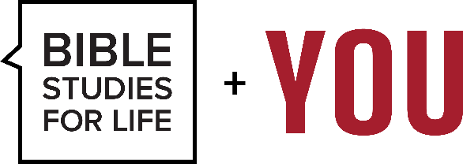
Quarter Fall 2025
Study Title: Greatest Truths of All Time

Sermon Title: The Greatest Gift
Text: Ephesians 2:1–6

Introduction: Story to Set the Tone
Tell the story of a man rescued after days lost at sea, dehydrated, sunburned, and barely alive. He was floating unconscious when a rescue crew found him. When revived, he tried to thank them, but they told him:
“You didn’t call us — you couldn’t. We came because we saw you needed saving.”

Transition:
This is a picture of what Paul describes in Ephesians 2. We weren’t just struggling — we were spiritually dead, unable to help ourselves. But God gave us the greatest gift: life with Christ.

Main Points:

1. We Were Dead Without Hope (v. 1)
“As for you, you were dead in your transgressions and sins…”

- Not sick. Not weak. Dead.
- Sin didn’t just hurt us — it separated us completely from the life of God.
- Dead people can’t revive themselves — they need resurrection.

Illustration:
Trying to fix ourselves without God is like putting makeup on a corpse — it changes nothing. What we need is life, not cosmetics.

2. We Were Slaves to the World, Flesh, and the Devil (v. 2–3)
“…following the ways of this world… gratifying the cravings of our flesh…”

- Our default setting: conforming to the world, obeying our desires, and falling under spiritual deception.
- Even our best efforts were stained by sin.

Application:
Without Christ, freedom is an illusion — we’re not as in control as we think.

3. But God — The Giver of the Greatest Gift (v. 4)
“But because of his great love for us, God, who is rich in mercy…”

- Two of the greatest words in the Bible: “But God.”
- Love + mercy + power = intervention when we could not save ourselves.
- God initiates salvation, not us.

Illustration:
Like a parent running into traffic to save their child — not because the child asked, but because love moves first.

4. We Were Made Alive with Christ (v. 5)
“...made us alive with Christ even when we were dead in transgressions…”

- The greatest gift isn’t just forgiveness — it’s new life in union with Jesus.
- This is resurrection power, not self-help.

Application:
You’re not the old you with a religious patch. You are a new creation.

5. We Are Raised and Seated with Christ (v. 6)
“And God raised us up with Christ and seated us with him in the heavenly realms…”

- Our position has changed — from wrath to welcome, from sin to status.
- We’re not just saved from something — we’re saved for something: a life with Christ now and forever.

Illustration:
Imagine being adopted into royalty. You're not just rescued from the streets — you're seated at the table, part of the family.

Conclusion:
The greatest gift isn’t money, health, or success — it’s life from death, freedom from sin, and a seat at the side of Jesus.
And the best part?
You didn’t earn it. God gave it.

Call to Action:
- If you’re still walking in spiritual death, today is the day to receive the gift of life in Christ.
- If you’ve received this gift, live it — not trying to earn it, but rejoicing in it.
- And most of all — share it. Gifts this great are meant to be given away.

