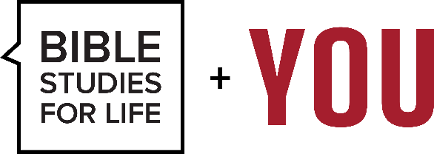
Quarter Fall 2025
Study Title: Greatest Truths of All Time

Sermon Title:
The Greatest Need
Text: Hebrews 11:1–6

Introduction:
Begin by posing the question:
“What is the greatest need in your life today?”
People may respond with health, security, finances, love, or peace. But Scripture tells us that the greatest need — the one that shapes every other — is faith.

Illustration:
Tell the story of Charles Blondin, the 19th-century tightrope walker who crossed Niagara Falls with a wheelbarrow. When he asked the crowd if they believed he could carry a person across, everyone said yes. Then he asked for a volunteer — and no one stepped forward. Faith is not just saying we believe — it's stepping into the wheelbarrow.

Main Points:

1. Faith Defines Our Spiritual Reality (v. 1)
“Now faith is the substance of things hoped for, the evidence of things not seen.”

- Faith gives substance to our hope — it makes the invisible real in our hearts.
- Faith anchors us in what we cannot see but know to be true through God’s promises.

Illustration:
Compare faith to Wi-Fi — invisible, yet powerful and essential. You may not see it, but everything runs through it. No faith, no connection.

2. Faith Connects Us to God’s Approval (v. 2)
“For by it the elders obtained a good testimony.”

- The heroes of faith were not perfect, but they trusted God — and He commended them.
- Approval from God isn’t earned through performance, but through trust.

Application:
God is not looking for superstars; He’s looking for believers.

3. Faith Believes Beyond Sight (v. 3)
“By faith we understand that the worlds were framed by the word of God…”

- Faith allows us to see God at work, even when we can’t explain or prove it.
- The universe itself is evidence of a Creator, perceived through faith.

Illustration:
Like an artist’s signature at the corner of a painting, creation bears the signature of God — but you need eyes of faith to see it.

4. Faith Is Essential to Please God (v. 6)
“Without faith it is impossible to please God…”

- You can give, serve, attend — but without faith, it’s hollow.
- Faith involves two convictions:
- God exists
- God rewards those who seek Him

Illustration:
A child running to their parent with confidence shows what God desires — not perfect performance but trusting approach.

Conclusion:
Your greatest need isn’t a changed situation — it’s a deeper faith in the One who controls the situation.
Faith opens the door to a life that pleases God, receives His promises, and lives with eternal perspective.

Call to Action:
- If you’ve been walking by sight, ask God to renew your faith.
- If you've never stepped into real trust in Christ, today is the day to start.

