WJ200 Series Inverter Reference Guide
- Single-phase Input 200V class
- Three-phase Input 200V class
- Three-phase Input 400V class


Refer to the Inverter Instruction Manual: NT325X or Quick Reference Guide: NT3251X for detail

Manual Number: SRG001.1
June 2015

Hitachi Industrial Equipment Systems Co., Ltd.

Wiring Diagram
The schematic diagram below provides the example of logic connector wiring, in addition to basic power and motor wiring converted. These are the connections that are currently made within the Demo Case.
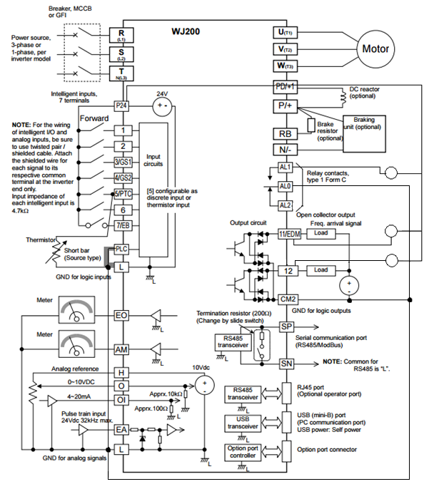
-LED

Using the Front Panel Keypad
The purpose of the keypad is to provide a way to change modes and parameters. The term function applies to both monitoring modes and parameters. These are all accessible through function codes that are primary 4-character codes. The various functions are separated into related groups identifiable by the left-most character, as table 1 shows on the next page.
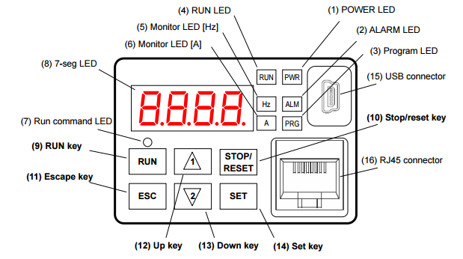
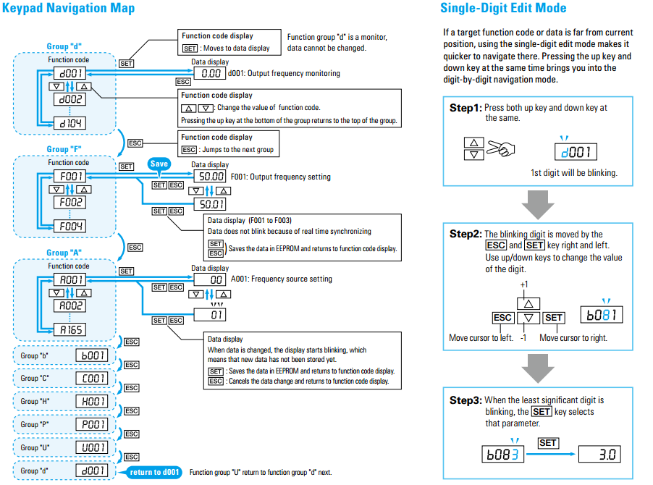
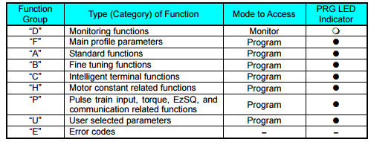
Table 1
For further list on all functions and further function details please refer to WJ200 Series Inverter Quick Reference Guide NT3251X
Function “D”- P.46-48
Function “F”- P.49
Function “A”-P.50-57
Function “B” P.-58-65
Function “C” P.-66-77
Function “H” P.-78-80
Function “P” P.-81-83
Function “U” See User Manual for Detail Sect. 3-61
Function “E” See User Manual for Detail Sect. 6-11

Control Logic Signal Specifications
The control logic connectors are located just behind the front housing cover. The relay contacts are just to the left of the logic connectors. Connector labeling is shown below. The chart on page 5 describes all terminals.
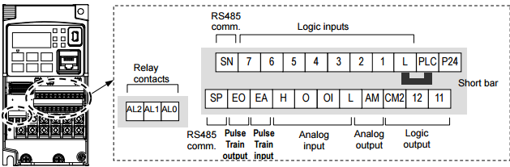

Terminal Functions
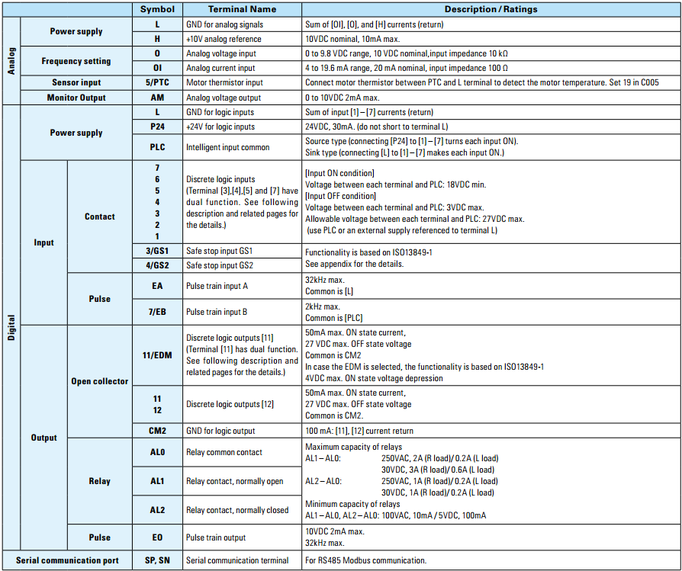

Function Groups
There are 9 different function groups programmed on the WJ200. These different function groups include functions, “d”, “F”, “A”, “b”, “C”, “H”, “P”, “U”, and “E”. In this manual we will discuss the most important functions “d”, “F”, “A”, and “C”. All detail and other functions can be found in the User manual or quick reference manual (Please refer to page 4 of this manual).

“d” Group: Monitoring Functions
You can access important parameter values with the “d” Group monitoring functions, whether the inverter is in Run Mode or Stop Mode. After selecting the function code number for the parameter you want to monitor, press the Function key once to show the value on the display. If a desired parameter is not displayed, check the setting of function "b037"(function code display restriction). To display all parameters, specify "00" for "b037". A List of “d” parameters can be seen below.
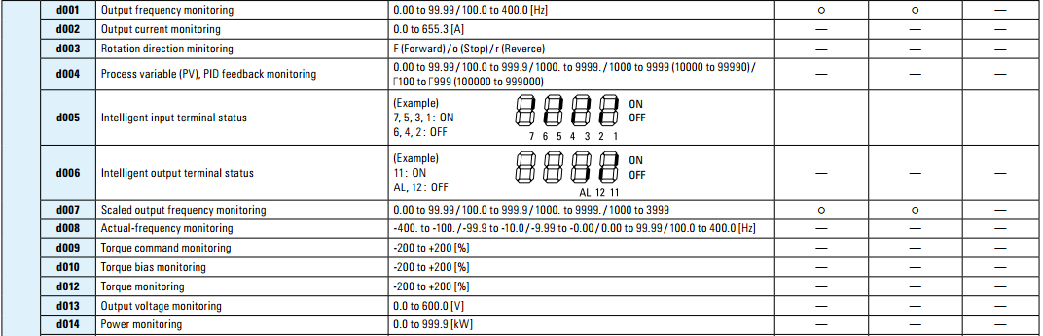
“F” Group: Main Profile Parameters
The “F” group are the Main profile Parameters. A list of these parameters can be seen below.
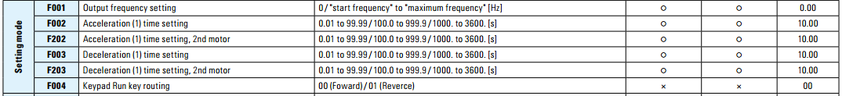
“A” Group: Standard Functions
The inverter provides flexibility in how you control Run/Stop operation and set the output frequency (motor speed). The “A” function also controls the source selection for the inverters output Frequency. A list of “A” functions can be seen below.
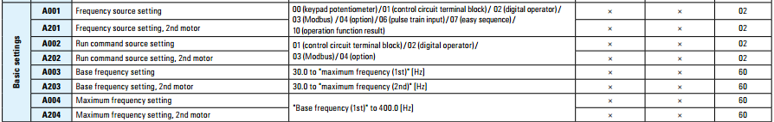
“C” Group: Intelligent Terminal Functions 1-7
The seven input terminals [1], [2], [3], [4], [5], [6], and [7] can be configured for any of 72 different functions. The next two tables show how to configure the seven terminals. The inputs are logical, in that they are either OFF or ON. We define these states as OFF=0, and ON=1. Terminals [3] and [4] have the ability to be logical inputs, and to be safety inputs in case of safe stop function is selected as marked by GS1 and GS2, and Terminal [5] has the ability to be a logical input, and to be an analog input for a thermistor device when PTC function (option code 19) is assigned to that terminal. A list of group “C” Intelligent terminal Functions 1-7 can be seen below.
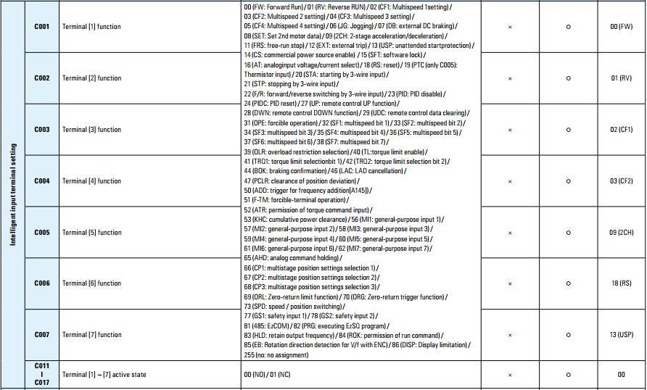

“C” Group: Intelligent Terminal Functions 11, 12, AL
The “C” group also allows for terminal [11], [12], and the alarm relay [AL] terminal to be programmed. These terminals, like terminals 1-7, are logical and can be in an OFF=0 state or ON=1 state. The function codes for terminal [11], [12] and [AL] can be seen below. Each of these terminals can be programmed to run 48 different functions, also seen below.
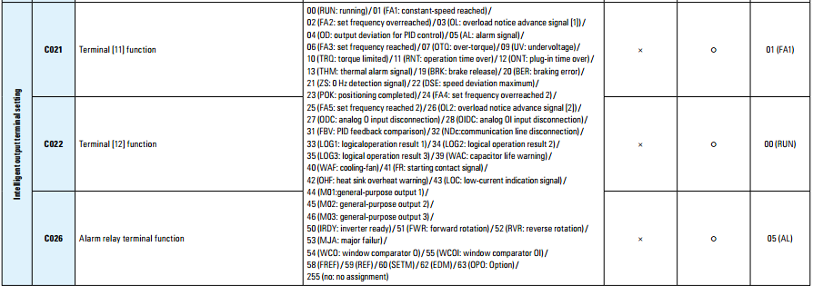

Using a PC to control the Hitachi WJ200
The WJ200 can communicate through a computer. The ProDriveNext software, downloadable on the computer, allows for communication between the inverter and a PC. The software allows for parameter adjustment to be made via PC.
Installing ProDriveNext Software
1) Visit this link http://www.hitachiamerica.us/ice/inverters/support_service_sales/software_dloads/?WT.ac=pro_smm_sss_sd
2) For installing PDN for the first time please download and save the “PDN drivers” folder, and click on the appropriate driver for your 32 or 64 bit system, the file name will be named “dpinst32.exe” or “dpinst64.exe” depending on your operating system. The required driver files will be installed in your computer device.
3) To download ProDriveNext click on the link named “Download ProDriveNext 2.1.2 English”. Once you have submitted the download form, select Save (do not select Open or Run) to download the software to your computer.
4) Please download and save the file PDN_Inv2.1.2_en.
5) Please unzip or extract all the files. Once the files are all extracted, please find the “Setup.bat” file inside the folder click on “Setup.bat” file to install the software.
6) After the installation of the USB drivers is finished, open ProDriveNext using the newly installed icon within the Programs files in your computer, and click on "Configuration" on top of tool bar
7) Then click on "Update Catalog" to get all the devices installed or updates from previous data files.
You can now begin creating new parameter and program files with the ProDriveNext projects.
Connecting the inverter to the PC
1) Open up ProDriveNext software and connect a USB cable from the PC to the USB connector on the top right of the WJ200
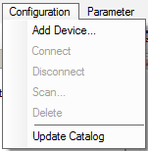
2) Click on the “Configuration” tab on the top of the page and select “Add Device…”
3) Click on the button and the software will find the connected device
4) The device is now connected
To change parameters via the PC click on the Parameter button shown here 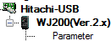
For more information on the ProDriveNext Software please refer to the “ProDriveNext Inverter Setup Program” or contact Sam Mirza for tech support at Sam.Mirza@hal.hitachi.com

