STAKEHOLDER ENGAGEMENT AND FREE, PRIOR AND INFORMED CONSENT
One of the key aspects of the CCB Standards is the requirement for participatory processes and the requirement for full and effective participation. This section will help you understand how to fulfil the requirements for stakeholder engagement including Free, Prior and Informed Consent in the CCB Standards (G3 and G5).
1. What constitutes full and effective participation in the CCB Standards?
Full and effective participation can be defined as a four scale gradient that includes access to information, consultation, participation in design and implementation and, finally, Free, Prior and Informed Consent.
Box 1: Full and effective participation

Adapted from the participation framework in Lawlor K., Madeira E.M., Blockhus J., Ganz D.J. 2013. Community Participation and Benefits in REDD+: A Review of Initial Outcomes and Lessons. Forests 4(2):296-318. http://www.mdpi.com/1999-4907/4/2/296

2. What is the recommended process for stakeholder engagement and what aspects need to be addressed in each of the phases?
3. What is the relationship between the impact assessment process for the CCB Standards and the stakeholder engagement process outlined above?
The impact assessment process recommended for the CCB Standards is outlined in Richards M. and Panfil S.N. 2011. Social and Biodiversity Impact Assessment (SBIA) Manual for REDD+ Projects: Part 1 – Core Guidance for Project Proponents, CCBA, Forest Trends, Fauna and Flora International and rainforest Alliance https://s3.amazonaws.com/CCBA/SBIA_Manual/SBIA_Part_1.pdf. A participatory approach to impact assessment is one of the aspects of an effective participatory stakeholder engagement process. Therefore, many of the aspects explained in detail and in the tools provided in the SBIA Manual provide helpful guidance for the stakeholder engagement process. For example, Step 1 in the SBIA Manual provides guidance on gathering information in the stakeholder engagement process while Steps 2, 3 and 4 relating to impact assessment in the SBIA manual assist with the stakeholder engagement process for ensuring full and effective participation.

4. What are the participatory analyses relating to ecosystem services that are required in the Standards? What are the best tools for participatory identification and evaluation of such ecosystem services?
The benefits of ecosystem services may be derived at different scales. For example, at the local level, ecosystem services may provide benefits to the Communities and Community Groups by serving as the basis for rural livelihoods and subsistence. Ecosystem services may also provide benefits at the regional level, such as a forested watershed providing clean water or helping to control flooding in downstream communities. At the global scale, examples of ecosystem services include regulating climate and acting as reservoirs of biodiversity. The CCB Standards require a participatory assessment of ecosystem services benefits at the local scale and regional scales (CM2.1, CM1.2a and CM2.3). For global scale benefits, it is highly recommended for projects to use a participatory approach for aspects on which Communities may have knowledge, such as local biodiversity in the Project Zone, presence of threatened species, endemic species, etc.
- Local scale benefits: As a part of net positive community impacts analysis, the project should take into account "potential impacts of changes in well-being due to all ecosystem services identified as important for communities"(CM2.1). The CCB Standards require that this analysis must be participatory, with the Communities playing a role in identifying the types of impacts (including direct and indirect benefits, costs and risks) as well as the magnitude of the impacts.

- Regional scale benefits: Projects should "maintain or enhance the identified High Conservation Values" of areas that provide critical ecosystem services (CM1.2a, CM2.3). Unlike the net community benefit analysis (CM2.1) which only needs to take into account ecosystem services identified as important for Communities, this analysis also needs to include critical ecosystem services that may not be identified as important for the Communities but may still be impacted.

- Global scale benefits: The CCB Standards require net positive benefits for the climate (CL2) as well as for biodiversity (B2). The Standards also require that projects should "maintain or enhance the identified High Conservation Values" of biodiversity including: globally, regionally or nationally significant concentrations of biodiversity values (protected areas, threatened species, endemic species and areas that support significant concentrations of a species during any time in their lifecycle); globally, regionally or nationally significant large landscape-level areas where viable populations of most if not all naturally occurring species exist in natural patterns of distribution and abundance; and, threatened or rare ecosystems (B1.2). It is recommended that projects consult the Communities for identification of these global ecosystem services, where they may have knowledge about them, such as local biodiversity.
Using participatory approaches for assessment of ecosystem services also leads to broader benefits such as:
- building community knowledge and/or capacity about ecosystem services, and
- context analysis, in terms of learning about community knowledge and practices around these ecosystem services that can inform project design.
Participatory mapping is a useful tool that may be used as part of the process for identification of ecosystem services at the local and regional scales. There are several good practice guidance documents such as: Participatory Mapping and Communication: A guide to developing a participatory communication strategy to support participatory mapping by International Fund for Agricultural Development (IFAD). 2010. http://www.ifad.org/pub/map/pm_iii.pdf. The Biodiversity Impact Assessment Toolbox (Part 3 of SBIA Manual) https://s3.amazonaws.com/CCBA/SBIA_Manual/SBIA_Part_3.pdf identifies some useful tools related to Biodiversity assessments. The Common Guidance for the Identification of High Conservation Values (HCV) http://www.hcvnetwork.org/resources/folder.2006-09-29.6584228415/cg-for-hcv-identification may be used for HCV analysis.
Finally, it is important to remember that ecosystem services also work over different temporal scales ranging from short-term to long-term impacts, which should be considered adequately.
Box 2: List of Ecosystem Services with definitions and examples 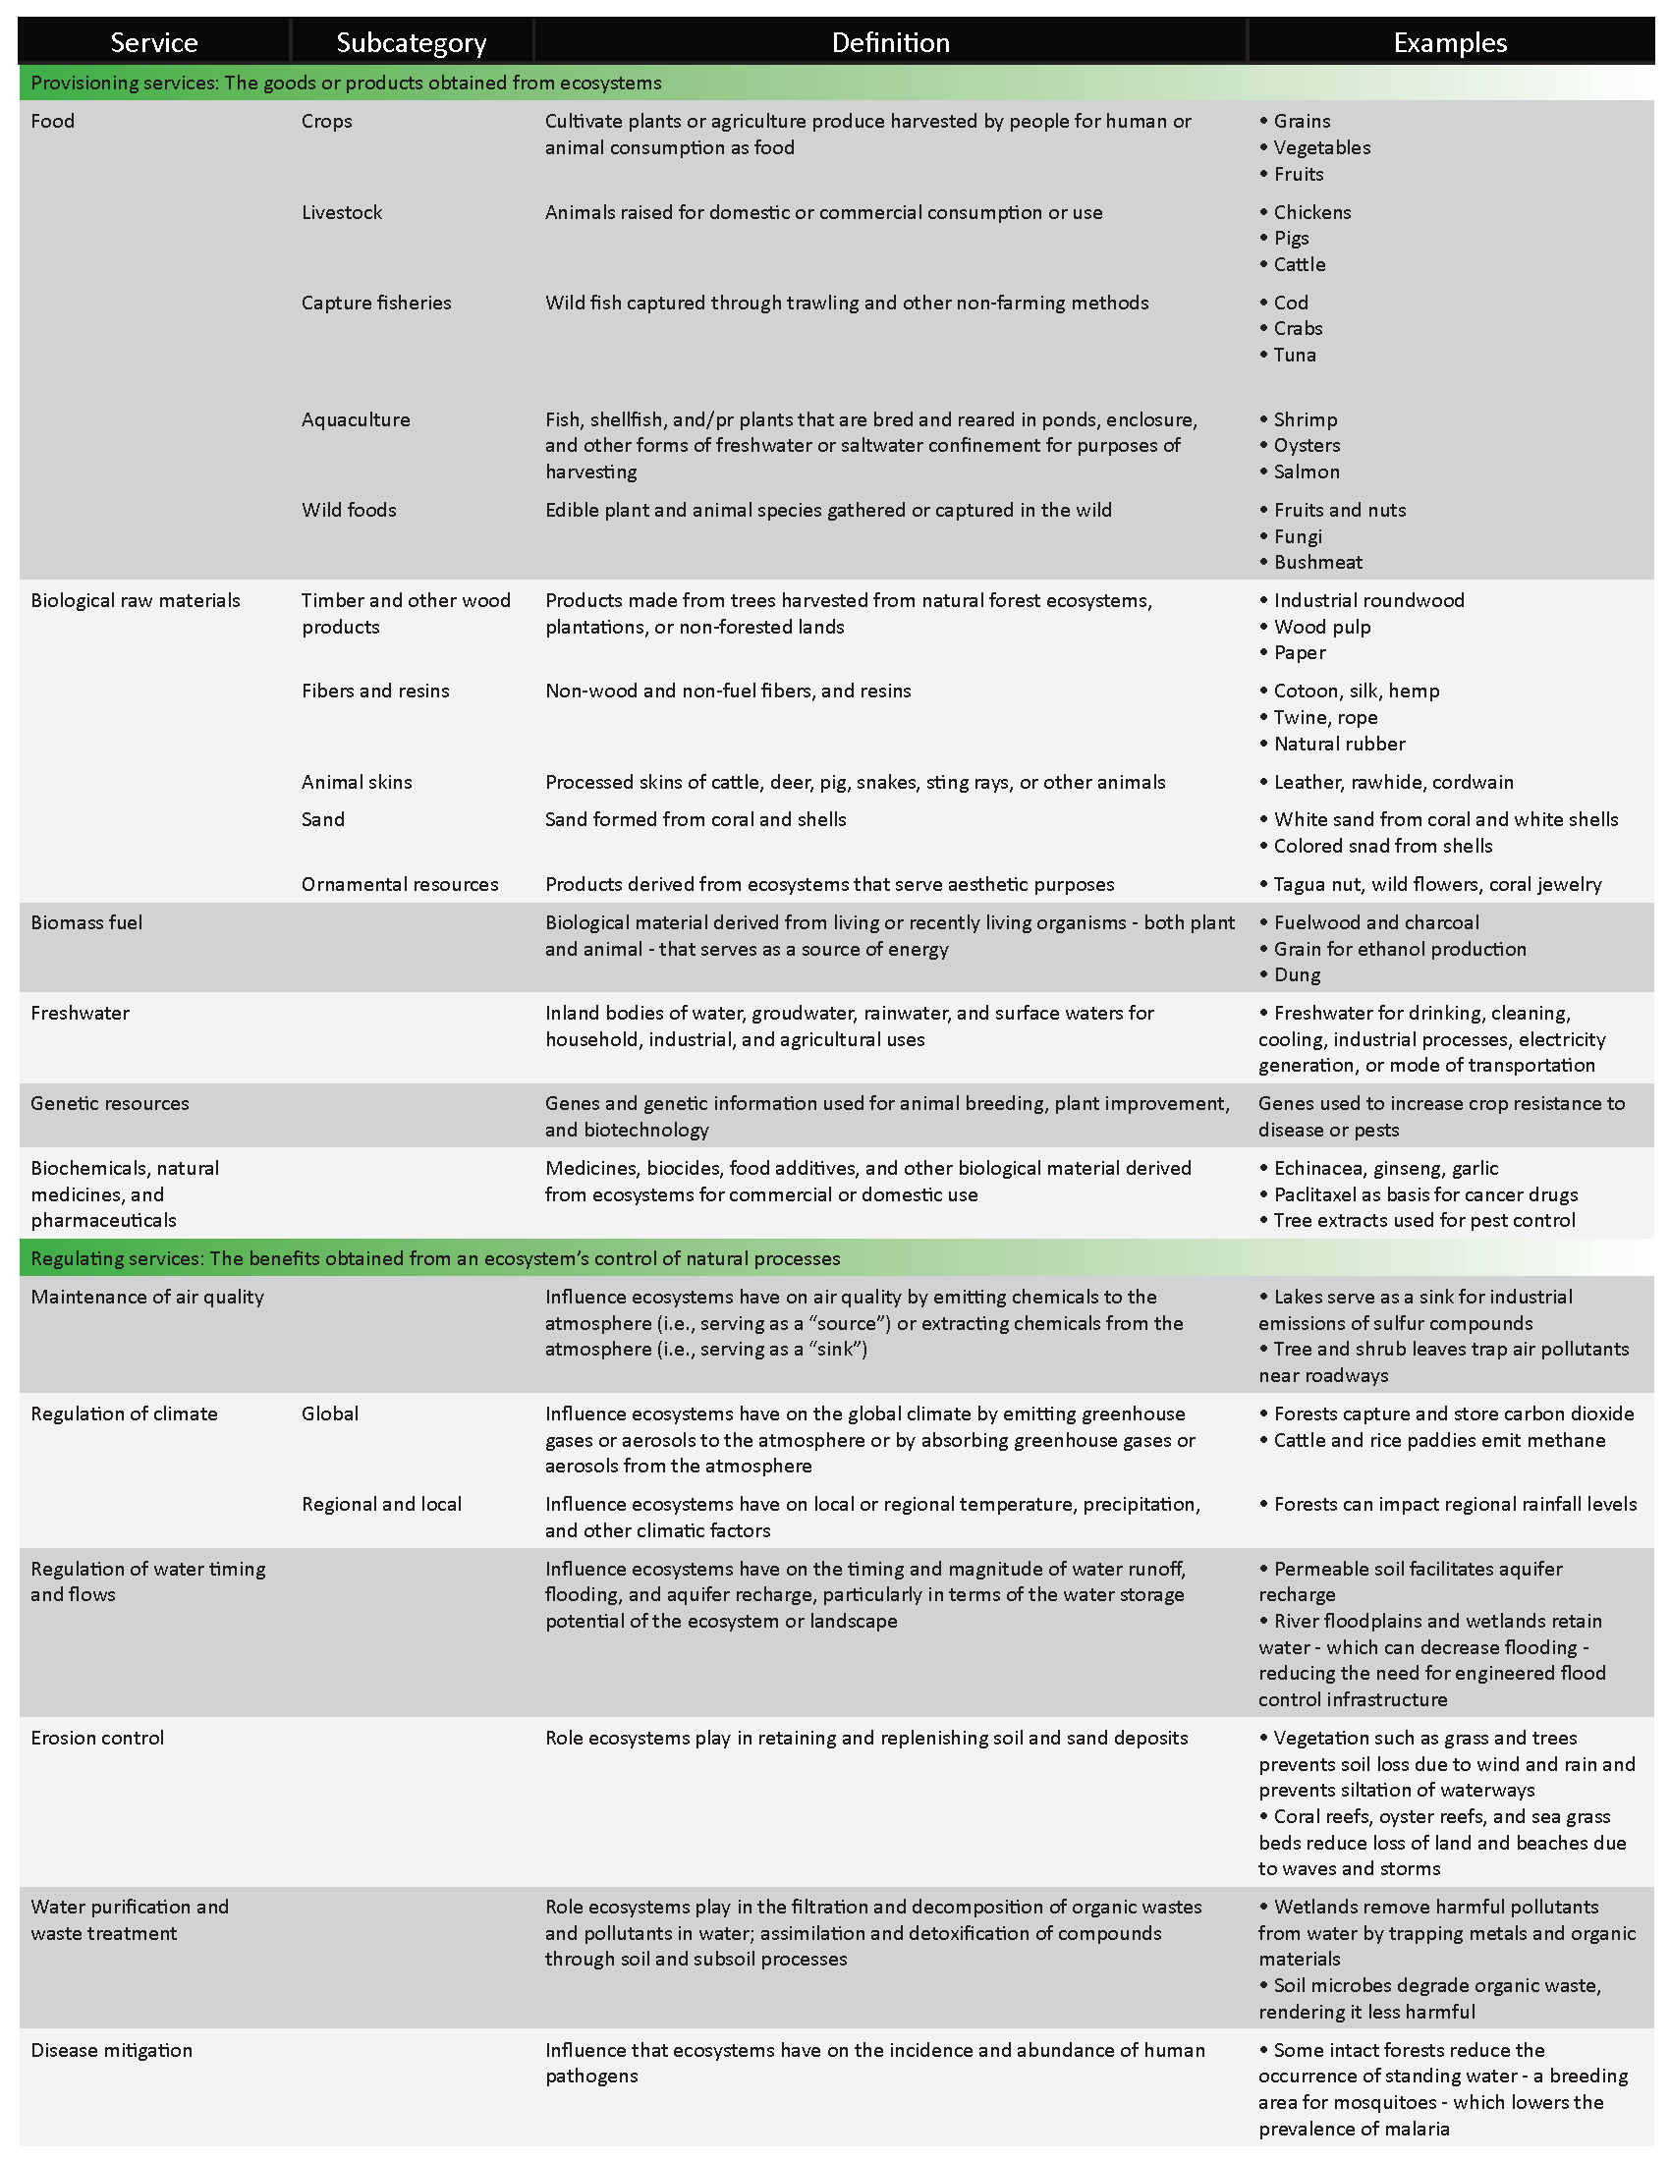

Box 2: List of Ecosystem Services with definitions and examples (Continued)
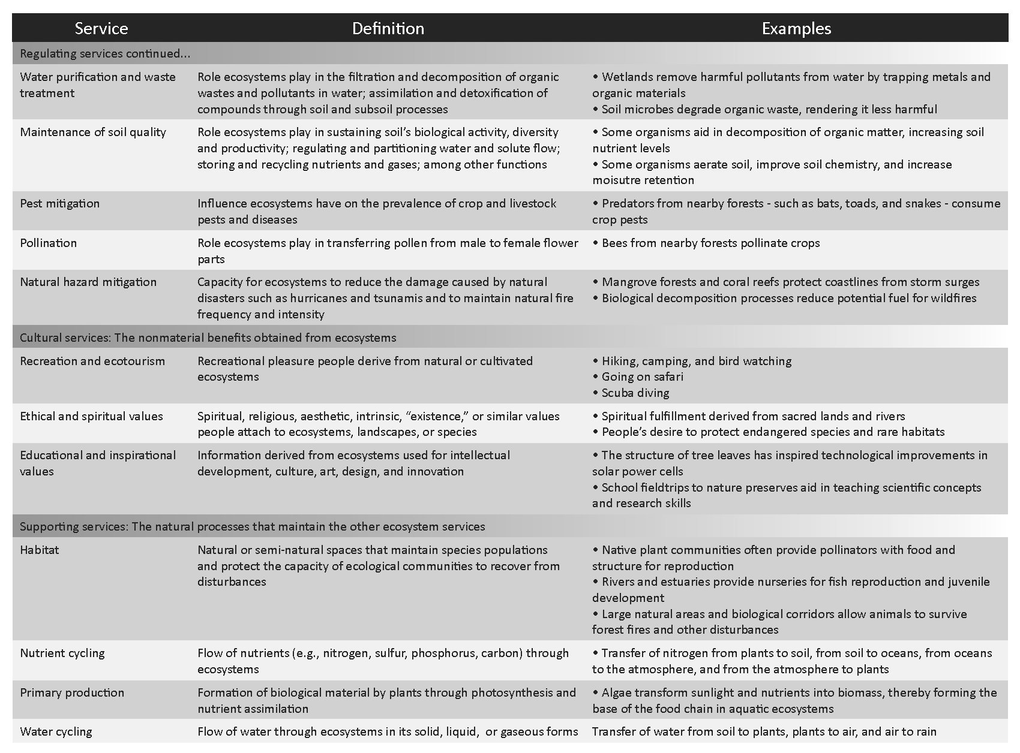 Source: Hanson, C., C. Van der Lugt, and S. Ozment. 2011. Nature in Performance: Initial Recommendations for Integrating Ecosystem Services into Business Performance Systems. World Resources Institute. Washington, DC.
5. What is the requirement relating to consultation on types and magnitude of impacts?
Participatory impact assessment is an important aspect of full and effective participation. The Project Proponent’s stakeholder engagement process must include identification of all direct and indirect, costs, benefits and risks in consultation with the Communities and Community Groups (G3.4 footnote). In addition, in the Community Section, CM2.1 requires that “the assessment of impacts must include changes in well-being due to project activities and an evaluation of the impacts by the affected Community Groups”.
The primary reason for a participatory approach to impact assessment is because well-being has an important subjective element. CM2.3 requires that “the net well-being impacts of the project are positive for all Community Groups compared with their anticipated well-being conditions in the without-project land use scenario”. ‘Well-being’ is a subjective perception of ‘people’s experience of the quality of their lives’ and therefore it is vital for Communities to define the important dimensions of well-being in their case and what constitutes an improvement (for more information on well-being refer to the Positive Community Benefits section of this document).
Participatory impact assessment is an iterative process since project design and understanding of impacts will change over time as a direct result of the participatory process. Some of the aspects that need to be included in this process relating to types and magnitude of impacts are:
- The Project Proponent must explain the project and its impacts or potential impacts to the Communities.
- The concept of impact assessment must be explained adequately and in a manner understood by the Communities, including that impacts include costs, benefits or risks, including direct and indirect impacts, for example by providing examples of impacts from a local context, etc.
- A comprehensive list of all types of impacts (negative - costs and risks - and positive - benefits), from the perspective of the Communities, must be compiled.
- The magnitude of all types of impacts (in the list mentioned above) must be assessed with participation of the Communities to build consensus between the Project Proponent and the Communities on the types and magnitude of impacts.
- Net positive benefits must be assessed for the Communities and biodiversity taking into account the type and magnitude of impacts.
The Social Impact Assessment Toolbox - Part 2 of the SBIA manual (https://s3.amazonaws.com/CCBA/SBIA_Manual/SBIA_Part_2.pdf) provides some useful tools and approaches to impact assessments.

6. How can projects ensure that consultations are gender sensitive? How is this requirement different for Community Gold projects that need to ensure that women influence decision making?
The CCB Standards requires that consultation is undertaken in a gender sensitive manner (G3.4), ensuring that women have similar opportunities and time to participate in consultations as men. In addition, in situations where women are not traditionally allowed a voice in consultations, the project must identify ways of obtaining their input and feedback. Ensuring that consultations are gender sensitive may be done by encouraging women to attend formal/informal meetings, for example by addressing meeting invitations specifically to women, holding meetings with women only, providing child care during meetings, holding meetings at a time of the day or year when women are most free to participate, etc. If effective approaches to ensure women’s participation are not easily identified, the project may initiate a dialogue with Communities including decision-makers and women to develop socially and culturally sensitive approaches to include women more effectively.
An additional requirement for Community Gold projects is to ensure that women influence decision making. This means that Project Proponents should identify and modify decision-making structures to ensure that both men and women participate fully and effectively in decision making related to the project. Demonstrating the importance of all community opinions, whether gathered formally or informally, to decision makers may be required. This may not be acceptable to the community through formal channels such as a community-wide meeting, but informal ways like casual discussions or a women’s gathering may provide an appropriate channel to achieve this participation. The Project Proponent may also need to undertake training and capacity building to support the ability of women to participate in decision making and to help decision makers understand the value of women’s participation. The Community Gold Level further requires demonstration that the final decisions taken regarding the project have been influenced by women.

7. How can projects ensure that consultations are inter-generationally sensitive?
Box 3: Definition of ’gender sensitive’
To be ‘gender sensitive’ is to understand and give consideration to socio-cultural norms and discriminations in order to acknowledge the different rights, roles and responsibilities of women and men in the community and the relationships between them.
Quesada-Aguilar, Andrea. 2013. Getting REDD+ right in Social and Environmental Standards. The Women’s Environment and Development Organization (WEDO) and the REDD+ Social and Environmental Standards (SES) Secretariat. http://www.redd-standards.org/index.php?option=com_eywafm&task=cat_view&gid=56&Itemid=185
The CCB Standards require that consultation is undertaken in a manner that includes the interests and opinions of younger and older people in the Communities. For example, it is important that the potential impacts of project activities on youth are considered, benefits to them are ensured and their influence and decision making is enabled. This becomes critical to the success of the project since land management projects may continue over several decades so the youth of today may be managing the project in the future. The approaches to ensuring an inter-generationally sensitive consultation may be similar to the strategies and methods described in the previous question on ensuring gender sensitive consultations.

8. How can projects ensure inclusion of marginalized and vulnerable people and groups?
CCB Standards require effective consultations that pay particular attention to marginalized (with little or no influence over decision making) and vulnerable (high exposure and sensitivity to external stresses and low capacity to adapt) people and groups, even if they are not recognized as a separate Community Group. The approaches to ensuring that the consultation process pays special attention to marginalized and vulnerable people and groups may be similar to the strategies and methods described in the question on ensuring gender sensitive consultations.
Marginalized and vulnerable groups need to derive net positive benefits for Community Gold projects. Even if the project is not using the Gold level, if any of the marginalized and vulnerable groups are identified as distinct Community Groups, these groups need to derive net positive benefits (see the Net Positive Benefits section of this document for more details).
The Community Forest Program in Nepal has institutionalized some approaches for inclusion of marginalized and vulnerable groups in decision making and benefit sharing (See Case study 3 in the section on Exceptional Community Benefits).

9. Why do the CCB Standards include a requirement for consultations with ‘legitimate representatives’?
It is important that consultations are undertaken directly with Communities or Other Stakeholders or, when this is not possible, with legitimate representatives, in order to ensure legitimacy of the decision-making and consultation process. If consultation with representatives is involved, the Project Proponent should ensure that there are appropriate processes within the Communities for them to select these representatives and that two-way information flows (sharing of information and feedback) are maintained between the representatives and the Communities.

10. What is the requirement relating to full and effective participation on the feedback and grievance redress procedure?
The Project Proponent is required to share details about the feedback and grievance redress procedure with the Communities. The CCB Standards Third Edition requirement for the Feedback and Grievance Redress Procedure is for a three tier system. The first level is negotiation, the second level is mediation and the third level is referral of the issue to ‘laws of the relevant jurisdiction’, that may include an option for arbitration. The independent mediator is selected in consultation with the Communities.

11. What is the requirement relating to ensuring Free, Prior and Informed Consent in the CCB Standards?
The CCB Standards not only requires the Project Proponent to share information and consult with the Communities but also to obtain Free, Prior and Informed Consent (FPIC) from those whose property rights are affected by the project. This right to FPIC extends to Indigenous Peoples and others in the Communities who have statutory or customary tenure, use, access or management rights to lands, territories and resources (‘property rights’) in the Project Zone and is required for both collective and individual rights. The FPIC process, unlike consultation, gives the Communities the option to give or withhold their consent to the project activities and this decision must be respected by the Project Proponent.
FPIC is required under two circumstances:
- When property rights are potentially affected, FPIC must be obtained from property rights holders (G5.2).
- When project activities may lead to the removal or relocation of habitation or activities important to their culture and livelihood (resettlement) (G5.3).
Participatory mapping is an important part of the FPIC process. The Project Proponent must undertake effective mapping of property rights and land and resource use (G5.1) through a participatory process including Communities and neighboring communities (so that they can confirm boundaries). All relevant Community Groups must participate in the mapping exercise. The mapping must include any overlapping or conflicting rights. Even rights that are disputed should be recognized and respected, and the Project Proponent needs to ensure that no activity is undertaken that could prejudice the outcome of an unresolved dispute (G5.5).
Box 4: Definition of Customary rights
‘Customary rights’ to lands, territories and resources refer to patterns of long-standing community lands, territories and resource usage in accordance with Indigenous Peoples’ and local communities’ customary laws, values, customs, and traditions, including seasonal or cyclical use, rather than formal legal title to lands, territories and resources issued by the State.
World Bank Operational Manual, OP 4.10 – Indigenous Peoples, July 2005. http://web.worldbank.org/external/default/main?Email=Y&contentMDK=20553653&menuPK=64701637&pagePK=64709096&piPK=64709108&theSitePK=502184.

The FPIC process leads to an agreement on whether project activities will move forward or not. If a community or rights holder does not give consent to the project activities that affect them, then those activities cannot move forward in their area. If the community or rights holder gives their consent to project activities, then project planning and implementation of those activities can proceed.
FPIC is location specific with some communities or rights holders giving consent to include their areas in the project while other areas for which consent was not given are kept out of the project. The right of FPIC is not a right of veto over the whole project. Consent can be withheld for project activities that affect their property rights, which may mean that activities cannot be implemented in a certain area where property rights are held, remembering that property rights include statutory and customary tenure/use/access/management rights to lands, territories and resources in the Project Zone and include individual and collective rights.
Bearing in mind that the decisions for FPIC should be made at the level at which rights are held (i.e. individually for individual rights and collectively for collective rights), and respecting tradition decision-making processes, efforts must be made to ensure that all relevant Community Groups within Communities must be included in the decision relating to FPIC. If there are groups within communities with collective rights that are excluded from the decision making process, the Project Proponent must seek dialogue with community leaders on the reasons for this, and determine if there are ways in which their opinions can be included. This may include training or capacity building for both the majority and any potentially marginalized groups or people.
Consent could be a written agreement or an agreement in other forms such as oral, traditional ceremony, show of hands, etc. The format of the consent should be recognized by both parties. The decision has to be documented and documentation methods may include: written document, a video/audio recording of the representative speaking the decision, etc.
Giving and withholding consent is also time-specific and can be revisited and revised. There should be provisions for periodic review of the agreement with the Community throughout the life of the project. The periodicity should be determined in consultation with the Communities. When consent has been obtained, it constitutes a binding agreement for both parties such that if the conditions upon which the original consent was based are being met, ongoing consent is implied. If these conditions change, the Communities may review and either reaffirm or withdraw consent. The feedback and grievance redress procedure must allow for the option of withdrawing consent to be invoked when conditions upon which the original consent was based are not met.
Box 5: Format of a consent agreement
A consent agreement may include the following:
- Agreed signatory parties;
- Mutually agreed substantive documented evidence of consent ;
- Description of location/rights holders/resources;
- Description of agreement details (according to location in the project cycle). For agreements on project implementation this may include: costs to be borne by the community; benefits accruing to the community; risks to be borne by the community;requirements (e.g. patrolling, data collection, reporting, etc.); rules and restrictions imposed on the community (such as limiting, use of forest products);
- Duration/term;
- Arrangements for making agreements binding;
- Independent verification provisions;
- Recourse mechanism/grievance process;
- Moniontoring plan;
- Withdrawal of consent terms;
- Agreed next point for consent to be sought; and
- Appendices such as management plans/details of agreed economic development activities/associated detailed processes for implementation
The consent agreement may not always be a one-off agreement but could also be a series of agreements that are progressively more detailed over time as project design is developed with communities.
Adapted from Anderson, Patrick. February 2011. Free, Prior, and Informed Consent in REDD+. RECOFTC and GIZ http://www.forclime.org/images/stories/RECOFTC-GIZ_FPIC_in_REDD_2011.pdf

