EXCEPTIONAL COMMUNITY BENEFITS
The Gold Level in the Community Section (GL2) showcases projects that are either led by smallholders or community members or that are explicitly pro-poor. This section of the guidance document will help you understand the requirements to achieve the Community Gold level and how these requirements can be met by providing an explanation of the concepts and examples of some projects on the ground.

1. What are the eligibility criteria for the Community Gold level?
The Community Gold Level of the CCB Standards Third Edition is an optional criterion that can be used to identify and promote projects that are smallholder- and community-led or pro-poor (including those that satisfy both these requirements).
- Smallholder- and community-led projects are projects implemented on lands owned or managed individually or collectively by smallholders or community members, where Smallholders/Community Members are defined as households within the Communities that are actively participating in the project.
- Pro-poor projects explicitly target benefits to globally poor communities.
An ‘or’ condition is used to accommodate all types of projects that deliver equitable benefit sharing and enable active involvement of the Communities. Only recognizing projects on land that is owned or controlled by communities or smallholders might have excluded some types of projects that deliver exceptional community benefits such as projects in concessions, national parks and other government-owned protected areas, privately owned forests, etc. Similarly, only recognizing projects that help poorer communities of the world might have excluded some community-led projects that deliver exceptional community benefits.

2. What are the additional requirements in the Community Gold Level (GL2) in the Third Edition of CCB Standards over and above the Community section (CM2)?
Both GL2 and CM2 focus on improving human well-being. However, GL2 is different in the following aspects:
- The Gold Level indicators mostly focus on the household level, whereas CM2 requires demonstration of net positive benefits for each Community Group. The only case where GL2 focuses on assessment at group level is for indicators GL2.4-5 that require that marginalized and/or vulnerable Community Groups and women benefit from the project. The Gold Level therefore requires gathering of data at the household level (e.g. household surveys). For GL2.2-3 and GL2.6-7, more than 50% of the households need to derive net well-being benefits. For GL2.3-4, more than 50% of the households within groups (marginalized and vulnerable groups in GL 2.4 and women in GL 2.5) must derive net positive impacts.
- The Gold Level requires net benefits for each of the aspects of human well-being as outlined in the ‘attacking poverty’ framework.
  - Opportunities: creating (and not blocking) material opportunities for wealth creation and well-being, such as jobs, revenue streams, infrastructure, and improved educational conditions;
  - Security: enhancing (and not weakening) populations’ security, including tenure security, food security, livelihood security, and adaptability to climate change; and
Box 1: Community Gold Level: Human well-being benefits

Source: ‘Attacking poverty framework’ (Lawlor K., Madeira E.M., Blockhus J., Ganz D.J. 2013. Community Participation and Benefits in REDD+: A Review of Initial Outcomes and Lessons. Forests. 4(2):296-318. http://www.mdpi.com/1999-4907/4/2/296)

  - Empowerment: facilitating (and not preventing) the empowerment of individuals and communities to participate in decisions affecting local land-use and development.
This requirement is more stringent than CM2 that requires net positive human well-being benefits across all well-being categories therefore allowing for tradeoffs in some areas.
- While gender is given attention throughout the Third Edition, the Gold Level requires projects to explicitly demonstrate net positive well-being benefits to women. The CM2 requires net positive benefits to women or sub-groups of women only if they are identified as a Community Group, deriving a different set of income, livelihood and cultural values from the project from others in the Communities. The Gold Level also goes further by requiring women to participate in or influence decision-making. For all projects, the General section requires participation to be gender-sensitive.
- The Gold Level focuses on ensuring equitable benefit sharing not only between the project and the Communities but also among Smallholders/Community Members for example by requiring net positive benefits to all identified marginalized and vulnerable groups. CM2 requires net benefits for all identified Community Groups, except those that are not significantly affected by or participating in the project.

3. What are the main requirements for the Community Gold Level in the Third Edition of the CCB Standards?
The requirements in the Community Gold Level primarily relate to ensuring equitable sharing of benefits, meaning equitable sharing of benefits, costs and risks associated with the project and not just sharing of revenues. Equitable benefit sharing consists of two aspects: (1) benefits need to be shared equitably with the Smallholders/Community Members, ensuring active involvement of Smallholders/Community Members to strengthen the equity of the benefit sharing mechanism, and (2) benefits need to be shared equitably among the Smallholders/Community Members.

4. What are the requirements for equitable benefits for Smallholders/Community Members?
The project must deliver comprehensive benefits in all three categories of human well-being: opportunities, security and empowerment. The project must deliver short-term and long-term benefits, must take measures to avoid and manage tradeoffs with food security, livelihood security, adaptability to climate change and tenure security, and must build capacity and enable full and effective participation of Smallholders/Community Members. Some of these aspects are explained below with examples.
1. Short-term and long-term benefits: GL2.2 requires the delivery of short-term as well as long-term benefits. This requirement is explained for Afforestation/Reforestation, Agriculture and Avoided deforestation projects below:
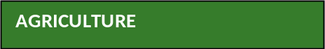
Agriculture projects, such as climate smart agriculture projects and afforestation/reforestation projects, may provide net well-being benefits to smallholders in the long term (such as increased crop yields, carbon payments, etc.), while involving costs and risks for these farmers in the short term. The costs and risks to smallholders may include establishment and maintenance costs of new practices, initial periods of low return, higher labor requirements, etc. Smallholders face constraints in terms of lack of required long-term capital to invest and inability to absorb risks due to their limited asset base (refer to Box 2 . Projects must therefore be designed and implemented in such a way that farmers receive both short-term and long-term benefits, taking into account costs and risks, and receive incentives to invest in new practices.
Box 2: Short-term income losses in climate smart agriculture
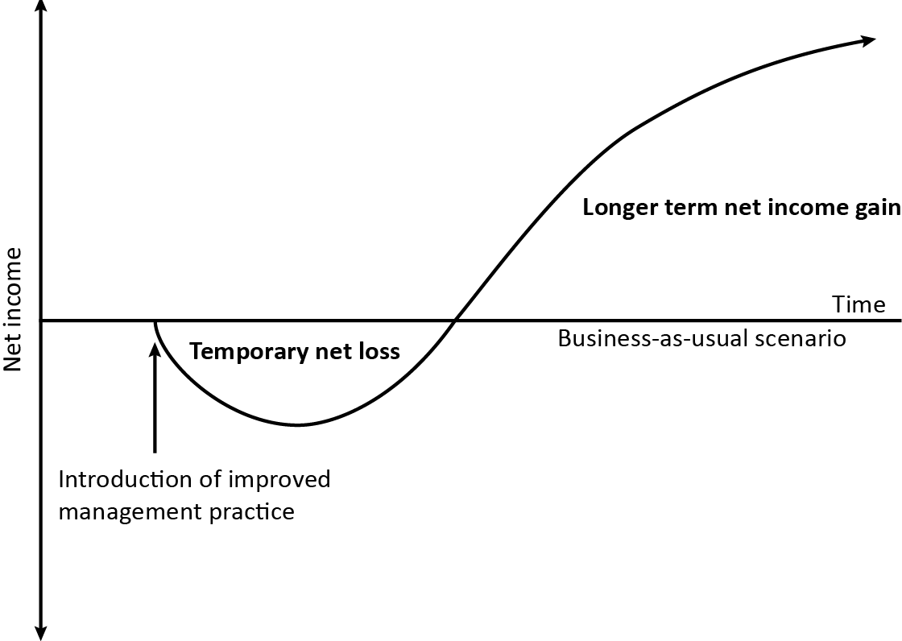
Source: Neufeldt H., Kristjanson P., Thorlakson T., Gassner A., Norton-Griffiths M., Place F., Langford K. 2011. Making climate-smart agriculture work for the poor, ICRAF Policy Brief 12; World Agroforestry Centre (ICRAF) Nairobi, Kenya. http://www.worldagroforestry.org/downloads/publications/PDFs/BR11267.PDF


AVOIDED DEFORESTATION
REDD projects must be designed and implemented in such a way that they provide short-term as well as long-term benefits. Pay-for-performance schemes take a long time to materialize and therefore benefits such as revenue distribution from sale of carbon offsets will materialize later on in the project. Other concrete benefits such as creation of sustainable forest enterprises, securing recognized management and land rights for forest-dependent Community Members, etc. may also not deliver immediate benefits. Early benefits (prior to performance) are often necessary in order to provide incentives for a change in community activities to reduce deforestation and/or where Communities are subject to opportunity costs or other costs from the start of the project. Short-term benefits help to build support and maintain interest of the affected Community Members in the project until the long-term benefits start flowing. There is evidence of improved outcomes in integrated conservation and development programs when visible and sustainable benefits are provided for Community Members at an early stage.
- Active Involvement: GL2.6-2.9 in the Gold Level requires that Smallholders/Community Members are not passive beneficiaries of projects, but must participate actively in the project with respect to participating effectively in the design of benefit sharing and in project decision making, implementation and management. Further, these Community Gold projects must also help to build the capacity and autonomy of the Smallholders/Community Members. While there are some projects where the Communities are the Project Proponents (see the Suruí project example explained below (Case Study 2)), for several smallholder- and community-led projects, NGOs/other organisations may still play a significant role, with their involvement decreasing over time as local capacity is built (see the Humbo project example explained below).
An example of an Afforestation/Reforestation project with active involvement is the Humbo community management natural regeneration project (see Case Study 1).
AVOIDED DEFORESTATION
An example of a REDD project that is not only led by community members but where they also own the project is provided below in Case Study 2.
Case Study 1: Self governance arrangements that promote active involvement
In the Humbo community management natural regeneration project, the project area is divided into seven sections, each managed by neighboring communities. Respective communities are aggregated through cooperative societies to manage and implement Farmer Managed Natural Regeneration (FMNR) in their jurisdictions of the project area. Each section is communally owned, with cooperative societies being assigned with user rights certificates. Cooperative society management boards are composed of an executive steering committee supported by the forest development, forest protection and savings and loans sub-committees. Forest Development and Forest Protection Sub-committees help to implement the forest management plan, which has been developed by the cooperatives in conjunction with World Vision Ethiopia (WVE). The Union is an umbrella body that governs the cooperative societies. It is envisioned that it will take over the implementation and management duties currently provided by the WVE (the Project Proponent), with WVE providing a technical backstopping role.
These governance structures facilitate information sharing and ensure full and effective participation of the smallholders. Information related to the project is readily available at the cooperative level. Central offices paste meeting dates, committee members and locations, project implementation activities and other details on their walls. Any interested members can access these offices or obtain information through sub-group leaders who are also part of the cooperative management committee. The smallholders have been involved in the step-by-step process on the development of this project. This has included designation of communal areas for afforestation/reforestation activities, development of implementation and management plans, assessment and benefit sharing within their cooperative structure. 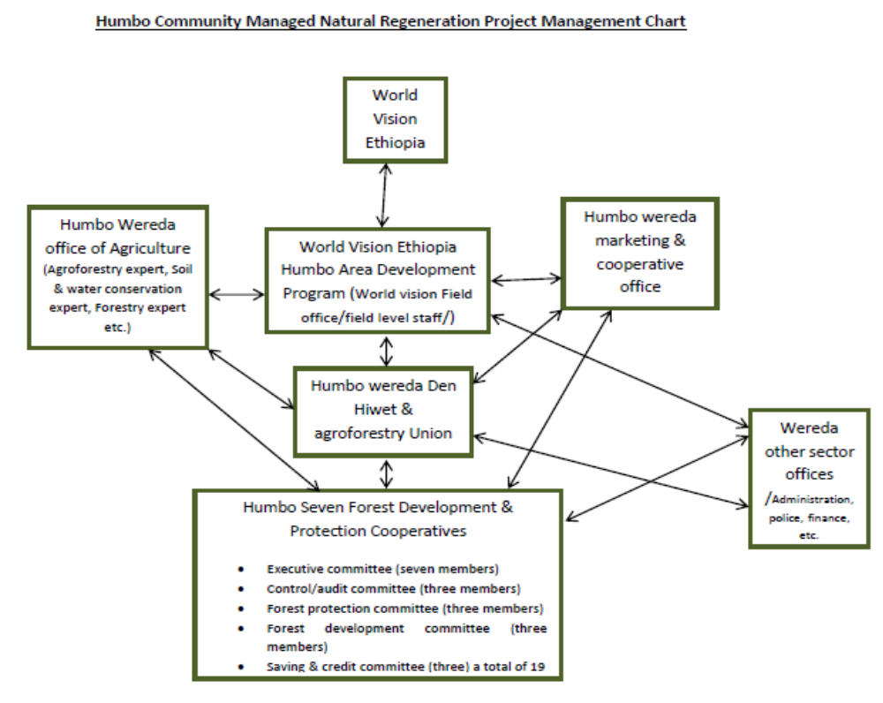

Case study 2: Example of active involvement in a Avoided deforestation project
The Suruí Forest Carbon Project is led by the Suruí people in the Brazilian Amazon. The Suruí is a tribe of roughly 1,300 members, structured in four clans, who were first contacted less than 50 years ago. The initiative to start the REDD project was their autonomous decision, and culminated in the signing of a cooperation agreement document by all four clans among themselves through their respective associations in June 2009. This agreement established that the clans would work together to implement the carbon project, and that all economic benefits would be shared in a just and equitable way among the Suruí communities.
The REDD project development process involved several meetings and workshops to explain the project objectives and share details on the project, including a transparent dialogue about the risks. The local communities participated in preparing and designing the project through meetings, consultations and processes of free, prior and informed consent that lasted close to two years. The project is also in alignment with their 50-year Plan, a long-term development vision that seeks to gradually improve the quality of life for the Suruí people through a series of activities based on socio-environmental sustainability principles
The participation of local communities in decision making is facilitated through self-governance structures that include traditional and practical decision-making structures. This decision-making structure is also responsible for decisions relating to benefit sharing. The governance structure consists of a Higher Parliament which is the Clan Council (3 representatives from each of the 4 clans) and a Lower Parliament which represents the villages (2 representatives from each of five zones, with each zone consisting of 5 villages.) The FUNDO Suruí has been set up by the Brazilian Biodiversity Fund (Funbio) to administer income from the carbon project. There is a five year plan in place to train the Suruí people to start governing and managing the fund.
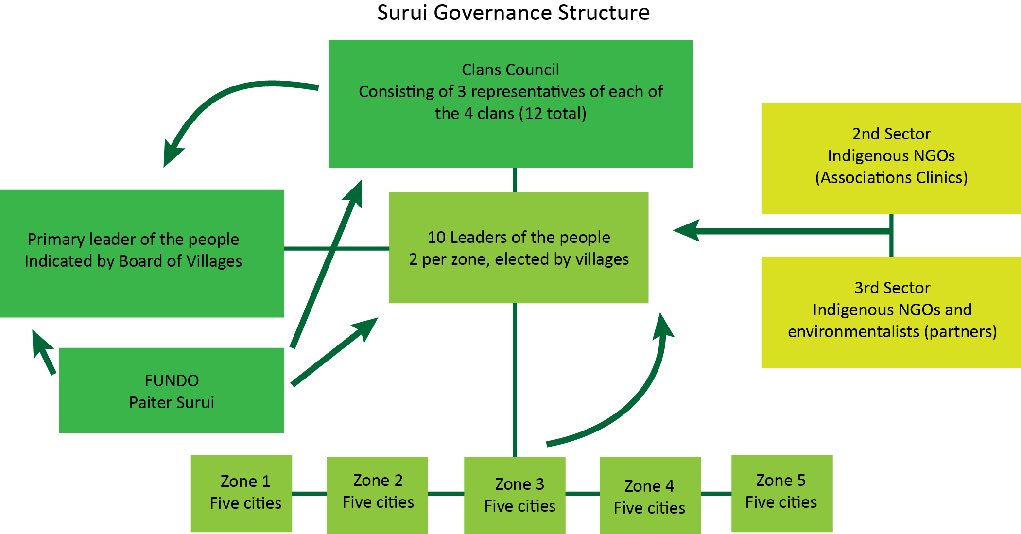
References: Olander J., Borges B., Surui A. 2011. The Surui Project: Building Indigenous Peoples’ Capacity for Informed Engagement with REDD Finance, Avoided deforestation (REDD) and indigenous peoples: experiences, challenges and opportunities in the Amazon context; Ethno-Zoning, Garah, Paiterey, Sete de Setembro Indigenous Land, Surui Project Documents. http://www.kaninde.org.br/upload/2012/04/etnozoneamento_surui_1334547167.pdf

- Monetary and non-monetary benefits (GL 2.6): In Avoided Deforestation projects, benefits often include non-monetary benefits such as securing statutory management and land rights for forest-dependent Communities or Community Members, empowering Community Members to participate in land-use decision processes and education programs, etc. These benefits not only help to mobilize community buy-in but also help a transition towards more sustainable economic activities. Monetary benefits could also be provided through mutually agreed revenue sharing mechanisms. For example, in the Oddar Meanchey project in northwest Cambodia, a minimum of 50% of project profits (revenues minus costs) will accrue to local communities. The revenue will be available as a grant fund for the communities to apply to a wide range of activities: education, health, agriculture, forestry, livestock, access to markets, infrastructure, micro-enterprises etc. In smallholder-led projects also, such as Afforestation/Reforestation and Agriculture projects, benefits could include monetary as well as non-monetary benefits, such as improved capacity for adaptation, empowerment of the smallholders, etc.

5. What are the requirements for sharing benefits equitably among Smallholders/Community Members?
GL2.4 and 2.5 require the inclusion of women and marginalized and/or vulnerable groups as beneficiaries of the project. The project also has to consider power dynamics among beneficiaries and safeguard against elite capture. Not only is equity essential for legitimacy, it also helps to reduce social risks and therefore contributes to the long-term success of the project.
Case Study 3: Community Forest Program in Nepal - A model for democratic governance and equitable benefit sharing
The Community Forestry Program in Nepal has institutionalized equity in decision making, empowerment over forest management and use, and access to forest resources at the community level.
Community Forest User Groups (CFUG’s), which are local institutions comprised of village residents using common forests (with the number of households in a CFUG ranging from fewer than a dozen to more than 10,000 households), have been given the authority to undertake management decisions regarding forest resources.
Issues related to the distribution of benefits (forest products and income), social exclusion and marginalization of traditionally disadvantaged groups, elite capture of benefits, decision-making processes, and transparency in managing CFUG funds have been addressed by the CFUGs by including explicit provisions for participation of poorer groups, women, lower caste groups, and other marginalized groups in their operational plans. Some examples are:
• Reservation of spots for the poor, women, and Dalits (low caste groups) on community forest committees and decision-making bodies.
• Special provisions for the distribution of forest products to vulnerable groups (for example, charcoal to blacksmiths, provisions to victims of natural disasters, single women, or conflict victims).
• Forest resource management with allocation of Community Forestry Program land to poorer community members.
• Scholarships for children from poorer families.
Some governance practices implemented are: mobilizing the marginalized groups to create pressures on elites, facilitation of interactions and knowledge networks that influence the perceptions of local elites about themselves and the poor, balancing gender distribution by forming women-only CFUGs, and including the names of women in the CFUG member list instead of the earlier practice of including only the male household heads, etc.
All these efforts have helped to increase representation by women and marginalized and vulnerable groups such as Dalits, in decision making over time. Participation in decision making helps to increase access to assets and resources and livelihood benefits from the project. A positive feedback loop is also created when greater access to financial assets drives up participation in decision-making.
Adapted from: Ohja Hemant, Persha,Lauren, Chhatre, Ashwini. 2009. Community Forestry in Nepal: a policy innovation for local livelihoods. International Food Policy Research Institute. http://www.ifpri.org/sites/default/files/publications/ifpridp00913.pdf
6. What are the gender requirements in the Community gold level?
The Community Gold Level requires that the gender dimension is effectively addressed to contribute to the well-being of women and to contribute to the success of the project as a whole. The project must demonstrate:
- that it delivers net positive impacts on the well-being of women and appropriate indicators are developed and monitored; and
- that women participate or influence decision-making and appropriate indicators are developed and monitored.
Process: The following key steps may be followed to ensure that gender is integrated into a project.

Net positive impacts on well-being of women: Some examples of potential benefits to women are:
- Increased income and assets (material goods, monetary resources, land and livestock, etc.) that are accessible to or controlled by women within households and communities where the project is implemented.
- Improved productivity of the women involved in or affected by the project leading to improved income, reduction in drudgery and/or greater time for leisure activities: increase in women’s discretionary or leisure time; shifts in the use of time away from lower-value activities toward higher-value activities; reduction in drudgery such as gathering fuel, carrying water, etc.; an increase in men’s share of work usually done by women; or, access to electricity, time-saving technologies and tools (e.g., tractors, biogas, improved cook stoves, water pumps, storage facilities, etc.) that can reduce the time women spend in household and farm tasks.
- Increased knowledge and skills among women, as well as the transmission of women’s knowledge and skills to others in the community, within the boundaries or scope of the project, such as increased access to extension services to enhance knowledge about agriculture, forest management, livestock and health, renewable energy, basic reading and writing, numeracy, business management, computer and GPS use, and communication.
Case Study 4: Planting of “women trees” in the ‘Sustainable Agriculture in a Changing Climate Project’
Gender equity is stressed as an important project outcome in the Sustainable Agriculture in a Changing Climate Project in the Nyanza Province in Western Kenya.
- Women have increased decision-making roles, for example women form the majority members in the savings and loans committees that have been formed for project implementation and the project is consciously driving their representation in management committees, as resource persons and in training.
- The project is improving the well-being and productivity of women by promoting the planting of ‘women trees’ such as Leucaena sp. and Callandria sp. These trees can be harvested for fodder and firewood without male permission and directly lessen women’s burden of work for cooking, fetching water, livestock grazing, etc. Planting these trees also helps to increase the income and assets of women since men cannot stake a claim to these trees. Other trees with higher timber value are perceived as belonging to men.
The project design was informed by a six-month baseline study undertaken by the Project Proponent to understand community dynamics, women’s roles, women’s preferences for benefits and barriers that might limit women’s full and effective participation and deriving of benefits.
Source: CCB Standards for Smallholders Case Studies - https://s3.amazonaws.com/CCBA/Upload/Revision+and+small/CCB+Standards+for+Smallholders+Case+Studies+July+2012.pdf
- Improvement in the overall health of women and their families within the Project Zone, for example improved local or regional air quality, improved local water quality and quantity, new or improved sanitation services, improved education, additional health clinics and improved staffing and supplies to existing health clinics, infant mortality rates, maternal mortality rates, rates of anaemia amongst women and local disease rates (respiratory, gastrointestinal, etc.).
Enabling women’s participation or influence in decision-making: Participation in decision making helps to ensure that women’s needs/wants/desires are taken into account and reflected in project design and benefits. Some types of benefits to women relating to increased decision-making roles for women, within the context of the project itself or within communities within the Project Zone include: the representation and participation of women both quantitatively and qualitatively in governance bodies of community organizations (measuring how many women are in leadership roles and how many are active in discussions and decisions); and, an increase in the effectiveness of women's groups to advocate, manage funds, negotiate and network through leadership and entrepreneurship skill development and coaching.

7. How does the Community Gold Level address the issue of managing risk in smallholder- and community-led projects?
Smallholder-led projects face certain types of risks related to grouping a large number of Smallholders/Community Members at scale such as: ensuring full and effective participation of all Smallholders/Community Members; and, ensuring that benefit sharing is perceived as legitimate and equitable. These risks are managed and mitigated in the following ways in the Community Gold Level:
- Equitable benefit sharing: GL2.1-9 ensures that the benefit sharing is equitable and increase perceptions of legitimacy.
- Appropriate institutional and governance arrangements to facilitate full and effective participation of all Smallholders/Community Members (GL2.8): While some projects may aim to build self-governance groups from scratch, other projects may use existing institutions/groups in order to be effective more quickly, to avoid competition between parallel structures and to reduce cost. Smallholders/Community Members may be grouped through cooperatives, microfinance groups, or under Community Resource Management Area (CREMA) arrangements (used in Ghana), etc. Many projects use aggregation structures that are recognized legal entities.
- Accountability and transparency of the institutions and mechanisms (GL2.8): Risks related to receiving carbon funds or other revenues as well as to the distribution of funds to individual households are identified as critical areas for risk management. GL2.6 requires transparency on inflow and benefit sharing of project revenues. Benefit sharing programs need to be defined with effective participation of the affected stakeholders, and communicated clearly and in a transparent process from the outset of the project. In addition, given the need for upfront financing, projects must also be transparent with stakeholders regarding entire project funding, costs and benefit distribution. There should be trust between the Communities and Project Proponents. There should also be good working relationship with the Government.
- Communication and information-sharing with Smallholders/Community Members (GL2.7): It is critical for projects to manage expectations of smallholders and community members regarding carbon payments. GL2.7 requires relevant and adequate information to be communicated about project costs, benefits and risks, including revenues, and also evidence that this has been understood, thereby demonstrating that the Smallholders/Community Members understand what they are agreeing to.
Box 5: Facilitating access of finance to smallholder projects
A study conducted by CCBA on the demand for smallholder- and community-led land based carbon projects through interviews of potential investors, donors and offset buyers indicated market interest and potential to stimulate new demand in the carbon voluntary market, in projects that provide improved livelihoods for small farmers, reduce poverty, have community benefits, boost economic return and reduce carbon emissions due to the strong sustainability story. However the buyers of offset projects are wary of the risks of these projects related to scale and aggregation, community organization and governance, benefit sharing and flow of funds, verification and due diligence. The Community Gold level helps to showcase high quality and low risk projects that provide long lasting benefits.
CCBA and Conservation International. 2012. Study on the Demand for Smallholder- and Community-led Land-based Carbon Projects https://s3.amazonaws.com/CCBA/Upload/Revision+and+small/CCB+Standards+for+Smallholders+Demand+Side+Interviews+September+2012.pdf

8. What is the main change in the Community Gold Level in the Third Edition compared with the Second Edition?
The Second Edition Community Gold level identifies pro-poor projects that target benefits to globally poor communities and the poorer households within them. The Third Edition maintains this focus and also identifies projects in which Smallholders and Community Members actively participate, since these projects also help to empower Smallholders and Community Members.
The Second Edition Gold Level requirement that at least 50% of households within the lowest category of well-being (e.g. poorest quartile) of the community are likely to benefit substantially from the project has been replaced in the Community Gold Level in the Third Edition by a requirement for net positive benefits to flow to women and to marginalized and vulnerable groups. Poorer households (such as those that would be in the poorest quartile) should be identified as vulnerable groups, and the project needs to demonstrate net positive benefit to this group and also to mitigate any negative impacts for this group. Net positive impacts on such vulnerable groups should result in more than 50% of the households in the group deriving net positive impacts similar to the Second Edition requirement where 50% of the households in the lowest category of well-being had to benefit from the project.

World Development Report 2000/2001: Attacking Poverty. 2001. Oxford University Press: New York, NY, USA. Lawlor K., Madeira E.M., Blockhus J., Ganz D.J. 2013. Community Participation and Benefits in REDD+: A Review of Initial Outcomes and Lessons. Forests. 4(2):296-318. http://www.mdpi.com/1999-4907/4/2/296. Note that other frameworks that consider well-being aspects beyond livelihoods may also be used for demonstrating community benefits, such as ‘The Sustainable Livelihoods Framework’ (see Richards M. and Panfil S.N. 2011. Social and Biodiversity Impact Assessment (SBIA) Manual for REDD+ Projects: Part 2- Social Impact Assessment Toolbox, (Richards and Panfil, 2011), Section 6. https://s3.amazonaws.com/CCBA/SBIA_Manual/SBIA_Part_1.pdf), ‘Nested Spheres of Poverty’ framework (see Gönner C., Haug M., Cahyat A., Wollenberg E., Jong W., Limberg G., Cronkleton P., Moeliono M., Becker M. 2007. Capturing nested spheres of poverty: a model for multidimensional poverty analysis and monitoring. Center for International Forestry Research (CIFOR), Bogor. Indonesia. http://www.cifor.org/publications/pdf_files/OccPapers/OP-46.pdf.) etc. The concept of well-being is discussed in detail in the Net Community Benefits section of this document.
‘Agriculture that sustainably increases productivity, resilience (adaptation), reduces/removes greenhouse gases (mitigation), and enhances achievement of national food security and development goals’: FAO. 2010. Food and Agriculture Organization of the United Nations: Policies, Practices and Financing for Food Security, Adaptation and Mitigation, The Hague Conference on Agriculture, Food Security and Climate Change, Climate Smart Agriculture, , Page ii http://www.fao.org/fileadmin/user_upload/newsroom/docs/the-hague-conference-fao-paper.pdf
Shames S., Buck L.E. and Scherr S.J. 2012. Reducing costs and improving benefits in smallholder agriculture carbon projects: Implications for going to scale; Climate change mitigation and agriculture. Earthscan.
Neufeldt H., Kristjanson P., Thorlakson T., Gassner A., Norton-Griffiths M., Place F. and Langford K., 2011. Making climate-smart agriculture work for the poor (ICRAF Policy Brief 12); World Agroforestry Centre (ICRAF) Nairobi, Kenya. http://www.worldagroforestry.org/downloads/publications/PDFs/BR11267.PDF
Madeira E.M., Kelley L., Blockhus J., Ganz D., Cortez R., Fishbein G., Sharing the Benefits of REDD+: Lessons from the Field; The Nature Conservancy 2013; Page 10. Available here: Some examples http://www.conservationgateway.org/Pages/REDDBenefitsReport.aspx
Madeira E.M., Kelley L., Blockhus J., Ganz D., Cortez R. and Fishbein G. 2013. Sharing the Benefits of REDD+: Lessons from the Field. The Nature Conservancy. http://www.conservationgateway.org/Pages/REDDBenefitsReport.aspx
Madeira E.M., Kelley L., Blockhus J., Ganz D., Cortez R.. and Fishbein G. 2013. Sharing the Benefits of REDD+: Lessons from the Field; The Nature Conservancy. http://www.conservationgateway.org/Pages/REDDBenefitsReport.aspx
Criteria and indicators in the Women’s Carbon Standard. http://www.gender-climate.org/Content/Docs/Publications/wocan_womens-carbon-standard.pdf
Criteria and indicators in the Women’s Carbon Standard. Available here: http://www.gender-climate.org/Content/Docs/Publications/wocan_womens-carbon-standard.pdf
CCB Standards for Smallholders Demand side interviews: https://s3.amazonaws.com/CCBA/Upload/Revision+and+small/CCB+Standards+for+Smallholders+Demand+Side+Interviews+September+2012.pdf

