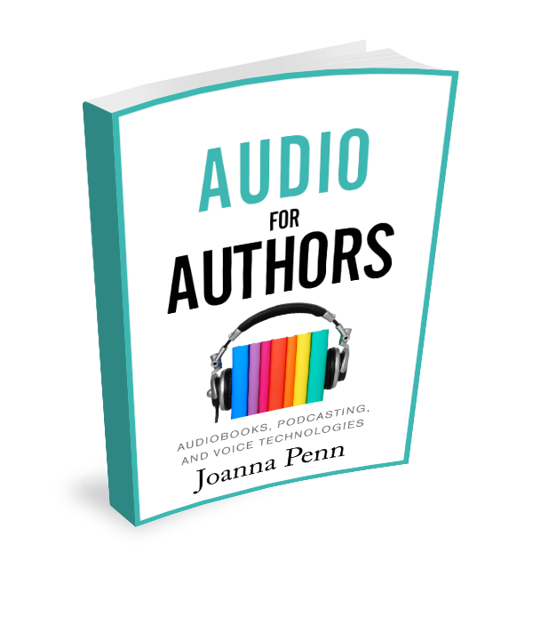
Audio for Authors Consolidated Question List
These questions relate to Audio for Authors: Audiobooks, Podcasting and Voice Technologies by Joanna Penn, available in ebook, paperback, hardback, large print and audiobook editions: www.TheCreativePenn.com/audio-for-authors/
The audio-first ecosystem
• What is your audio behavior like right now? How has it changed over time?
• What are some examples of the audio ecosystem that you have experienced yourself or noticed in others? What devices do people use around you? What situations do people listen in?
• How can you widen your perspective to include a global, digital, audio-first consumer?
The audio mindset
• What is stopping you from doing audio?
• How can you shift your mindset to embrace the possibilities of the audio ecosystem?
1.1 Types of audiobooks
• What are the different types of audiobook?
• Where might your work fit into the ecosystem?
• Go to your preferred audiobook store online and sample some of the different types of audiobooks to see what you enjoy. You can sample for free, so it’s worth trying a broad range.
1.2 Writing, adapting and editing for audio
• How much adaptation will your book need for audio?
• Why is editing and adapting your work a good idea?
• What are some of the things to consider specifically for fiction?
• What are some of the things to consider specifically for non-fiction?
• What are the possibilities for audio-first writing?
1.3 Intellectual property considerations for audiobooks
• Do you own the subsidiary rights for your book? If you have signed a publishing deal, did that contract include audiobook rights? For which territories and in what format?
• Has the publisher exploited those rights and produced an audiobook or are they just sitting on those rights, in which case you might be able to get them back?
• Do you have a contract with your book cover designer that also includes the audiobook cover? Do you have the rights to use a similar design? Have you ensured your contracts cover the copyright for your book cover designs?
• Do you have a contract with your audiobook narrator and/or producer? Have you been assigned the copyright for the production files?
1.4 Your options for audiobook publishing and distribution
• If you want to license your audio rights, do you have proven sales or a reason that a publisher might want those rights?
1.5 How to find and work with a professional narrator
• What kind of voice do you have in mind for your book?
• How will you find the right narrator?
• How long is your book? How many finished hours of audio will that result in? How much might the narration cost? What rate can you afford for your book?
• What kind of contract will you arrange with your narrator?
• How will you work successfully with your narrator to ensure happiness and success on both sides?
• How will you deal with the QA process?
1.6 Reasons to narrate your own audiobook
• Why might you consider narrating your own audiobook/s?
• How do you feel about someone whose voice you like? What attributes do you ascribe to them? Do you connect more to that person because of their voice?
• Do you have the time, budget, and attitude to invest in learning about self-narration?
• What might be your first project?
1.7 Audiobook narration tips
• How confident are you at reading or performing your written work? What can you do to increase your confidence?
• What will you do if you make a mistake during narration?
• How can you make sure that you maintain energy and a personal connection to the listener while recording?
• How will you prepare yourself and your environment?
• What can you do to reduce extraneous noise?
• Record yourself narrating a piece of your work. Listen back for any noises in the recording. What do you notice?
• If you’re hiring a professional studio, what can you do to make sure you get the most out of your time?
1.8 Recording studio options
• What will you use for your recording studio? Why are you making this choice?
1.9 Audiobook recording, editing and production
• What software will you use for recording and editing your files?
• How will you manage your files so you don’t lose any work?
• Are you interested in learning the technical side of sound engineering, or do you want to outsource the mastering and production of your files?
1.10 How to self-publish an audiobook
• What are the different options for self-publishing an audiobook? What are the pros and cons for each?
• What would suit your project right now, and how might that change in the future?
1.11 How long does an audiobook take to produce?
• How long will it take for the production of your audiobook?
• What are some of the aspects that might delay your audiobook?
• How will you time the releases of your other editions so you can market the audiobook simultaneously?
1.12 How do audiobook readers discover audiobooks?
• If you listen to audiobooks right now, how do you discover what to listen to next? Ask your friends and family for a wider response.
1.13 How to market audiobooks
• What are some of the ways you could market your audiobook? Note down any quick wins you can achieve in the next month as well as a plan for long-term marketing.
1.14 The money side of audiobooks
• How does the money work if you license your rights?
• How does the money work if you independently publish?
• What are the pros and cons of each for your situation?
2.1 Why podcasting is important for authors
• Why is podcasting important for authors? What are some of the benefits that you find most interesting?
2.3 Types of podcasts
• What are the different types of podcasts?
• Try a few episodes of each, so you understand the possibilities. What do you like or dislike about the different types?
2.4 How to research and pitch podcasters
• What potential niches could you target for your book? Think topics, theme, settings and your own interests.
• What shows do you currently listen to that resonate with your topic?
• Make a list of 15-20 other podcasts you could pitch in your niche and list them in order of importance
• Find out about each host and their audience. What can you offer that would be useful?
• Craft your first pitch for a podcast interview. Does it follow the recommendations as outlined?
• How will you deal with success or rejection?
2.5 How to be a great podcast guest
• Have you researched the host and audience? Do you know how best to serve them?
• Have you prepared your technical setup and environment for the best recording experience?
• Have you prepared talking points?
• How will you ensure that the audience remembers how you made them feel?
• How will you make sure that you can bring your energy?
• How will you make sure the conversation is natural?
• What is your call to action? Have you said it out loud to check that your link is easy to say?
• What will you do after the interview?
• What if the interview goes badly? How will you make sure it’s better next time?
2.6 Should you start your own podcast?
• What is your why?
• Are you ready to learn new skills? Do you have the time and budget?
• Are you prepared to put yourself out there?
• Who is the show for? What’s in it for them?
• Is the niche big enough? Is there potential future growth in your niche or demographic? What evidence do you have for thinking that way?
• Can you be consistent with production?
• What would make podcasting worth it for you?
2.7 Podcast prerequisites
• Do you know your market? What are the top shows in your niche? What are the second-tier shows? What do you like and dislike about them?
• What specific audience are you going to serve? What do they want to know? How do you already fit into that community?
• What will the name of your show be? What ideas do you have for your sub-title and description?
• How long will the show be? How often will you publish?
• Have you organized your artwork?
• Have you made an initial content plan? Do you have enough ideas for an ongoing show?
2.8 Intellectual property considerations for podcasts
• What do you need to consider around intellectual property for your podcast?
• How will you source music for your show?
• How will you find artwork?
• What will you need to consider around interviews and working with other people?
2.9 Podcasting equipment and software
• What equipment and software do you need right now in order to get started?
• What might you consider investing in later?
• What skills do you need to practice?
2.10 Podcast structure
• What are the different segments that you enjoy on your favorite podcasts? What might be effective for your audience?
• What material will be evergreen, and what will be newsworthy about your show? What will keep people coming back?
• Have you scripted and recorded your intro and outro?
2.11 How to be a great podcast host
• Make a list of 10 people you’d like to interview. Do your research on them and craft a pitch asking them to come on your show.
• How will you prepare for the interview in order to make it a good experience for your guest?
• How will you make sure the conversation goes smoothly and is useful for your audience as well as pleasant for your guest?
• How will you handle it if things go wrong?
2.12 Podcast distribution
• What do you need to consider around distribution for your podcast? What are the pros and cons of paying for hosting?
• Have you researched the different services available? What would work best for your situation?
2.13 Show notes and transcripts
• Why are show notes and transcripts useful for you and also for your audience?
• How will you generate your show notes and/or transcript?
• What kinds of images will you include in your show notes?
2.14 Collaboration and freelancers
• What are the pros and cons of co-hosting a podcast?
• If you are considering co-hosting, write down what you would bring to the arrangement and what skills you would need in a co-host. How will you make this work for the long term?
• How could you use freelancers to make podcasting easier? What tasks could you outsource?
• If you’re interested in a podcast collective, what are the benefits and the things to watch out for?
2.15 Podcast workflow and tools
• What might your podcast workflow look like?
• How can you make the time to achieve this on a regular basis or how can you budget for freelance help?
2.16 How to launch a podcast
• What do you need to prepare in advance of your launch date?
• Have you decided on your launch date? Will you have time to get everything done by then?
• Do you have a content and production schedule, so you know when everything needs to be done? Does this also stretch into the weeks after launch, when you will need to post regular content to gain traction?
• Is your website optimized for possible traffic and email signups?
• Have you created your marketing material?
• How will you measure a successful launch?
2.17 How to market a podcast
• How will you market your podcast? What ideas resonate with you?
2.18 Re-purpose your podcast content
• What are some ways that you could re-purpose your podcast content?
2.19 The money side of podcasting
• What do you want to achieve with your podcast? What will make it worthwhile even if you don’t make any money?
• Do you want to be an independent podcaster or work within a network where they control content and advertising?
• What are some ways you could monetize immediately?
• How could you monetize in the future if your listenership grows?
• If you want to do corporate advertising, what are some of the companies that might be interested in your niche? How will you approach them?
• How could you offer value to a community on Patreon? What might you offer for reward levels?
• Have you considered the P&L of your podcast? How will the timing of cash flow affect your business?
3.2 Speech to text: Dictation
• Why might you consider dictation? How might it help your writing?
• What’s stopping you from dictating? How can you work through those issues in order to try it?
• What method of dictation might work for you?
• What tools do you need to get started?
3.3 Text to speech
• Are there any situations where you might find text-to-speech applications useful?
3.4 Voice assistants, smart speakers and devices
• In what situations have you experienced or observed people interacting with voice assistants?
• Consider what might be possible. Then go check whether it already exists.
3.5 Optimizing for voice
• Are your books available in audio on every voice ecosystem?
• Are you creating free audio content like podcast episodes or interviews for marketing?
• How can someone who chooses voice-first find you?
3.6 Artificial Intelligence (AI) and the future of voice
• What are you excited about in terms of potential for future voice technology? How can you take advantage of what might come?
• What concerns you? How might you position yourself to participate in the conversation and protect your lifestyle in the years ahead?
• How will you stay up to date with the changes in voice technology?

