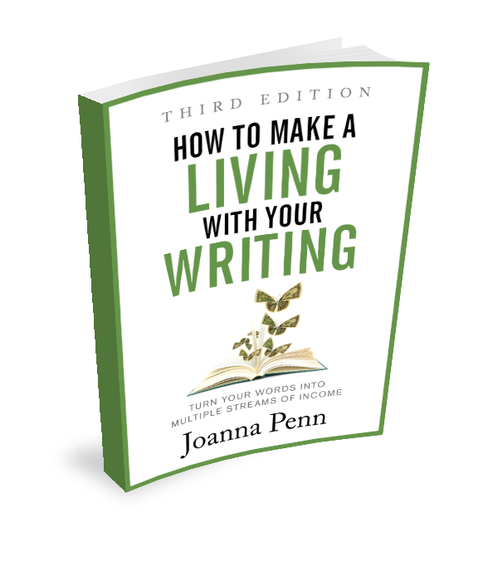
Appendix 3: List of Questions
First principles
• What is your definition of success?
• What will you do to achieve it?
• How much money is a ‘living’ for you? How much money do you want to make per year from your writing?
• Why are multiple streams of income important over the long term?
• Do you believe you can make a living with your writing? Do you need to work on your money mindset?
• How much of your income is money for time? How much is scalable? How could you shift this split?
• Writing is only one aspect of making a living with your writing. What are some other things you might need to learn?
• How will you embrace the growth mindset?
• Who are your models? How do they make money? Are those methods possible for you?
• If you don’t have models in mind yet, how could you find them?
• Why is it important to think long term about making a living with your writing?
Part 1: How to Make Money with Books
1.1 Your publishing options and how the industry has changed
• What are the opportunities for your book/s if you consider the market to be global, digital, and mobile?
• What are some shifts to digital business that you’ve seen or read about due to the pandemic?
• How has your own reading and purchasing behavior changed over the last decade?
• How do you currently support independent creators in the way you choose to purchase?
• How could you embrace the Maker Movement as part of your own creative journey?
• Do you consider yourself an empowered creator? How could you move further toward this in order to expand your creative potential?
1.2 Your book is a valuable intellectual property asset
• What is copyright?
• How does rights licensing make you money?
• Why is selective rights licensing a good idea?
• How can you empower yourself with the knowledge you need in this area?
1.3 Traditional publishing
• What are the benefits of traditional publishing?
• What are the downsides of traditional publishing?
• How does the money work?
• Are you considering this route to publication? What are your reasons for this? What is your definition of success?
• How could you take the next step?
Contracts are for negotiation, so discuss the following with your agent and/or publisher:
• What countries or territories will the book be published in? If it won’t be available everywhere, then why license World English?
• What formats are specified? For example, if audiobook rights are included, how long will it be before the audiobook is published and in which territories?
• What subsidiary rights are included, and how will these be exploited? Many publishers will sub-license foreign languages or may license for film/TV and other media.
• How long is the contract for? Is it term-limited, for example, five years for foreign language rights? When and how will the rights revert? For example, if the audiobook is not produced within three years, the rights revert to the author.
• Is there a ‘do not compete’ clause which may prevent you publishing during the term of the contract under the same name, in the same world or with the same characters?
1.4 Self-publishing or becoming an indie author
• What’s the difference between self-publishing and becoming an indie author?
• What are the benefits of being an indie author?
• What are the downsides?
• How does the money work?
• Are you considering this route to publication? What are your reasons? What is your definition of success?
• How will you find recommended freelancers and services to work with?
• What do you need to take the next step?
1.5 Write more books
• How could you write and produce more books?
• What is stopping you from writing more books?
• How can you break through those blocks?
1.6 Write books that people want to buy
• How can you make sure that there is an audience for your book?
• Who are your ‘comp’ authors and/or specific books?
• What are the reader expectations for these types of books?
• What do the top-selling books have in common? How does your book fit alongside them?
• What sub-categories are they in?
• What keywords might be relevant?
• How could you combine writing what you love with writing what people want to buy?
1.7 Publish in multiple formats
• What formats do you read?
• What formats are your books available in right now?
• What other formats could you create? (If you retain the rights)
1.8 Publish globally
• Are your books available globally in English in ebook, paperback, and audiobook (if appropriate)?
• How can you expand your distribution to more global markets?
• Are you interested in foreign rights licensing? Would self-publishing in translation work for your author business?
• What are your next steps to take this further?
• How could you market your books to a global audience?
1.9 Sell direct to your audience
• What are the benefits of selling direct, both for the customer and for you?
• How could you sell direct from your website?
• What do you need to have in place to make this worthwhile? If you’re not at that point yet, how can you move in that direction?
1.10 Market your books
• What is your current attitude to book marketing? How could you improve your mindset?
• If you have a book or more out already, do you have the basics in place?
• How could you use your books to market your books?
• What kinds of marketing are you interested in learning more about? What might work for your personality and lifestyle over the long term?
• How could you improve your marketing skills?
• When is a good time to outsource your marketing? Is it the right time for you?
Part 2: How to Make Money with your Writing in Other Ways
2.1 Your author ecosystem
• How does an ecosystem work to drive revenue in multiple ways?
• What does your ecosystem look like now?
• If you carry on as you are for the next five years, or ten years, what will your ecosystem look like?
• What do you need to change to ensure it works for you over the long term?
2.2 Affiliate income
• What are the pros and cons of affiliate income?
• How can you be an ethical and successful affiliate?
• How could you start making affiliate income?
• How will you expand this to increase traffic and revenue?
2.3 Crowdfunding, patronage, and subscription
• What are the benefits of crowdfunding?
• Research the publishing and writing section of Kickstarter and Indiegogo to find ideas for what you could create. What sparks your curiosity?
• What are the benefits of patronage or ongoing subscription?
• Research the writing and creative section of Patreon to find examples of creators who make a monthly income. What might work for your community?
• How could you successfully incorporate crowdfunding and/or patronage into your streams of income? What do you need to have in place to make this happen?
2.4 Professional speaking, teaching, performing, and live events
• What are some benefits of speaking and how could you incorporate it as a stream of income?
• Research speakers in your niche. What can you learn from their websites around branding, pitching, products, and pricing?
• Who is your target market for professional speaking? How could you reach them? What rates do they pay?
• What topic/s could you speak on? Does this fit with your target market and your expectation of income?
• Do you need training and/or experience in order to charge for professional speaking? How will you develop these further?
2.5 Online courses, webinars, events, and membership sites
• What are the benefits of creating an online course? How could it form part of your multiple streams of income?
• What type of course might be useful to your audience?
• What topic will your course be on?
• How much time do you need to set aside for learning new skills, preparing and recording your course?
• What tools and technology do you need to investigate? What skills do you need to learn, and how could they be useful for your wider author business?
• What is stopping you from creating an online course?
2.6 Advertising and sponsorship
• Do you have a niche audience that is large enough to consider offering advertising or sponsorship?
• Which companies or services might work best for your audience?
2.7 Physical products and merchandise
• What are the pros and cons of physical products and merchandising? How do these differ from swag?
• What aspects of your books or business might be relevant for products and merchandising?
• What could you create through print-on-demand? What might need to be a bigger project with more funding?
• Do you have the right to use the images related to your books on merchandise?
2.8 Freelance writing and ghostwriting
• What are the pros and cons of freelance writing and/or ghostwriting?
• How could you develop this stream of income for your author business?
2.9 Consulting or coaching
• What are the pros and cons of offering consulting or coaching services?
• What could you help people with?
• Who are the successful coaches and consultants in your niche? What can you learn from them and model in order to set up and grow your own service?
2.10 Author services
• Do you want to offer services to authors? What would be the best fit for your skills, and what does the author community need?
• How will you balance your time between clients and your own creative work?
2.11 Other ways to make money with your writing
• Do any of these additional ideas spark your curiosity? How could you take the next step?
The transition to making a living with your writing
• Do you want to make a living with your writing? Or make some money on the side of your day job? What are your reasons for this?
• Which areas spark the most ideas? What are you curious and/or enthusiastic about trying?
• What will you focus on first?
• What suits you as a creative personality?
• Who are your role models? What specifically do you want to model from them? Or how will you find a role model, if you don’t have one yet?
• Why is skiing a good metaphor for making a living with your writing?
• If you’re not already making any money from your writing, how will you make that first ten dollars?
• Have you set a deadline and written it down so you can see it every day?
• How much do you want this?
• If you’ve started to make some money, how can you expand your streams of income even further?
• Do you have a supportive community of writers who you learn from and can encourage and help you along the way? If not, how can you find them?
• What is 10% of your monthly income? How could you make that from your writing?
• How could you take the next step in the transition to making a living with your writing?

