Philippians 1: 1-2 July 27, 2025 Office of the General Believer
1. A Letter in Writing to the Royal Priesthood (v. 1a)
a. Apostolic greeting—“servants” modeling humility.
b. One-line acknowledgement:
2. The General Office Defined: “You Are the Saints” (v. 1b) a. Saints ≠ super-Christians; saints = those set apart by God’s calling.
b. Our office is received, not achieved; it rests on divine election (WCF 10) and union with Christ, (WCF 26.1).
c. Implication: you already possess a divinely bestowed “office.”
3. The Sacred Office: Ministry of “One-Another” Imperatives: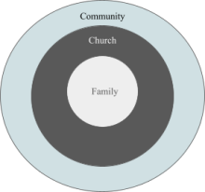
4. The Fuel for the One-Another Life: Grace & Peace (v. 2) a. “Grace and peace” come to the entire congregation.
i. Grace – received at justification, daily renewed.
ii. Peace – covenant wholeness that makes horizontal “one-anothering” possible.
b. Trinitarian Source – Every saint draws from the same infinite well.
5. Application: Orientation Toward Mission
a. Identity Check: Ask, “Do I live as a ‘saint’ or as a spectator?”
b. The ordinary believer’s vocation: Home, school, factory, or legislature is an outpost of the kingdom.

