E-mail 1: 3 values + what to expect + ask (Day 1)

Subject: Thanks for taking the quiz <f.name>

Hey <FirstName>

Thanks so much for going through the quiz. I hope it gave you some clarity on <x>.

Before we keep going, make sure to drag my e-mails into your primary folder so you don’t miss out on all the amazing stuff coming your way :)

I want to make sure you receive them so make sure to add me to your Safe Senders list (and if you use Gmail, make sure to drag me into your primary tab)!
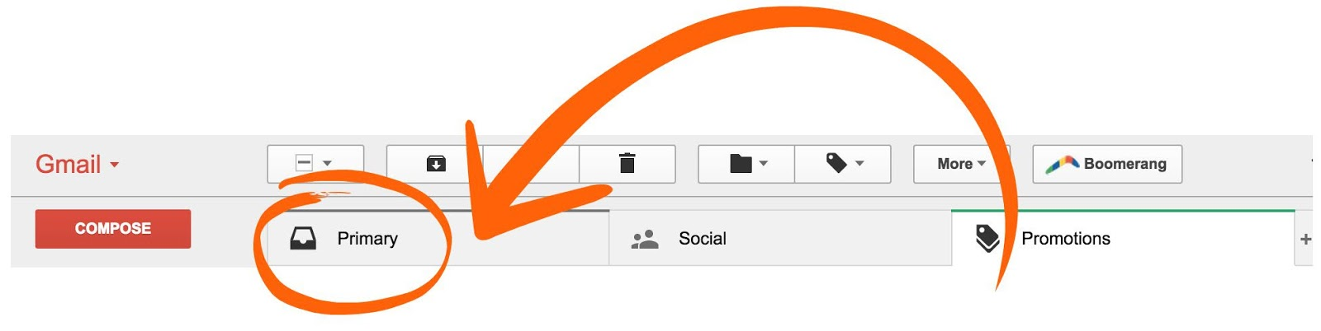

Before we keep going I’d love to get to know each other better.

Here are the 3 things I’m/we’re all about

- Value + story/why
- Value + story/why
- Value + story/why

Okay, here’s the deal ~Contact.FirstName~, I want to know the 3 things that YOU’RE about? What are your values? The things that get you fired up and excited about life?

I believe every new relationship should start by us figuring out if we jive or not.

I seriously want to know the 3-4 things that you’re about by you clicking "Reply" and letting me know below!

E-mail: 2: 1 What to expect + Value (Day 2)

Subject: [1/7]: Are you ready to have your mind blown?

<F.Name>,

Here’s what I got for ya!

For the next week and a half I want to introduce to you my way of thinking. To do so, I’m going to give you some of my best stuff so that you can take action and start seeing results immediately.

I’ll be numbering these emails as 1/5, 2/5 ….” and so on, so you can keep track of where you’re at.

Today I want to share with you 1 strategy that if you implement right now <x >(mind blowing result) will happen.

<Give content>

You in for giving this a shot? If so click Reply and say, “I’m in!”
Ask for response:

Respond back saying, “I’m in”

E-mail 3: Curiosity + value (Day 4)

Subject: [2/7]: you probably thought this wasn’t possible?

<F.Name>,

Wouldn’t you just love _______ (their ideal destination)

I’m sure you would. And, I’ll be revealing exactly how to get there over the next few emails...

I need to prime you for ___, so let’s see if you can handle X (one small step they can take to get to ideal destination)

<Value> (Send to link- blog post)

E-mail 4: Story (yours or client) (Day 6)

Subject: [3/7] Let’s get to know each other better

<f.name>

I’d like to share a story with you.

<Go into story of client or your own personal story>

Make sure it’s clear how your product/service helped with that.**

So what does this have to do with you?

<Enter mission/goal of company>

I’ll be sharing more about what we do in the next email but wanted to share our why first.

I’d love to hear more about you and your story. Click “Reply” and share with me a little about your story.

CTA: Ask them to share story

E-mail 5: Let’s Get Personal + invitation (Day 8)

Subject: [4/7]:

So ~Contact.FirstName~ we’ve been getting to know each other for a little while now.

So, I hope you don’t mind me asking:

Are you really serious about getting an answer to your ______ problem? One that will avoid having the feelings of ___________?

So often we just talk about what we want to accomplish but never get around to it. So if you are serious about this on a scale of 1-10 (1 being not at all, 10 being a ‘heck ya I’m ready!’) send me over where you rate your desire to get results.

Or if you are ready to jump start the process >>Click Here<<< to learn more where you can get started today.

>>Click to learn more about ____ <<

Since you’re reading this letter, I know you are strong, capable, and serious about making a change for the better.

I would love to help you if you are serious about wanting a change.

Email 6: May I help you? (Day 10)

Subject: [5/7] May I help you?

Do you know that feeling when you feel lost, uncertain and don’t know what is the right next move?

It’s frustrating and overwhelming.

Then, in what feels like magic an opportunity presents itself for a solution to your problem.

If you are serious about solving x, may I help you?

May I extend my hand and show you what’s worked for so many other folks just like you when it comes to X, Y, without Z?

I really believe you deserve this:

>>>> Click here to begin your transformation. All you need to do is decide. <<<<<

Email 7: 9 word e-mail (Are you still interested in _ _ _? (Day 12)

Subject: Hey OR <f.name>

Are you still interested in _ _ _ ?

Your name

E-mail 8: Gift It Forward (Day 14)

Subject: [7/7] My promise to you

~Contact.FirstName~,

I understand that other _____ have let you down….and frankly, I don’t blame you a bit for being skeptical.

It may very well be that you’re just not ready...however, everything you’ve showed me thus far suggests otherwise.

I really desire to earn your trust, so let me make you a promise...one that will set your mind and heart at ease.

My mission is _________ ~Contact.FirstName~ I can help show you the way.

I understand you may not be there just yet, but I want to help you regardless.

I’d like to gift you with a free _______ to help you get started.

**Make sure there is a CTA at the end of the free gift as well leading back to product/service**

