**Subject: (Name), Congratulations “EXPERT PROFILES” Hit the Best Seller List**

(Name), I am excited to let you know Amazon officially listed “EXPERT PROFILES” as the #1 New Release / Best Selling book in the Business Company Profiles category yesterday!

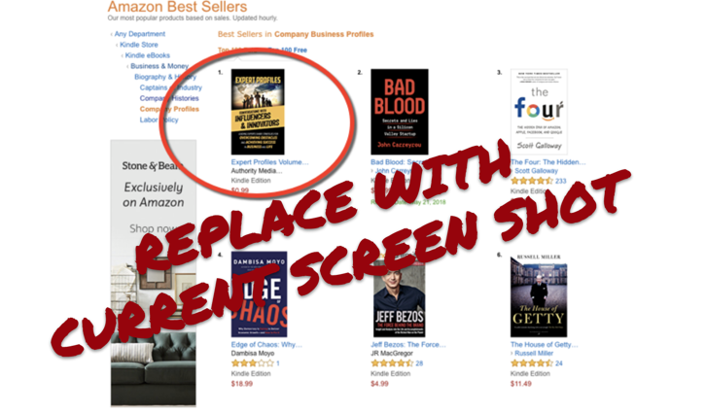

Congratulations on being part of this important project and now an official Best Seller. Definitely an achievement to take pride in.

A press release went out about this yesterday and it’s getting some nice coverage as well. Take a look. **(link to google index results).**

This kind of accomplishment is truly worth celebrating. Many of the experts featured in the book have already ordered their ½ priced ($9.99) contributor copies and we are about ready to ship those out.

**But before we do…**

I’m excited to announce that we have put together a very special “Honoree Marketing & Recognition” bundle to help you showcase your achievement.

You can check it out **HERE (link to offer)**

This is a great way to not only commemorate this special project but a powerful **marketing tool for your business as well.**

You can give these Special Edition books out to clients, prospects, etc. and order more anytime you want at an even lower wholesale price of only $5

AND REMEMBER...this is a **total tax write off**. (**Of course, check with your accountant) If you are using this as a legitimate marketing tool to promote your business, the costs of this package are generally 100 percent deductible.**

***We need all the orders in this week so we can start production. So please order ASAP.

If you do NOT want this at all, please reply and let me know and I’ll get the regular edition copies shipped out.

Thanks,