SEXTON HIGH SCHOOL
ATHLETIC HALL OF FAME
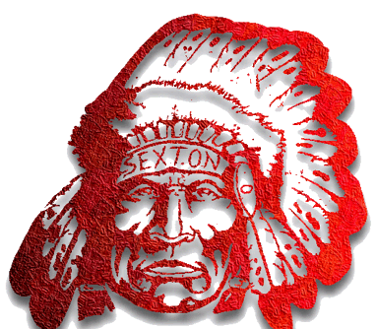

February 20th, 2015
Individual/Team Induction Ceremony
Program

Agenda:
- 5:00pm- Sexton Foyer, Induction Dinner

- 6:00pm- Induction Ceremony and recognition of Individual and Teams

- 7:10pm- Half time introduction of Inductees and Sexton High School Athletic Hall Of Fame Committee

On behalf of the Sexton High School Athletic Hall Of Fame Committee and administration, we would like to congratulate and thank you for participating in the first year Induction Ceremony.
Yvonne Caamal Canul, Superintendent
Sandra Noecker, Principal of Sexton High School
Dan Boggan, Athletic Director
Chris Henderson, Assistant Athletic Director
Sexton High School Athletic Hall Of Fame
Individual Inductees:
Russ Maples
Matt Mann
Brian Ferguson
Fritz Kellermann
Dick Allen
Emerson Boles
Bill Ross

Team Inductees:
1958-1959 Wrestling Team
Coach Iggy Conrad
Jim Trumble
Mickie DeVoe
Gary King
Bud Swagler
Gary Roberts
Emerson Boles
Tom Mulder
Lee Payne
Wendell Crumbley
Mike Fitzgerald

Team Inductees:
1958-1959 Basketball Team
Coach Clayton Kowalk
Johnny Robinson
Greg Eaton
Bob Davis
Art Franks
Glen Fletcher
Ken Johnson
Larry Nalett
Brian Ferguson
Bob Thompson
Jerry Sutton
Chris Ferguson
Al Freeman
Doug Herner

Team Inductees:
1959-1960 Wrestling Team
Coach Iggy Conrad
Bud Swagler
Gary Roberts
Emerson Boles
Ton Mulder
Lee Payne
1959-1960 Wrestling Team Cont.
Wendell Crumbley
Mike Fitzgerald
Dave Toomey
Bob Hansen
Sam Hopkins

Team Inductees:
1959-1960 Basketball Team
Coach Clayton Kowalk
Bob Davis
Art Franks
Larry Nalett
Brian Ferguson
Jerry Sutton
Doug Herner
Coy Woodruff
Ralph Barnett
Jim Chouinard
Cloyd Barnes
Tim Larsen
Richard Rule
Don Lambie
Reid Cook
Hershel Milton
Otis Davis
Howard Miller

