**2017 Skyview Hawk Baseball Order Form**

**Due March 2nd**

**Spirit Pack for __________________________________$75 (checks payable to Skyveiw Baseball)**

**Player’s name**

**1 Game Hat**

**2 T-shirts (navy and white)**

**2 pair stirrup socks (game socks)**

**2 pair of sani socks (worn under stirrups)**

**We will once again produce a Baseball program this spring.  This program will be similar to the fall and winter programs.  To produce this program, we are asking businesses to submit a business card and a $50 donation to have an ad placed in the program.  These programs will contain all three team rosters, pictures, and advertising.  These programs will also be available at all three team’s home games, free to fans.  As an incentive to help us produce these programs, we are asking our players to get out and ask businesses for their support.  *Players who sell two (or more) program ads will receive their spirit pack FREE.  Players who sell one program ad will receive their spirit pack for ½ PRICE ($37)***

**Additional items (should arrive in approximately 3-4 weeks)**

**Please specify sizes for each article ordered. Hats are limited so first come first serve if size fits.**

**Total Qty.  Sizes        Item                                              Color Price**

_____      ________ Team Embroidered Hooded Sweatshirt **NAVY** $45

______    ________ Under Armor Cold Gear Thermal ¼ zip pullover **NAVY**              $45

(Embroidered Left chest)

______    ________ Under Armor Cold Gear Thermal ¼ zip pullover **Graphite**            $50

(Embroidered Left chest)

______    ________ Under Armor lightweight ¼ zip pullover **WHITE**             $40

                                  (Embroidered left chest)

______    ________ Under Armor lightweight ¼ zip pullover **GREY**             $40

                                  (Embroidered left chest)

_____         ________ Rawlings Convertible Batting Jacket **NAVY**  $58

(two jackets in one, sleeves zip off)

_____         _______ Under Armor **Ladies** ¼ zip        **NAVY**                 $40

                                  (with Embroidered left chest)

_____         ________ Under Armor **Ladies** ¼ zip        **WHITE**                 $40

                                  (with Embroidered left chest)

_____        ________ Under Armor **Ladies** ¼ zip        **GREY**                 $40

                                  (with Embroidered left chest)

_____       _________ Rawlings Dugout pullover     **NAVY**  $45

(Embroidered S at center neckline)

_____        _________   Rawlings Dugout pullover     **GREY** $45

(Embroidered S at center neckline)

______ _________   Rawlings Dugout pullover     **WHITE** $45

(Embroidered S at center neckline)

_____       __________ **LADIES** Under Armor Long Sleeve T-shirt: **NAVY/GRAPHITE**          $30

_____        __________ Team Embroidered Sweatpants                 **NAVY** $25

_____       __________ Team Embroidered Sweatpants                        **ASH** $25

_____       __________ Shorts w/pockets                                            **NAVY** $25

_____       __________ **Navy** T-Shirt     (additional)                **NAVY**  $12

_____        __________ **White** T-Shirt    (additional)               **WHITE**  $12

_____       __________ **Navy** Hat                                                          **NAVY**  $20

_____        __________ **Navy/White** Hat                                                 **NAVY /WHITE**  $20

_____        __________ Dugout Skyview parka                           **GREY**  $80

                                  (Expensive, but well worth it when it’s cold!!)

**Total ______________**

**\*Please understand these are custom made items.  Exchanges are not possible, so please be certain of the sizes chosen.**

**Receipt for Program Advertising:**

**From: _______________________________________    Amount__________________**

**For:  Skyview High School Baseball Game Day Program.  These programs will be available at all Skyview home games and include team photos, rosters, and history.**

**Please. Come join us for a ball game; Present this receipt and receive one free admission.**

**Thank you and GO HAWKS!**

**------------------------------------------------------------------------------------------------------------**

**Receipt for Program Advertising:**

**From:_______________________________________ Amount __________________**

**For:  Skyview High School Baseball Game Day Program.  These programs will be available at all Skyview home games and include team photos, rosters, and history.**

**Please Come join us for a ball game; Present this receipt and receive one free admission.**

**Thank you and GO HAWKS!**

**Sweatshirt:** UA Thermal ¼ zip: UA Lightweight ¼ zip: Rawlings pullover:

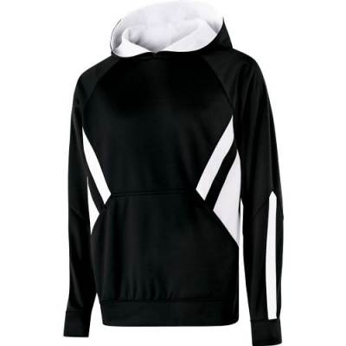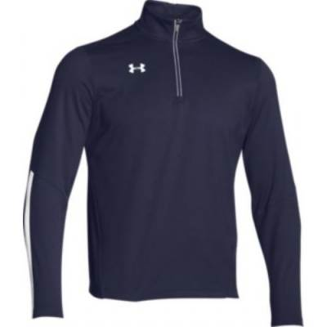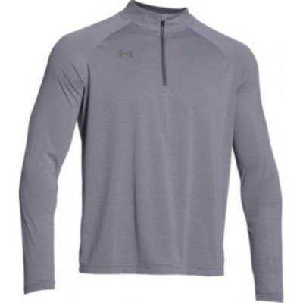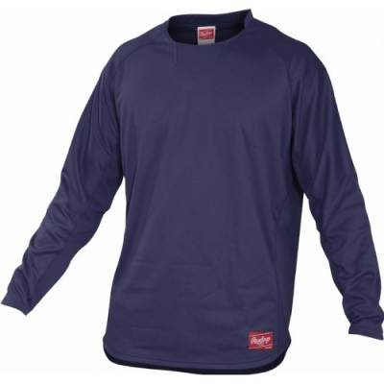

Rawlings batting jacket: Ladies ¼ zip pullover:

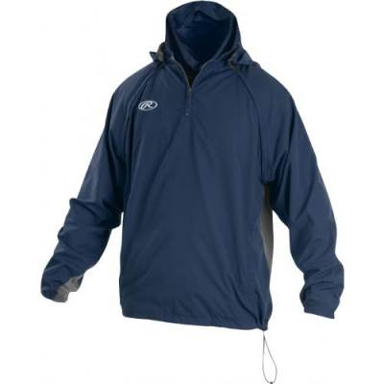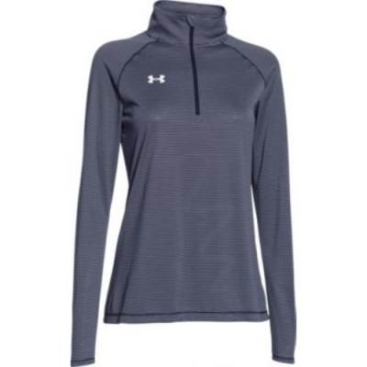

Ladies Long Sleeved Tee: Shorts:

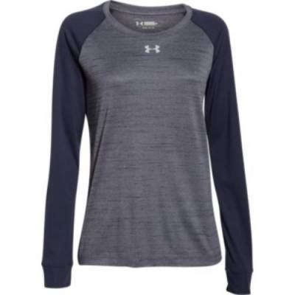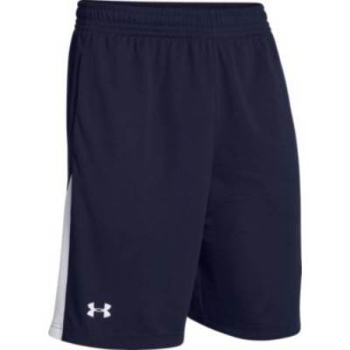

Dugout parka: 