MONDAY | TUESDAY | WEDNESDAY | THURSDAY | FRIDAY | SATURDAY
1  1st Day of Practice  Helmets Only  8-2:15 | 2  Helmets/Shoulder Pads  8-2:45  Start of Card Sales | 3  Helmets/Shoulder Pads  8-2:15 | 4  Full Pads  8-3:00 | 5  Full Pads  8-2:15 | 6  Full Pads  8-3:00
8  1ST TEACHER DAY  AM PRACTICE  AFTER SCHOOL PRACTICE | 9  1ST STUDENT DAY | 10  Team Scrimmage  Team Dinner  Parent Meeting | 11  Popcorn Parade  6:15 | 12  MARION SCRIMMAGE  @ MARION  7:00 | 13  FILM 10 AM  BLITZ DAY  Players are required to attend from 10-2:30
15 | 16 | 17 | 18  Full Pads  3:30-5:30 | 19  NORWELL  A | 20  FILM 10 AM
22 | 23 | 24 | 25 | 26  HUNTINGTON  H | 27  FILM 10 AM
29 | 30  WE WILL PRACTICE ON LABOR DAY, SEPTEMBER 5TH FROM 6-8 PM. PLAN ACCORDINGLY! | 31
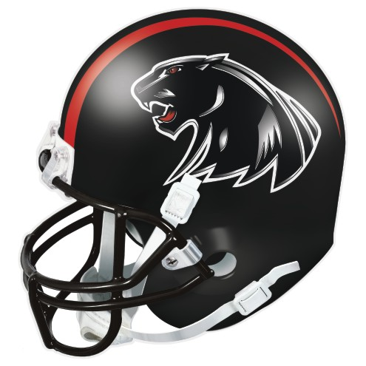
All players must have a completed physical on file in the office BEFORE you will be allowed to practice on August 3RD.

If you must miss practice, you are expected to contact a coach prior to practice

All players will need to have black football cleats for practice and games. Shoes can have white trim, but should not have other colors.

Contact Information for Coach Adamson:
Home: 998-6078
Cell: 661-2183
HS Office: 664-1214, EXT. 101
FB Office: 664-1214, EXT. 122
Email: jadamson@eastbrook.k12.in.us

EASTBROOK FOOTBALL WEBSITE:
Eastbrookfootball.com

TO ORDER EASTBROOK FOOTBALL FAN GEAR:
https://stores.inksoft.com/eastbrook_fbfans
THE STORE WILL CLOSE ON MIDNIGHT OF AUGUST 7TH!!!

