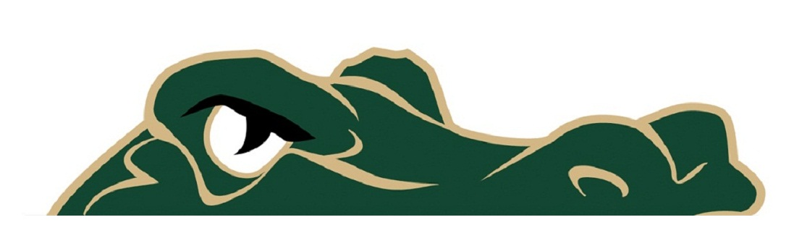

Gator Football Gameday

GENERAL INFORMATION FOR FOOTBALL GAMES AT RIVER BLUFF HIGH SCHOOL STADIUM “THE SWAMP”

- Gator Gear apparel will available on the home side.
- Lawn chairs, camping chairs, coolers, backpacks and other similar items are not allowed in the stadium.
- You will not be allowed to bring food or drinks into the stadium.
- No alcohol, weapons, glass or tobacco are allowed on school property.
- Security will be checking bags for safety reasons.
- Bleacher cushions are allowed in the stadium.
- All spectators must enter and exit thru the main entry gates.
GENERAL INFORMATION
- All ticket prices are $6.
- Kids 5yr and under are free.
- General parking is free.
- No tickets can be purchased in advance. All tickets must be purchased at the ticket office at the stadium.
- Lexington School District One employees (only) can enter with their Employee ID for free. You must bring your ID badge.
- If you leave the stadium for any reason you must purchase a new ticket to re-enter.
- Concessions and restrooms will be available on both the home and visitor sides of the stadium.

River Bluff High School Contacts for more information.
GATOR NATION
Booster Club President:
John Senter
(803)404-0115
jasenter10@hotmail.com
Athletic Administrative Assistant:
Amanda Chandler
(803)821-0714
alchandler@lexington1.net

Athletic Director:
David Bennett
(803)821-0709
dbennett@lexington1.net
Principal:
Dr. Luke Clamp
(803)821-0700
lclamp@lexington1.net

RIVER BLUFF GATORS COACHING STAFF
David Bennett - Athletic Director/Head Football Coach
Ricky Tillmon – Head JV Team Coach
Gary “Hammer” Smallen — Head B Team Coach
Amanda Chandler – Athletic Administrative Assistant
Offensive Staff
Terrance Ashe - Offensive Coordinator, Quarterbacks
Bryson Williams – Receivers Coach
TJ Watkins – Tight Ends Coach
Racheed Gause – Running Backs Coach
John Bass – Offensive Lines Coach
Defensive Staff
Brian Thompson - Defensive Coordinator, Defensive Backs Coach
Brock Snyder- Linebackers
Bill Bacon- Defensive Line Coach
Evan Moxie - Defensive Line Strength Coach
Heyward Hinton - Defensive Backs / Safeties Coach
Special Teams
Anthony Giugliano – Kickers and Punters Coach
Brock Snyder - Special Teams Coordinator
Stadium Event Staff
Robert Risinger - Gameday Coordinator

Location | Time / Result

