Quick Reference Guide to TennisLink

What is TennisLink?
TennisLink is the United States Tennis Association’s (USTA) online player, team and tournament registration and record management system for USTA-sponsored programs including Leagues, Team Tennis and Tournaments.

First Step: Create a User Login on TennisLink
TennisLink requires users to login to the software, which means having a TennisLink account. When you create a TennisLink account, you establish your login ID and password. If you are a USTA member, use your USTA membership number to set-up your Login ID. You can create a non-USTA member account to login to TennisLink, but keep in mind that USTA League play and many tournaments administered on TennisLink require a USTA membership. The non-USTA member account is ideal for a parent who does not have a USTA membership, but would like to be a Jr. Team Tennis coach/manager.
Use this link if you want to obtain or renew a USTA Membership.
Use this link to Create an Account on TennisLink.

Player Use of TennisLink
Players use TennisLink to register for teams and tournaments and to view schedules, results and standings. Click on the links below for instructions on each use of TennisLink.
- Register for a team
- View team information (match schedule, match results and standings)

Team Coach/Manager Use of TennisLink
Jr. Team Tennis coaches/managers use TennisLink to:
- Register as a Jr. Team Tennis coach/manager
- Create new teams
- Register players for a team
- View team information (player contact information, match schedule, match results and standings)
- Print match scorecards
- Enter match results
- Locate contact information for coaches/managers of opposing teams
- Locate contact information for your team members

How to Register as a Jr. Team Tennis Coach/Manager
First-time coaches/team managers need to register themselves as a coach/manager in TennisLink. You do not need a USTA number to register as a coach/team manager.
Step | Action
1 | Go to the Team Tennis Home Page
2 | Scroll down to the USTA Membership/ Options section of the page.  Click on Become a Coach/Manager located under Options | 
3 | Complete the Coach/Manager registration form. When you register as a Coach/Manager, you establish a login number and password for TennisLink. If you have one, enter your USTA membership number or Team Tennis number. If you do not have either of those, TennisLink will assign you a TennisLink ID number so you can login. Write down your login number and password.
4 | Click SUBMIT. You are now a registered Coach/Manager and can create teams on TennisLink.

How to Create a New Team
Only registered coaches/team managers can create new teams in the Jr. Team Tennis program.
Step | Action
1 | Go to the Team Tennis Home Page
2 | Login to TennisLink using your Coach/ Manager login ID number. | 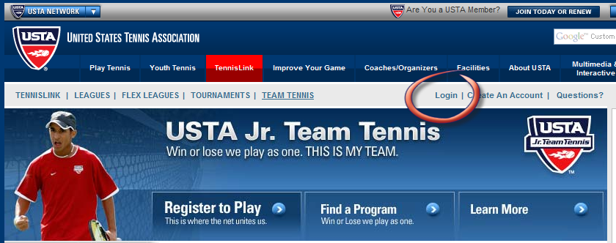
3 | Click on Create New Team located under My Options |  | 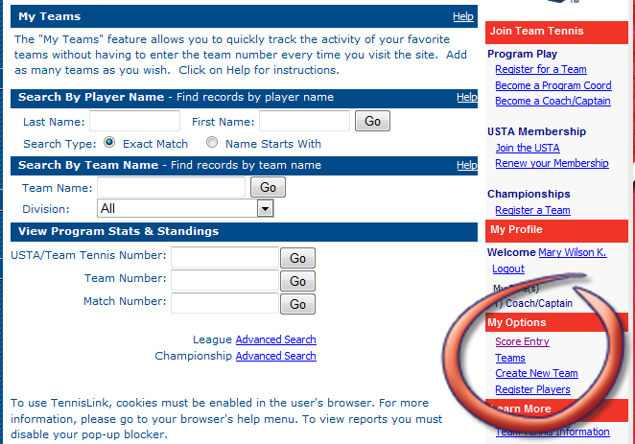
4 | Search for the Jr. Team Tennis program in which you want to create your team.  Click Go after you enter search criteria. |  |  | 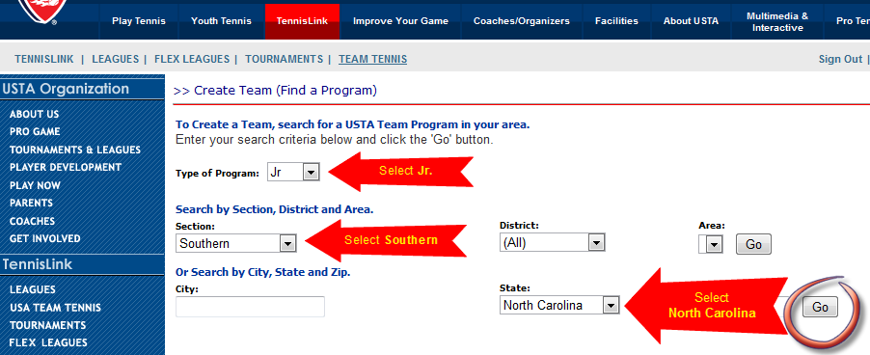
5 | Click on the Jr. Team Tennis program in which you want to create your team.
6 | Complete the form. Write down your system-generated Team Number.
7 | Click SAVE. Your team is now created.
8 | Approximately 48 hours after you create your team, your team will be viewable in TennisLink.

How to View Your Team in TennisLink
Step | Action
1 | Go to the Team Tennis Home Page
2 | Login to TennisLink using your Coach/ Manager login ID number.
 | Click on Teams located under My Options
4 | A list of your teams will appear in a pop-up window. | 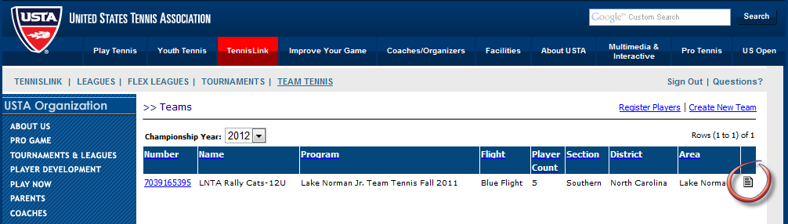
4 | Click on document icon [] to view your team’s players, standings and match schedule
5 | View Reports for Your Team.
5 | 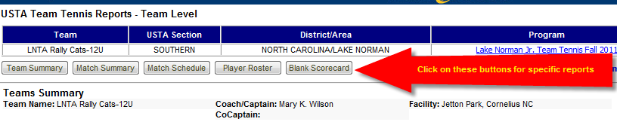  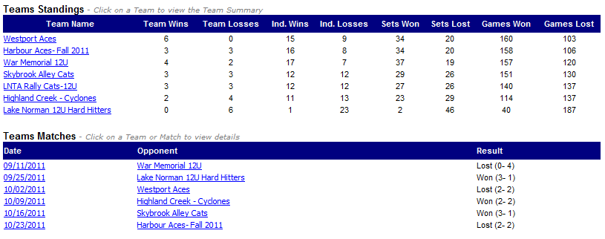

How to Register for a Team (Player Procedures)
Jr. Team Tennis is a United States Tennis Association (USTA) program and all junior players must be registered members of the USTA (and have a USTA player number) before they can register for a local team. An annual junior membership costs $20. Kids 10 and under who are registering with the USTA for the FIRST TIME can receive a FREE 1-year junior membership.

Step | Action
1 | Locate the player’s USTA Number.  If the player does not have one use the following links to register with the USTA and obtain a USTA number:  - USTA Membership Home Page (Junior Membership - $20)  - FREE 1-Year USTA 10 and Under Junior Membership (Use source code NEWGAMES)
2 | Locate the Team Number.  The Team Manager/Coach registers the team on TennisLink and obtains the Team Number. Contact your Team Manager/Coach if you need the Team Number.
3 | Go to the Team Tennis Home Page
4 | Click on Register to Play  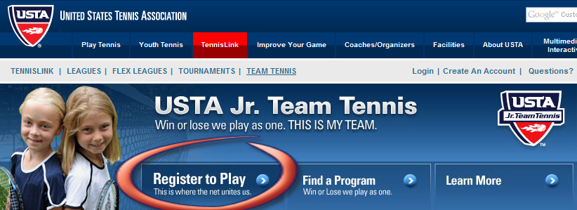
5 | Enter the Team Number and click Enter  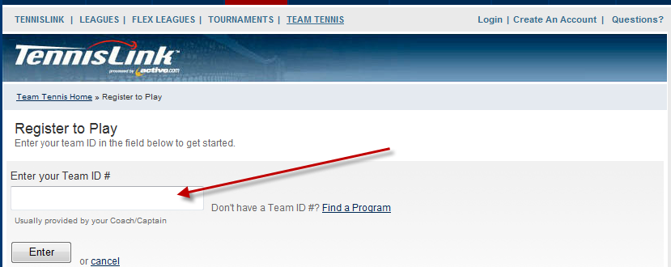
6 | Enter the player’s USTA Number on the Team Details Screen and click Enter  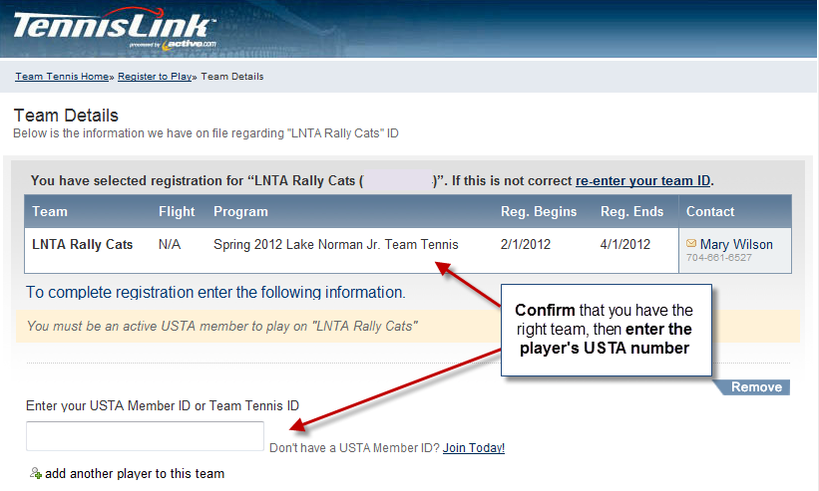
7 | Complete your payment information on the Checkout Screen and click Register Player  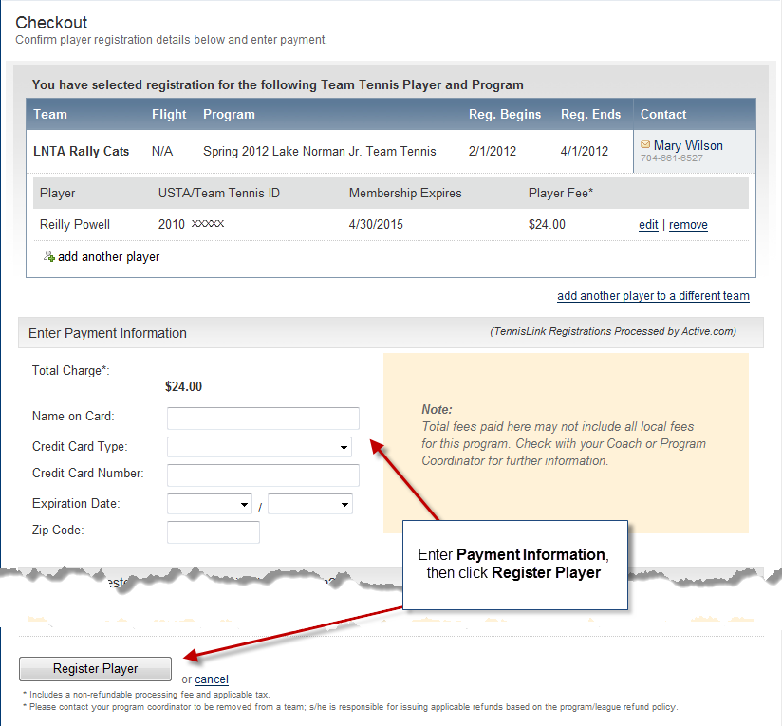

How to Register Players (Team Manager/Coach Procedures)
Step | Action
1 | Go to the Team Tennis Home Page
2 | Login to TennisLink using your Coach/ Manager login ID number. | 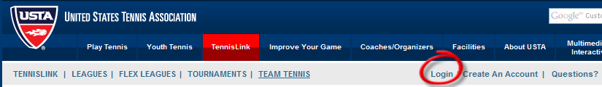
3 | Click on Register Players located under My Options | 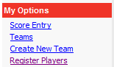
4 | Enter the Team Number and USTA Numbers for each player. Click Submit after you enter all players.  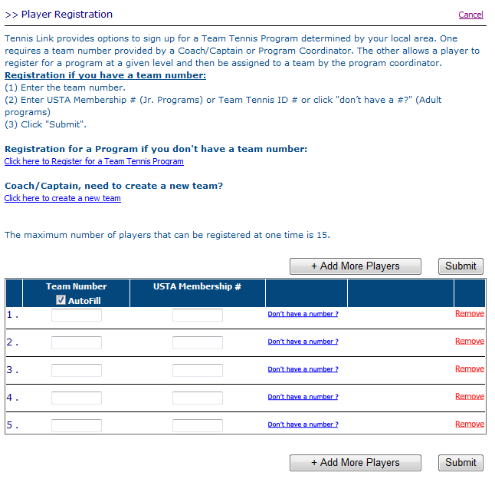
5 | Enter Payment Information and click on Register Players.

How to Print a Match Scorecard
**JTT Scorecard Procedures: Upon completion of the match, each team manager/coach needs to confirm the recorded results and SIGN the opponent’s scorecard and their own scorecard. The Jr. Team Tennis Coordinator will use the signed scorecard to resolve any discrepancies with incorrect scores entered into TennisLink. An unsigned scorecard means the home team will receive the benefit of any doubt.
Step | Action
1 | Go to the Team Tennis Home Page
2 | Login to TennisLink using your Coach/ Manager login ID number.
3 | Click on Teams located under My Options
4 | A list of your teams will appear in a pop-up window. Click on document icon [] on the far right to access Team Level Reports
5 | On the Team Tennis Reports – Team Level Screen, you have two options:  - Click on the Blank Scorecard button. This will give you a blank scorecard with your player information only. Print this scorecard.  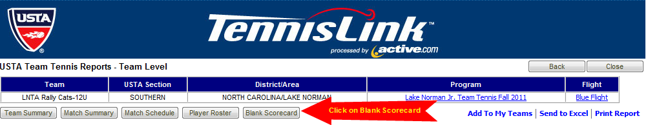
5 | - Another option is to click on the Date link in the Team Matches section. This will give you a scorecard with the match number, your team’s roster and the opposing team’s roster. Print this scorecard.  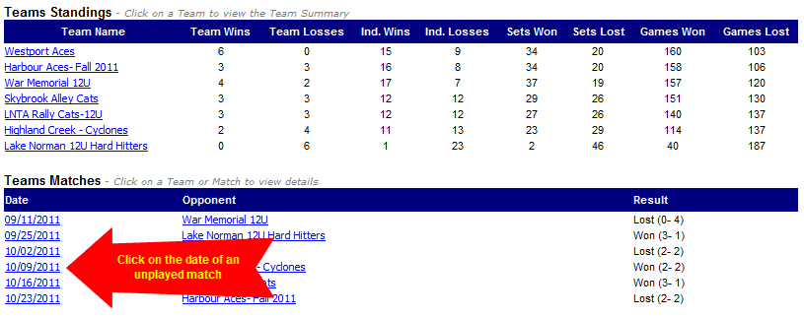

How to Enter Match Results
In Jr. Team Tennis, the Team Manager/Coach of the HOME team is responsible for entering match results into TennisLink. However, the visiting team Manager/Coach should Confirm scores. Any discrepancies should be addressed with your opponent first, then the Jr. League Coordinator.
Step | Action
1 | Go to the Team Tennis Home Page
2 | Login to TennisLink using your Coach/ Manager login ID number
3 | Click on Score Entry located under My Options
4 | Enter the Match Number and click Next. The match number appears on the Match Schedule report and the match-specific scorecard.
5 | Enter the following:  - Date match was played  - Players and scores for each line. Always enter the match winner’s score first, even if the winning team lost a set.  - Indicate the winning team for each line.  Click Next after all scores are entered
6 | Review the scores entered and confirm that all scores are correct. If correct, click Finish

How to Locate Contact Information for Your Opponents
Step | Action
1 | Go to the Team Tennis Home Page
2 | Login to TennisLink using your Coach/ Manager login ID number.
3 | Click on Teams located under My Options
4 | A list of your teams will appear in a pop-up window. Click on document icon [] on the far right to view your team’s players, standings and match schedule
5 | On the Team Tennis Reports – Team Level Screen, click on the Match Schedule report
6 | The Match Schedule for your team includes the phone number for the Coach/Captain for each opponent

How to Locate Contact Information for Your Team
Step | Action
1 | Go to the Team Tennis Home Page
2 | Login to TennisLink using your Coach/ Manager login ID number.
3 | Click on Teams located under My Options
4 | A list of your teams will appear in a pop-up window. Click on document icon [] on the far right to view your team’s players, standings and match schedule
5 | On the Team Tennis Reports – Team Level Screen, click on the Player Roster report
6 | The Player Roster for your team includes the address, phone number and date of birth for each player on your team. The Player Roster also indicates how many matches each team member has played.

