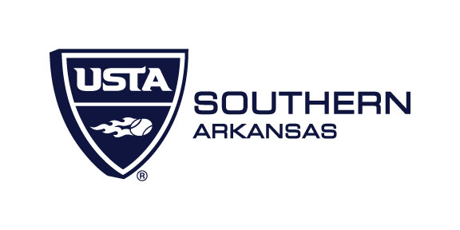
USTA Arkansas Outstanding Senior Winners

1982 – Don Pritchard
1983 – Jerry Saubers
1984 – John Layman
1985 – Myron Shofner
1986 – Raymond Owens
1987 – George Caristianos
1988 – Charlotte Kraft
1989 – Bob Kline
1990 – Jo Mills
1991 – Don Oosterhous
1992 – Marga Franken
1993 – Ned Kraft
1994 – Art Robertson
1995 – Dick Mills
1996 – Ann Harris
1997 – Harold Henderson
1998 – John Iskra
1999 – Roger Harmon
2000 – Bronson Van Wyck
2001 – Anita Russell
2002 – Bud Weinstock
2003 – Patsy Burton
2004 – Judy Breckon
2005 – Jim Russel
2006 – June Tackett
2007 – Ray Beal
2008 – Joyce Faulkne
2009 – Pat Lawson
2010 – Pat Nelson
2011 – Gayle Fowlkes
2012 – John Andrews
2013 – No Award
2014 – No Award
2015 – Joel Gambill
2016 – Tom Eppler
2017 – Jan Coester

