Thursday, April 7, 2016
5:00 PM

How to update Sophos VPN Client with current keys and configurations after receiving notification they have changed.

How to update Sophos VPN Client with current keys and configurations after receiving notification they have changed.

This guide provides complete instructions to update keys and configurations for the Sophos VPN Client. If this is the first time using Sophos VPN or are attempting to use the Sophos VPN Client on a different system please follow guide, "How to connect to your Abacus employee workstation remotely using Sophos VPN"

3 Steps

- Login to Sophos Head Quarters UserPortal using Sophos Authenticator app
- Update keys and configurations
- Test connection to Abacus office network using Sophos SSL VPN Client

Login to Sophos Head Quarters UserPortal

  - Open internet browser within a desktop
  - Go to: https://utm-hq.abacuslaw.com/
  - Prior to logging in, ensure Sophos Authenticator app is open on Mobile Phone (Android / Apple) and displaying the Sophos Authenticator Verification Code
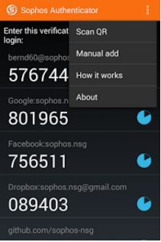
  - Login to the Sophos Head Quarters UserPortal site (Step 2), using current network username & network password with verification code
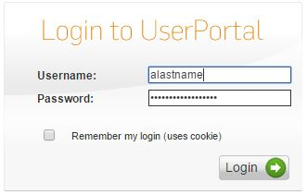

5. Upon successful login the following will be displayed

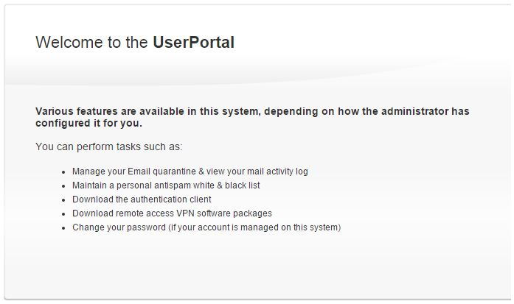

Update Sophos VPN Client (Windows)

- Select Remote Access from menu bar within Sophos Head Quarters UserPortal
- Select second Download button from SSL VPN listings
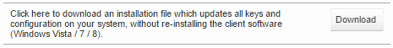
- Follow on screen instructions
- Once finished, Sophos VPN Client has been updated and is ready for use

Test connection to Abacus office network using Sophos SSL VPN Client (Windows)

NOTE: Sophos Verification Code is required to be entered along with network password for successful connections
- Right-Click SSL VPN Client from quick launch menu > Select Connect
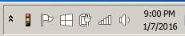
- Log in using current network username & network password with verification code
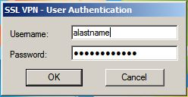
- Upon successful connection, SSL VPN Client icon will change to the following:
