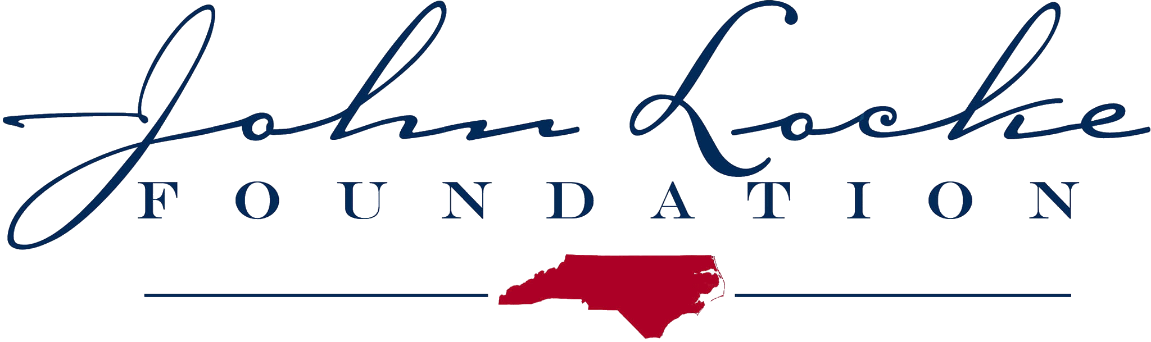

Key Points on House Tax Reform Plan
June 6, 2013

The N.C. House of Representatives will soon vote on House Bill 998, the Tax Simplification and Reduction Act of 2013. The legislation will make North Carolina’s tax code simpler and fairer, encourage investment and job creation in the state, and reduce the state tax burden for most North Carolina households. Here are some facts and resources to keep in mind:

• North Carolina’s current top marginal tax rate on personal income of 7.75 percent is the highest in the South and one of the highest in the country. HB 998 enacts a flat-rate income tax of 5.9 percent, making the state a more attractive place for entrepreneurs, investors, and high-value professionals to earn income and create jobs. Flat income taxes also produce steadier revenue growth rather than the boom-and-bust revenue swings of multiple-rate tax codes.

• North Carolina’s current 6.9 percent tax rate on corporate income is higher than the national average and one of the highest in the South. HB 998 will bring this rate down to 5.4 percent, giving North Carolina the second-lowest corporate rate among Southern states. Corporate taxes represent a double or triple layer of taxation on corporate dividends and capital gains, so HB 998 will make North Carolina a more attractive place to build, expand, and invest in job-creating businesses.

• While HB 998 will apply the sales tax to some currently untaxed services, the expansion is targeted to businesses that already collect tax on the goods they sell. Therefore, the bill does not compel new industries to shoulder the burden of becoming unpaid sales-tax collectors for state government.

• North Carolina’s relatively high marginal tax rates have been a factor in the state’s economic weakness since the 1990s, when competing states and nations began reforming their tax codes to make them friendlier to investment and job creation. During the last decade, both private investment and per-capita economic growth in North Carolina have trailed the national average.

• Many scholarly studies have found significant relationships between state tax rates or tax burdens and state economic growth. The strongest findings are for personal and corporate income taxes. The empirical support for state tax reform as a useful tool for promoting economic growth is discussed at great length in the John Locke Foundation books Our Best Foot Forward (2012) and First in Freedom (2013), as well as numerous other articles and papers published by JLF in recent years.

• According to a tax-scenario analysis by the General Assembly’s research staff, the income and sales tax changes in HB 998 will combine to reduce state taxes from the current baseline for 80 percent of North Carolina households studied, including virtually all families with incomes below $40,000.

• Keep in mind that HB 998 does more than reduce marginal income-tax rates. It also increases the standard deduction and the per-child tax credit, thus shielding a larger share of family income from taxation. Not only are these provisions justified on the grounds of good tax policy — because family investments in their children deserve to be treated like other forms of tax-deductible investment — but they also help to explain why the bill cuts overall state taxes on most households.

CONTACT: Becki Gray (919-828-3876 or bgray@johnlocke.org)

