Aufiero Engineering & Consulting LLC 16 Mitchell Grant Way  Bedford, MA 01730 | CURRICULUM VITAE | Telephone: 617.719.5291  E-mail: FGA@verizon.net
 | Frederick G. Aufiero, P.E. | Telephone: 617.719.5291  E-mail: FGA@verizon.net

Background
Mr. Aufiero has been a practicing engineer since 1967, dealing with civil, environmental, and building projects. He was employed by S E A Consultants, Inc. of Cambridge, Massachusetts for 40 years (until July 2011) and was President and CEO for 12 years. In 2011, he formed a new company –
Aufiero Engineering & Consulting LLC where he is the President.
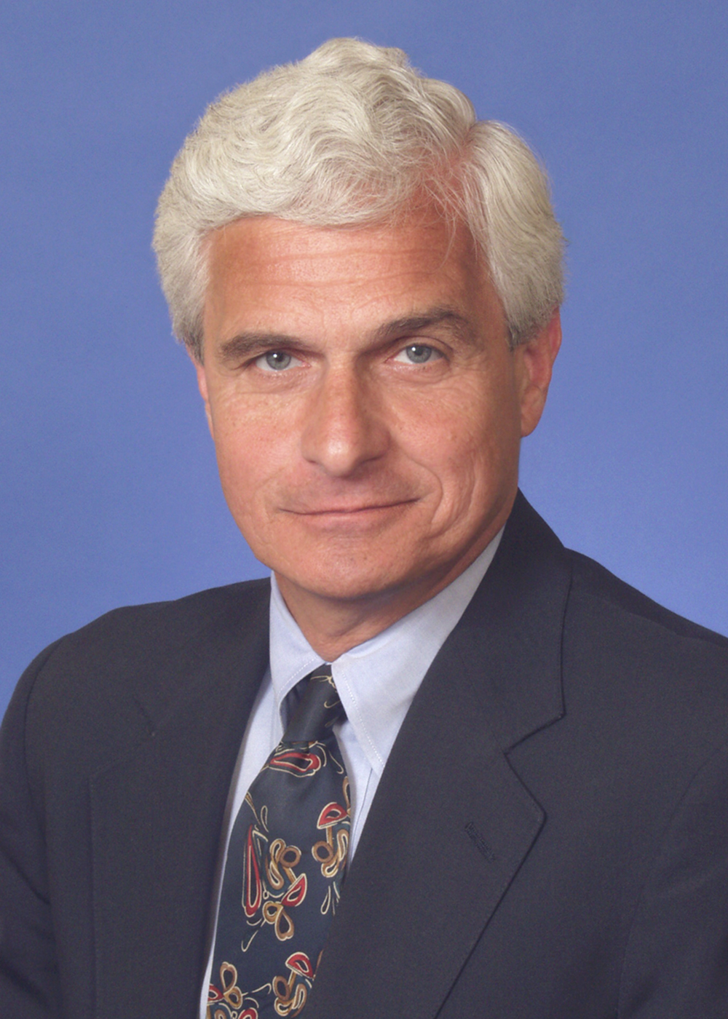
He has experience both as a designer and project manager responsible for the development of construction plans and specifications suitable for public bidding. He also has experience in providing construction administration and resident engineering services for municipalities and public agencies.
Mr. Aufiero has also been responsible for the development and negotiation of professional service contracts for engineering/architectural services with both public and private owners. He has extensive knowledge and understanding of the services and responsibilities of the Engineer/Architect to the owner under the design and construction phases of projects. He has been responsible for the preparation of construction documents, including general conditions and supplemental general conditions associated with public construction for agencies of the federal government, military, state agencies, housing authorities, municipalities and private industries. He has had responsibility and oversight for hundreds of millions of dollars of construction projects during his career.
He has been involved in projects where S E A has taken over responsibility for work started by another engineering firm; most notably, the $200 million combined sewer overflow abatement program for the City of Cambridge, Massachusetts. He negotiated risk allocation and professional responsibility allocation with the replaced firm and the City. He worked with the City to determine appropriate cost to undertake due diligence of the prior firm’s technical work so S E A could assume final responsibility for design.
Mr. Aufiero was responsible for S E A’s quality assurance and quality control programs for over 20 years. This involved establishing design review functions at critical points in a project and an intensive final document review. He also managed S E A’s risk management program consisting of seminars, training programs and contract negotiations.
Mr. Aufiero has provided expert witness services since 2007. He has been retained by both defense and plaintiff counsel. Cases have involved claims as large as $70 million. Issues on which Mr. Aufiero has opined involve standard of care assessments of the performance of design professionals, technical matters, contractual responsibility and personal injury.

Representative Projects:
- 1.2 BCF LNG Facility, $100 million, Private Utility Company (Design-Build)
- Water Treatment Facility, Cohasset, MA
- Water Treatment Facility, Hanover, MA
- Water Treatment Facility, Dover, NH (Design-Build)
- Wastewater Treatment Facility, Hartford, CT, MDC
- Wastewater Treatment Facility, Templeton, MA
- Taunton Court House, $40 million, DCAM (Design-Build)
- Logan Airport Terminal E Renovations, $20 million, Massport
- East Boston Piers Park, $35 million, Massport
- Route 7 Bypass, $30 million, Connecticut DOT

Professional Qualifications
M.S., Civil Engineering
Northeastern University, 1979
B.S., Civil Engineering
Northeastern University, 1967
Professional Registrations
Registered Civil Engineer  - Massachusetts (#26961)  - Vermont (#3151)  - New Hampshire (#3284) | - Maine (#3030)  - Connecticut (#11543)  - Rhode Island (#4184) | - New Jersey (#GE30765)
Certificate in Value Engineering
Professional Affiliations
American Council of Engineering Companies of Massachusetts, Past President
American Society of Civil Engineers – Life Member
Boston Society of Civil Engineers Section, ASCE – Life Member
New England Water Works Association
New England Water Environment Association
Water Environment Federation
The Engineering Center, Past President
The Engineering Center Education Trust, Past President
Northeastern University Civil and Environmental Engineering Department, Industrial Advisory Board, Chairman (1997 – 2011)
Wentworth University, Engineering Program Development Committee – Past Member
Publications
“Payment Plans.” (The measurement and payment section of a contract requires special attention to ensure project success.) CE News, February 2012
“Ensuring A Good Prime/Subconsultant Relationship.” CE News, January 2012
“Making Quality Job One.” PE The Magazine for Professional Engineers, June 2011
“Inside the Minds: The Business of Engineering – Chapter entitled; The Process of Consulting Engineering: Establishing Models”, 2007
“Engineering Education for the Future”, 2004, American Council of Engineering Companies of Massachusetts
Honors and Awards
“Outstanding Engineering Alumnus of the Year”, Northeastern University, 2005
“Outstanding Civil Engineering Alumnus of the Year”, Northeastern University, 2000

