VALUE

Form Refers to an element of art that is three-dimensional (height, width, depth) and encloses volume.

Proportion A principle of design that refers to the comparative relationship of one part to another or to the whole with respect to size, quantity, or degree.

Shading Showing change from light to dark or dark to light in a picture by darkening areas that would be shadowed and leaving other areas light. Blending of one value into another is sometimes called feathering. Shading is often used to produce illusions of dimension and depth.

Gradient The gradual transition from light to dark.

Blending Value created by coloring and smudging a soft medium.
Hatching Value created by drawing straight and parallel lines.
Cross hatching Value created by drawing straight and parallel lines that cross.
Stippling Value created by drawing dots.
Scumbling Value created by drawing scribbled, random marks.
Cross contour Value created by drawing crossed lines that follow the contours of the object.

Compressed Charcoals Big black chunks of charcoal made of charcoal shavings that bond together with clay and other binding substances. It is the blackest and densest of the charcoals we will use.

Vine Charcoal (also called stick charcoal) These are actually small pieces of vine and willow sticks that are carbonized (or burnt). They are much less dense and make lighter marks on your paper.

Charcoal Pencils Made by inserting tubes of hard charcoal into tubes of wood and are used just like a drawing pencil.

Graphite is a form of carbon, and leaves a shiny metallic grey color on a surface when moved across it. It can be removed with an eraser. The most common form of graphite an artist will encounter is the "lead" inside a pencil, compressed and baked to varying degrees of hardness. You can also buy it in powder form, like you would paint pigment. It works the same as graphite in pencil form, in that you can build up tones with it and remove it with an eraser. Apply it with a brush (but, as with all art materials, be careful of inhaling dust!)
Graphite has been used since the sixteenth century, when it was discovered in the Lake District in England. According to legend, in the early 1500s a tree was blown over in a storm in the Borrowdale region of Cumberland. Underneath its roots an unfamiliar soft, black rock was found, graphite. Local farmers started using it to mark their sheep. From this other uses grew, and a cottage industry developed making pencils.

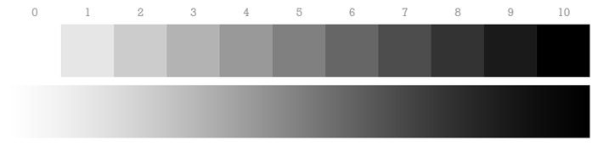
This illustration is known as a Value Scale. The left side of the value scale is completely white, and the right side is completely black. In between, there is a gradual progression of light and dark grays. At the top of each value in the value scale is a number, which you can think of as a percentage of darkness. A value of 0 is completely white and contains 0% darkness, a value of 10 is at 100% darkness, a value like 4 is at 40%, and so on. A canvas or a piece of paper will usually start out as white, and then colors and values are added to it.
The value scale portrays a full spectrum of dark and light, but in reality, every image has its own individual value scale. In other words, the brightest value in a design doesn’t necessarily have to be completely white, and the darkest color might not be completely black.
Value is the lightness or darkness a color or hue.
- In painting, value changes can be achieved by adding either black or white to the chosen color. (see the grey scale chart)
- However, this also reduces the saturation and adds to the dilution of the color. (see the color chart)
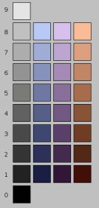
Believe it or not, value is more important than color to the design and success of a painting.

Here’s why:
- Value is used to create a focal point within a painting or drawing.
- The human eye is immediately drawn to a light element against a dark element. This creates the focal point of interest.
- To create the illusion of depth, gradations of value are also used.
- Areas of light and dark give a three-dimensional illusion of form to subject matter.

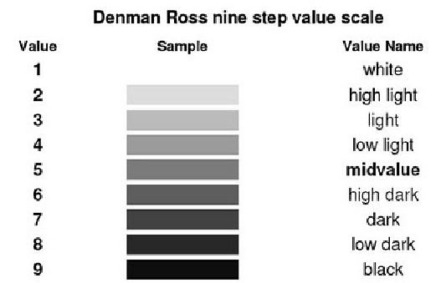

The above value scale of Denman Ross was introduced in 1907. His value terms set the standard still used today. This scale helps artists understand and identify light, mid-tones and darks more easily.
Value is independent of its hue (color). This is a fundamental element in the impact of visual art whether abstract or representational.

