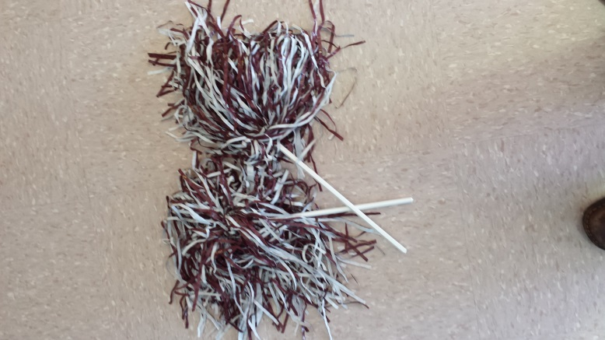Spirit Store

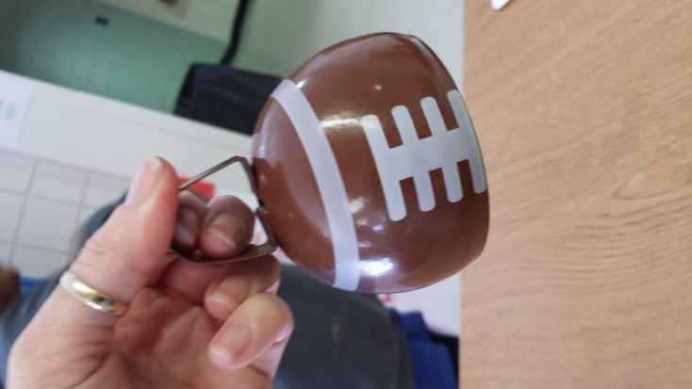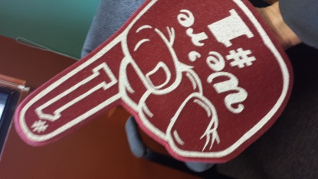

Pom Poms $1.00

Cow Bell $3.00

Foam Hand $2.00

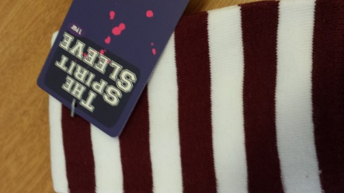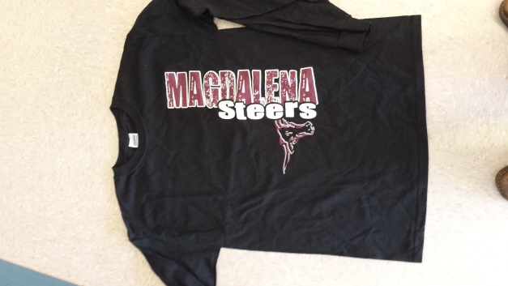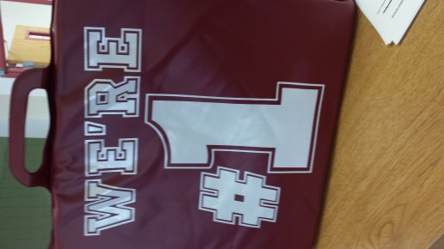

Seat Cushion $5.00

Sleeves $10.00

Long Sleeve $20.00

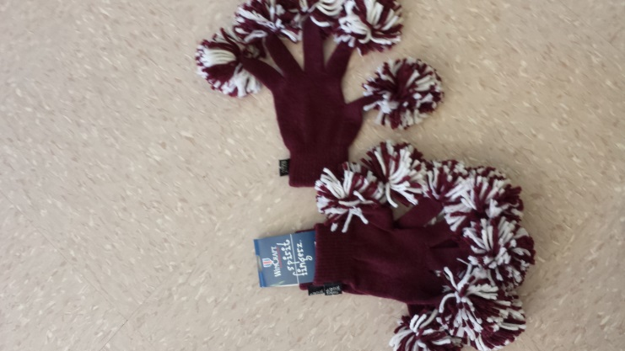



Gloves $15.00

Fleece Scarf $10.00

Infinity scarf $15.00

We also have:

Clappers $1.00

Black t-shirts $15.00

Jacket $40.00

Sweatshirts $18.00

T-shirt scarf $6.00