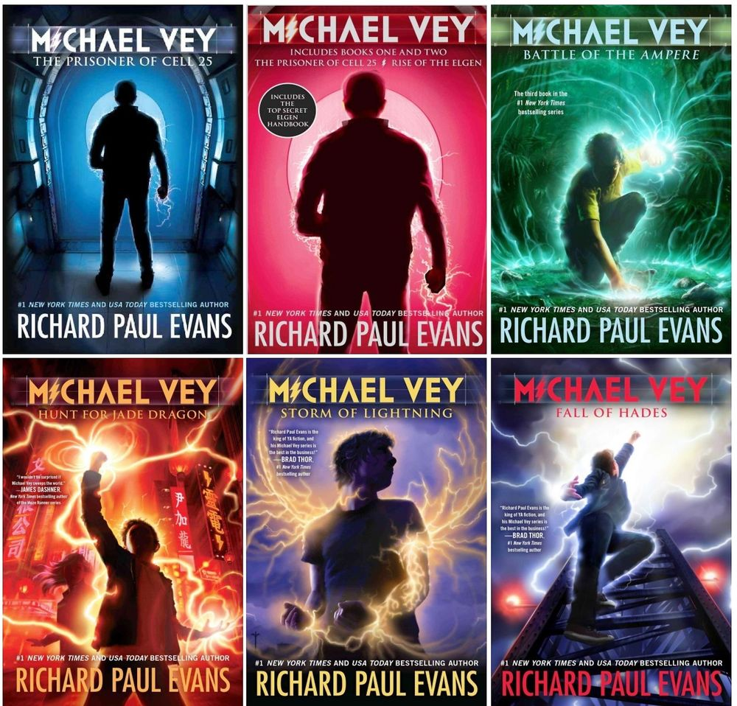
The Michael Vey series by Richard Paul Evans

-It starts with high school kids doing normal things, dealing with grades, bullies, friendships, and love. But a special boy named Michael has electric powers he has to deal with. Through his long journey he finds friends just like him. Some of his enemies he befriends, some he defeats.

