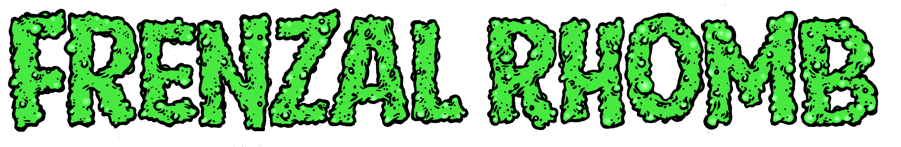

Back in the mire of the early nineties, from somewhere beneath a pile of wallet chains and cut-off army pants **Frenzal Rhomb** emerged, their white suburban fingers clutching onto goon casks and bucket bongs and other appropriate paraphernalia. Before too long those fingers wrote riffs and those riffs became songs and their voices sung rhyming swear words in perfect(ish) three-part harmony. This went on for a while.

In fact all the way to now, in 2017. After countless world tours (if you've counted them, please let us know for taxation purposes), sharing the stage with everyone from NoFX to Nickelback (that was actually at the same gig). Playing all around Australia, from Broome to Bunbury and Bundaberg to Brunswick, offending and entertaining people in equal measure along the way. Being welcomed into people's lives and banned from radio stations, often for the same reasons. Nominated and losing myriad awards, the dubious (if unofficial) honour of being the most hospitalised band in the world – everything from broken drumming arms and detached guitar-playing retinas to an actual pig-borne tapeworm in the lead singer's brain – it's amazing that **Frenzal Rhomb** are here at all (it's certainly a surprise to distant relatives at summer bathing parties), but **Frenzal Rhomb** ARE still here, and they're still playing music. And that's not all.

**Frenzal Rhomb** have made a new fucken album.

Their ninth album. And just like a ninth child to a religious family, they're really getting good at it. Recorded once again by Bill Stevenson (Descendents, Black Flag) and Jason Livermore at The Blasting Room in Fort Collins, Colorado, ***Hi-Vis High Tea*** is a concept album about a whole bunch of different concepts. 20 songs clocking in at just over 30 minutes, but what they lack in length they make up for in brevity.

And it sounds fucken rad!

From the high-octane punk-rock blast of opener *“Classic Pervert”*, to the high-octane punk-rock blast of the ode to Hard-Ons bassplayer *“Ray Ahn Is My Spirit Animal”*, and not forgetting the high-octane punk-rock blast of retail recreational rectal drug use anthem *“I'm Shelving Stacks (While I'm Stacking Shelves)”*, ***Hi-Vis High Tea*** is an album as diverse as it is varied. Gordy, Tom, Jay and Lindsay are like a well-oiled machine, but one that makes songs, and is not so much a machine but four different people, who aren't oiled all that regularly. But don't take my word for it, I'm just a computer-generated bio-writing algorithm Frenzal Rhomb downloaded from the darknet: you should listen to the album. You probably already have. It takes less time than it takes to read this nonsense. Off you go then.