­

**Brian Gorsegner – vocals | PJ Russo – guitar |**

**Mike Hunchback – guitar | Joe Keller - bass | Darick Sater - drums**

This summer, **Night Birds** will celebrate their ten-year anniversary. That’s a long time for any band, but it’s especially long for a punk band, which **Night Birds** vocalist Brian Gorsegner is acutely aware of. “Ten years in punk years is kind of like dog years. Not a ton of bands make it that long,” he says. But unlike a lot of bands, **Night Birds** aren’t hanging on for dear life. Instead, they’re as spry as they’ve ever been, and they’ve got the eight-song mini-album *Roll Credits* to prove it.

As every song on *Roll Credits* shows, **Night Birds** are just as inspired as they were a decade ago. This is due, in part, to the return of the band’s original guitarist, Mike Hunchback, who played his last show with **Night Birds** on January 12, 2012. But just because Hunchback has returned doesn’t mean that long-time guitarist PJ Russo has left the band. Instead, on *Roll Credits*, **Night Birds** have become a five-piece, effectively bringing their career full circle.

With their new lineup, **Night Birds** decided to pay homage to one of punk’s best formats: The 12-inch EP. “Whether it’s Negative Approach’s *Tied Down* or Minor Threat’s *Out Of Step*, people think of those as full albums but, technically speaking, they’re not,” says Gorsegner. “They go down smoother, and you’re not left with any filler album tracks.” The proof is in *Roll Credits* itself, which, across eight tracks, is a lean combination of the band’s best elements. There’s the propulsive, self-deprecating “Onward To Obscurity,” and the fantastically tongue-in-cheek “My Dad Is The BTK,” which sees Gorsegner singing about a kid who starts to think his dad is a serial killer and snitches on him to the FBI, as well as a couple surf-inspired instrumentals, making *Roll Credits* as richly detailed as anything the band has done before.

Though it’s a mini-album, *Roll Credits* is still wildly ambitious. Fat Wreck Chords will be releasing it as both as 12-inch EP and a limited seven-inch box set, and for the artwork of both, **Night Birds** asked eight of their friends to contribute art to the project. Featuring art from Chris Shary, Nathan Gattis, Perry Shall, Marissa Paternoster, Michael Saunders, Paul D'Elia, Alex Hagen, and Keith Marlowe, *Roll Credits* features the handiwork of some of the most iconic artists working in punk rock today, the cumulative effect being a flashback to the band’s past as well as punk’s history. “Getting into the *Killed By Death* compilations as a teenager, that was huge,” says Gorsegner. “So laying the whole thing out like that, it’s interesting for us. It was our attempt at creating something that was just fresh and cool.”

But that’s not the only nod to punk’s past, as “Onward To Obscurity” features guest vocals from Poison Idea vocalist Jerry A.  “He’s the king of punk, and the king of nihilism in punk, and it meant the world that he liked our band enough to have a hand in something like that,” says Gorsegner. “I get chills when I hear his voice come up on the recording.” It’s fitting, given that **Night Birds** are entering an era comparable to that of Poison Idea’s five-piece, *Feel The Darkness* lineup, or even Black Flag around the time of *Damaged*. They’re at the peak of their power, and there’s no sign of slowing down. This summer, the band will go out on tour with their new, expanded lineup, hitting 17 cities and showing the world that, a decade into their career, **Night Birds** are more exciting than ever.

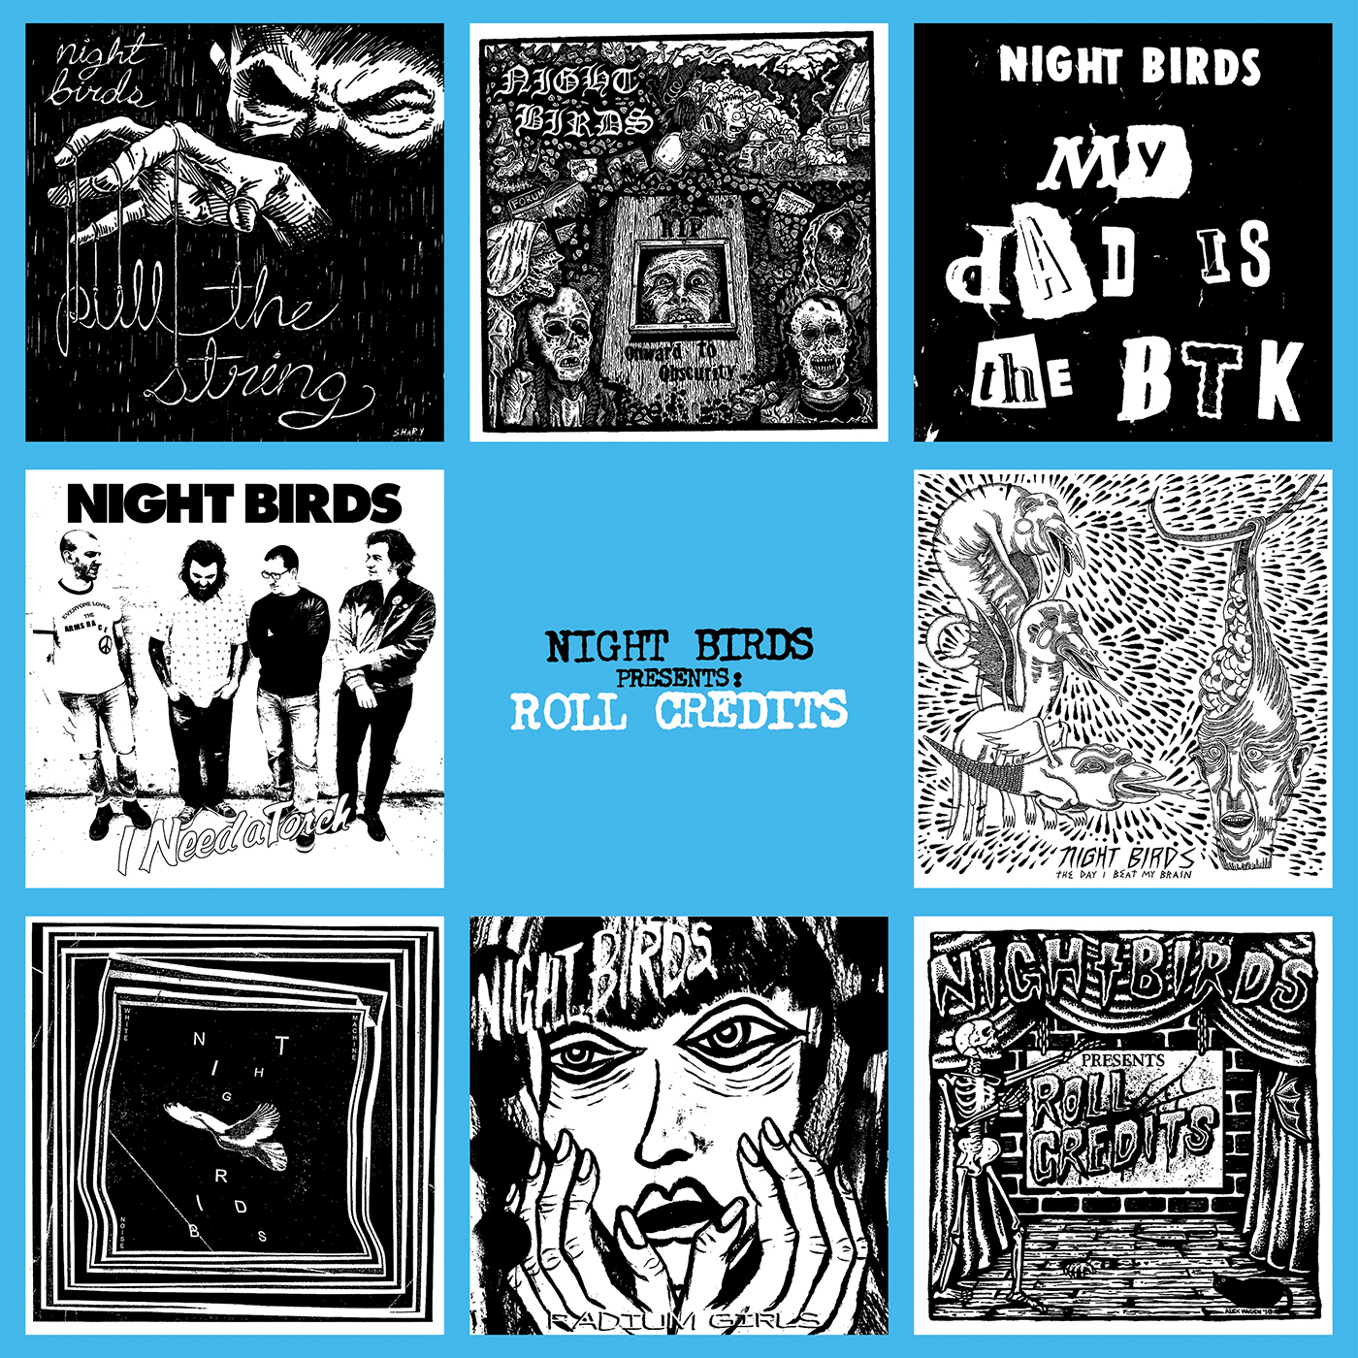

**FAT WRECK CHORDS @ (415) 284-1790 Fax: (415) 284-1791**

**www.fatwreck.com // for press inquiries contact Vanessa@fatwreck.com**

## 2196 Palou Ave. San Francisco, CA 94124

