Science’s Alliances
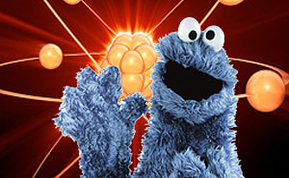
Mom and apple pie. Computers and silicon. Martians and death rays. Some things just go together naturally. But how about science and politics? Science and religion? Science and fiction? These pairings are often unnatural and contentious … but they don’t have to be.
Discover how science can team up with other endeavors in productive, if surprising, symbiosis.
Meet a particle physicist, turned U.S. Congressman, who calls for more scientists on Capitol Hill. Also, a tour of the Golden Age of Islamic Science.
Plus, scientists named Elmo and Super Grover 2.0 teach small children to conduct experiments with the help of chickens and dancing penguins.
And, it’s not quite science but it’s not entirely ficition either: how sci-fi helps shape our cultural debates about the future.
Guests:
- Bill Foster – Physicist and former U.S. representative from Illinois
- Carol-Lynn Parente – Executive Producer, Sesame Street
- Ranjana Mehra – Docent at The Tech Museum, San Jose, California
- Brooks Peck – Curator, EMP Museum, Seattle, Washington

