Blame it on Bacterio
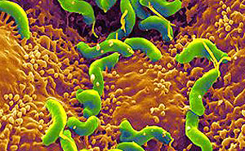
Think small! Microbes are tinier than the dot at the end of this sentence, yet they can make humans sicker than dogs, dogs sicker than humans, jump from animal to human and keep scientists guessing when and where the next disease will appear.
Discover how doctors diagnosed one man’s mysterious infection, the role that animals play as hosts for disease, and why the rate of emerging diseases is increasing worldwide.
Also, why your kitchen is a biosafety hazard, and how the Human Microbiome Project will tally all the microbes on – and in – you.
Plus, the extreme places on Earth where microbes thrive and what it suggests for the existence of alien life. And, how one strain of bacteria helped a farmer grow a pumpkin the weight of a small car!
Guests:
- Peter Hudson – Biologist, Director of Life Sciences at Penn State University
- Peter Krause – Senior research scientist at the Yale School of Public Health
- Durland Fish – Epidemiologist at the Yale School of Public Health
Information on his Lyme disease app
- David Relman – Stanford University microbiologist and infectious disease clinician
- Erich Fleming – Biologist, SETI Institute
- O. Peter Snyder – Hospitality Institute of Technology and Management
- John Raeside – Oakland, California
- Francis Raeside – Oakland, California
- Jennifer Kate Arnold – Infectious Disease Clinic, Kaiser Permanente Medical Group
- Dave Stelts – Farmer, head of the Great Pumpkin Commonwealth
- Neil Anderson – Owner, president of Reforestation Technologies International Find retail products.

