NASA or What?
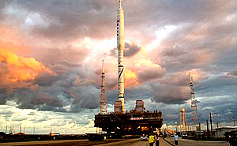
“Making space for everyone” could be NASA’s motto. But as commercial spaceships get ready to blast off, that populist idea is being tested. Space cowboys in the private sector say they’re the ones who can provide unfettered access to space, for tourists and scientists alike.
Meet a scientist who already has a ticket to ride on SpaceShip Two and discover what he hopes to learn about asteroids during his five minutes of weightlessness.
Plus, NASA in motion: it’s back to the moon as the GRAIL mission probes the interior of our lovely lunar satellite. Also, can you dig it? The rover Curiosity can. It’s headed to Mars to hunt for clues to alien life … with a jackhammer.
Also, as the Hubble Space Telescope shuts down, the James Webb Space Telescope revs up. Or does it? The telescope is designed to study the birth of galaxies and hunt for evidence of water on far away worlds. But will Congress pull the plug?
Guests:
- James Oberg – former Space Shuttle Mission Control engineer, and space expert
- Maria Zuber – Planetary scientist, Massachusetts Institute of Technology and Principal Investigator of NASA’s GRAIL mission
- Joy Crisp – Geologist at NASA’s Jet Propulsion Laboratory and Principal Investigator on the Mars Science Laboratory, Curiosity
- Massimo Stiavelli – Astronomer at the Space Science Telescope Institute, and Project Scientist for the James Webb Space Telescope
- Dan Durda – Planetary scientist, Southwest Research Institute, Boulder, Colorado

