j
Fine Arts Spring Concert Program Ads
April 26 at 7:00
NCHS Hartnett Arena
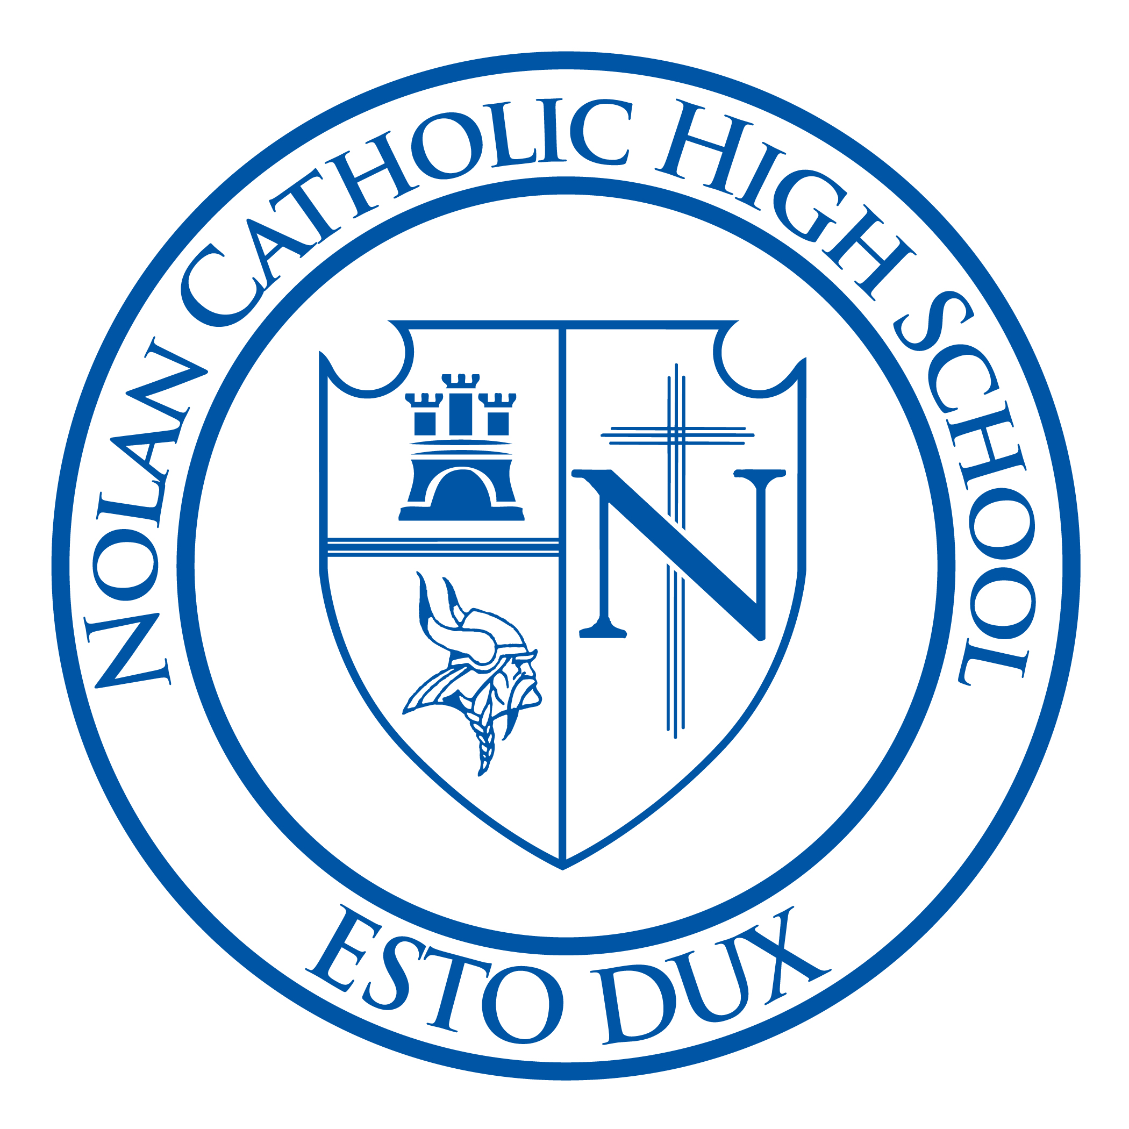

Make the Fine Arts Spring Concert especially memorable for your student. Please consider purchasing an ad in support of your student/students. (Attention parents of seniors: senior ads make the program a cherished keepsake.) The program will be printed on 8.5x11 and ads will be displayed in the program. Ads will be available in three sizes:
¼ page for $25 ½ page for $50 full page for $100.

We thank you for your consideration. You do not have to send payment at the time your order is placed. Please complete the bottom half of this form if purchasing an ad or send an electronic version to:

cmeiners@nolancatholichs.org or mail to: Nolan Catholic High School
4501 Bridge Street
Fort Worth, Texas
76103
ATTN: Mrs. Cary Meiners

The deadline for submitting an ad is April 11, but please send it to us as soon as possible so we may begin arranging them.

I am purchasing a (circle one): ¼ page ($25) ½ page ($50) Full Page ($100)

Message:____________________________________________________________________________________________________________________________________________________________________________________________________________________________________________________________________________________________________________________________________________________________________________________________________________________________________

Please attach a picture or email photo to cmeiners@nolancatholichs.org

