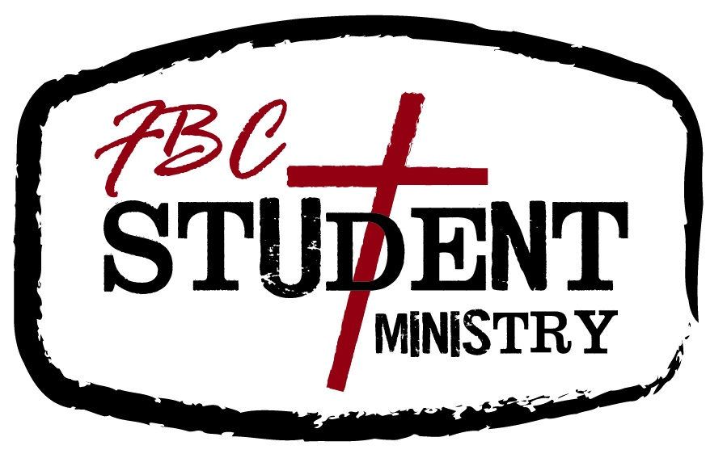

Handbook

Everything you need to know about the
Student Ministry at FBC DeWitt (almost).

- Why We Exist:
The Student Ministry at First Baptist Church, DeWitt, AR exists as a ministry for 6th-12th grade students in the community of DeWitt and surrounding areas. Any goal, vision, expectation, etc. this ministry has exists as part of the overall strategy of the local body here at First Baptist Church. In other words, we exist as a ministry of First Baptist Church, not a separate entity or congregation. (Matt. 16:15-19, Acts 2:41-47, Revelation 2-3, etc.)
A. Purpose Statement: FBC Student Ministry exists to run the R.A.C.E!: Reach students for Christ, Adore God, Connect church and home and Equip the Saints.
1. Reach students for Christ (Proclaim the Gospel): Our desire is to proclaim the Gospel to the nations. We want to reach students for Christ but we acknowledge that God saves, not us. Therefore, our calling is to faithfully proclaim a Holy God, a fallen man, and the life, death, and resurrection of Jesus Christ as the only way unto salvation. (Matt. 28:18-20, Acts 1:8, Eph. 1:4, John 14:6)
2. Adore (Worship) God: The sole purpose of human existence is to glorify God! We want to show our students what it means to worship the living God. (1 Cor. 10:31, Romans 12:1)
3. Connect church with home: We want to have a biblical model of youth ministry. We believe a foundation for that type of ministry is found in Deuteronomy 6:5-7. The primary disciple makers of students are the parents. Our goal is to equip and encourage parents to disciple their children. Effort will be made to reach the parents of all students. If, however, parents are not believers, we will attempt to connect students (spiritual orphans) with other faithful adults (faith families) to disciple them. Connecting church and home also involves teaching students the importance of the church and the home and how these two institutions work together for God’s glory.
4. Equip the Saints (Eph. 4:12): We do not have a “bench” for any of our youth to sit on. We want them all in the game! Our desire is to help equip students to grow in their relationship with Christ through the process of sanctification. Part of our mission in equipping young people will be by intentionally cultivating the spiritual disciplines in their lives. The spiritual disciplines include, but are not limited to: Evangelism (Matt. 28:18-20), Bible intake (2 Tim. 3:16), Prayer (Matt. 6:5-9), Worship (Matt. 4:10), Serving (Psalm 100:2), Stewardship (2 Cor. 9:6-7), Fasting (Matt. 9:14-15), Silence and Solitude (Matt. 4:1, 1 Kings 19:11-13), Journaling (Psalms, Lamentations, etc.) and Learning (Mark 12:29-30, Romans 12:2). Many of these disciplines will be practiced through faithful attendance to church, therefore church attendance and fellowship is vital to our students’ spiritual growth (Heb. 10:25). The primary faith builders in students’ lives are the parents. Therefore, part of “Equipping the Saints” will be for this ministry to equip parents to cultivate these spiritual disciplines in the lives of their children as well.
B. Doctrine: Again, we exist within the context of First Baptist Church, DeWitt. The church here agrees with the Baptist Faith and Message (2000).
C. Model of Ministry: Family Equipping - The process of intentionally and persistently realigning a congregation’s proclamation and practices so that parents are acknowledged, trained, and held accountable as the persons primarily responsible for the discipleship of their children.
II. How We Exist:
We exist as a ministry because of one word: GRACE! Our belief about God’s grace is defined in more detail in the Baptist Faith and Message (2000). Another reason that we are able to exist is families (which are here by God’s grace of course!). Without families there is no youth ministry. We intentionally encourage and partner with parents believing that they are the primary disciple makers of students. Our ministry exists as a resource to families and we believe that the church and home must partner together in order to be successful in discipling this generation of students. (Deut. 6:4-8)
III. What We Do:
The foundations for our programs and strategies are listed above. Although our programs and strategies may change from time to time as we engage culture, our foundations, built upon the Word of God will not change.
A. Sunday Activities
9:15am- Sunday School: Will instruct students from the whole counsel of God’s Word which is completely relevant to their daily walk. Various subjects will encounter almost all of the spiritual disciplines. Numbers permitting, we will have Jr. High and Sr. High boys and girls classes (4 classes).
10:30am- Sunday Morning Worship Service: Will allow students to sit under sound preaching of the Word of God and participate in corporate worship, giving, and prayer. At least twice a year the students will have a Sunday Morning Service where they lead in worship, prayer, and taking up the offering.
5:00pm- Discipleship Classes: These classes will take place periodically throughout the school year. They are designed to allow Bro. Cuatro more 1 on 1 time with the students. The classes will cover a wide range of relevant topics derived from the whole counsel of God’s Word.
6:00pm- Evening Worship and Activities: Similar to Sunday Morning Worship, Evening Worship will allow students to sit under sound preaching/teaching of God’s Word. Occasionally the church will have special events/activities that will take the place of Sunday Evening Worship (students and families are encouraged to attend any of these events).
B. Wednesday Activities
6pm-7:30pm- Wednesday Night Service: Currently, our service is called “TwelveOneTwo” (cf. Rom. 12:1-2). TwelveOneTwo features, games, fellowship, worship, and preaching/teaching. Everything done during this service is specifically geared towards enriching students’ walk with Christ and running the R.A.C.E (see above). An offer to trust Christ as Savior is publically issued at almost every Wednesday night service (as well as Sundays). Wednesday night activities will change during the summer time to bible studies/fellowships held at various volunteers’ homes.
For both Sunday and Wednesday Services we encourage parents to be involved. If you would like to volunteer you can contact Bro. Cuatro. However, volunteering your time is not the only way to be involved. You can commit to pray for our services and we encourage all parents to actively engage their students about what they are learning.

C. Other Events/Activities
1. Our biggest “other” event is church camp. Currently, we attend church camp at Centrifuge in Jackson, TN. Some summers, and spring breaks there may be opportunities for students to participate in mission trips. Details of these events will be given to parents by Bro. Cuatro.
2. In the continuing process of growing our students there will be various student and family oriented events scheduled throughout the year (retreats, concerts, mission projects, etc.). Details about these events and their purpose in the ministry will be communicated to the parents by Bro. Cuatro.
3. Cost: We strive to make ministry as low cost to families as possible. During certain times of the year we will have to charge for certain events. We understand the need for family budgets and that every event may not be attended by every youth because of financial reasons. We encourage parents to never let their child miss an event solely on the basis of finances. Always check with Bro. Cuatro to see if there is any “scholarship” money available. Also, you can assist raising money for youth events by participating in fundraising activities.
D. Partnering with Parents
As stated above, we believe partnering with parents is vital to our ministry. The family can exist apart from the youth ministry, but the opposite is certainly impossible! The programs below are continually evolving as we strive to reach families more effectively. It is important to note that in the family equipping model of ministry “programs” are simply an outflow of our ministry philosophy…In other words, our ministry model drives our programs, not the other way around.
1. Family Night: This event is on a Wednesday night and will take place during the beginning of the new school year. Family Night is a time families can get to know one another and learn the ins and outs of the ministry here at FBC.
2.SuperTraining: This training will be for parents and students and will occur periodically throughout the school year on Wednesday nights at 5pm. The training topics will cover a wide range of topics derived from the whole counsel of Scripture.
3. Parent Night: This event will take place at least twice a year. At Parent Night we invite parents to sit in on TwelveOneTwo to interact with students. Parent Night will also give parents a better understanding as to how we are ministering to their student(s).
4. PRT: Parent Round Table. Throughout the year Bro. Cuatro and volunteers will schedule time with parents to discuss what we have been learning as a youth group and provide parents with specific ways they can incorporate this teaching in their home.
5. Parent Breakfast: Twice during the year (once in the Fall, and once in the Spring) families will be invited to a breakfast on Sunday morning at 8:45am. Families will have the chance to visit with one another and at 9:15am students and children will dismiss to Sunday School so Bro. Cuatro can lead the parents in a devotion.
6. Parent newsletter and Parent helps: Once a month parents will receive a newsletter form Bro. Cuatro that has updates about things going on in the ministry. Parent helps is a web page on our website, www.fbcdewitt.com, that offers links that are helpful in offering ideas and encouragements for biblical parenting.
7. Parent Leadership Team and Parent Prayer Team: The Parent Leadership Team is a group of parents that meet intermittently (without Bro. Cuatro) to discuss the “Family friendliness” of the Youth Ministry. The team then reports to Bro. Cuatro with ideas, comments, suggestions, etc. on how he can more effectively minister to students and families. The Parent Prayer team is a team that meets at least once a month to pray for the pastor, Bro. Cuatro, adult volunteers, students, and families.
E. Youth Involvement:
1. Youth Leadership Team: During appropriate seasons* in our ministry we will have a Youth Leadership Team (YLT). The YLT is made up of a handful of committed students in our ministry who are natural leaders. The team will meet on a monthly basis with Bro. Cuatro to hold one another accountable and to offer insight to the ministry. Any student who might be interested in being on the YLT should contact Bro. Cuatro and go through the interview process.
2. Ministry teams: During appropriate seasons* in our ministry we will have ministry teams led by the students. Example of these teams are Games/rec. team, worship team, Drama team, and missions team. We may have more or less teams depending on student involvement. The purpose of these teams (and the YLT) is to give students “ownership” of the ministry. To lead a ministry teams students must be committed to this church. The leaders of the ministry teams will be responsible for coordinating meetings and reporting/meeting with Bro. Cuatro. There are no prerequisites to just be a member of one of these teams as we want to encourage commitment and student involvement at all stages of spiritual growth.
*appropriate seasons are times in the ministry when we have enough committed students to be able to carry out the vision of the YLT and Ministry Teams. There may be times that we are unable to have these teams because of lack of numbers/mature leaders.

IV. Policies and Procedures
A. Discipline: Minor offenses will be dealt with by Bro. Cuatro, the pastor, or the appropriate adult volunteer. Minor offenses are defined as any offense that does not endanger any student, child, or adult. For some minor offenses, such as dress code or cell phone use, the parents may need to be involved. Other offenses, depending upon their severity, may involve authorities outside the church and parents. With repeated minor offenses and major offenses it may be necessary for Bro. Cuatro to meet with parents in order to establish a way to better minister to a student or group of students.

B. Volunteers: All adult volunteers will be a member of this church in good standing. Volunteers go through special training specific times during the year. If an adult is a volunteer it means that Bro. Cuatro completely trusts him/her and is confident that he or she will effectively minister to students. Although they are not paid (monetarily), our volunteers are seen as “staff”. Anyone interested in volunteering with the youth ministry can contact Bro. Cuatro. We love our volunteers at FBC and would be excited to have you on our team!

C. Dress Code: We have one word to sum up our dress code: modesty. This means we ask students to not wear clothing that would draw inappropriate attention from the opposite sex. We also ask that students do not wear any clothing that promotes, advertises, displays, etc. anything contrary to our calling as born again believers (i.e. clothes with inappropriate language, drugs, alcohol, etc.- Rom. 12:2).

D. Music: Generally we will not play or allow secular music during our meeting times. Depending on the event this may be subject to change as long as the secular music is positive and clean. MP3s, IPods, and other music devices are allowed during trips but no music that is blatantly contrary to our conduct as Christians will ever be allowed (i.e. foul message and/or language). Final say on the use of portable music players and particular songs will be up to Bro. Cuatro (who is of course, under the authority of the pastor). Students and parents should understand that portable music devices may have to be confiscated for misuse.

E. Fundraising: Periodically the youth group will participate in fundraising activities to help pay for certain events like church camp. We do fundraising to help raise money but also to teach students the importance and value of hard work that hopefully they will carry on through adulthood (cf. 2 Thess. 3:10). Generally, we will encourage all members of the youth group to participate in all fundraisers.
F. Attendance: There is no “attendance policy” so to speak other than the fact that we encourage all parents and students to make their spiritual journey in Christ (process of sanctification) the #1 priority. As a ministry we encourage students to be involved in sports, school, music, and many other extracurricular activities- NOT however, at the expense of their growth in Christ. We feel that students can find balance in their life if they will seek first the Kingdom of God (Matt. 6:33)! There is purpose and biblical precedent behind everything that we do here.
We therefore, unapologetically, ask students to be at all our weekly services and extra-curricular activities barring vacation or emergency. Just as coaches expect their players to come to every practice and every ball game, so too this church expects this level of passion and commitment.
V. Misc. Issues
A. Counseling: Bro. Cuatro is available to counsel parents, students, and families. This is part of his calling as a minister of the gospel and something he loves to do. However, there will be certain issues that may arise that are beyond his level of training and understanding and he may therefore recommend you to someone more appropriately equipped to counsel you.
B. Resources: FBC has a library on site and from time to time Bro. Cuatro purchases books that are helpful to parents, students, and volunteers. We strongly encourage any parent, student, or volunteer who is interested in a book or training material to ask Bro. Cuatro what resources are available.
C. Video/Photography: During certain events and activities Bro. Cuatro, students, and volunteers may take pictures and/or video of what is taking place and post these videos/photos online. It is our goal to never post anything that would compromise the safety of any student. If you do not wish to have you or your student videoed or photographed for any reason please contact Bro. Cuatro.
D. Catch-all statement: This handbook is designed to give parents, volunteers, and church members information on the Student Ministry here at FBC. It is by no means intended to be seen as legally or ecclesiastically binding. It’s just a resource to help you know what makes us “tick” here at FBC! God bless!

Contacting Bro. Cuatro:
By Phone:
870-946-4361 (office)
By Email:
By Office hours:
By Appointment:


________________________________________________________________________________________

I believe, healthy youth ministry is built on the Gospel of Jesus Christ—that Holy God made man in His image, man is born guilty of Adam’s (our first representative) Sin, Jesus (God in the flesh, the Second Adam) lived the life of perfect obedience to God and died in our place on the Cross, man must respond to the Gospel by repenting of his wickedness and trusting Christ through faith as Savior, Lord, and King of his life.
This definition is taken from the Southern Baptist Theological Seminary see www.sbts.edu

