Mid-Atlantic Christian University
2010 Fire Safety Report
(1/1/10 - 12/30/10)
For Campus Housing

Below is a summary, by institutional residences, of all fire-related incidents and activities for 2010. Please note that each residence hall conducts one fire drill a semester with-in the first two weeks of classes. Each residence is equipped with smoke detectors in the hallways. In addition pull stations are located in the dormitory and Commons Areas (Heritage Hall and the Student Center). The detection systems are connected to fire panels that are monitored by a local security company. The institutions security company follows protocol by contacting the appropriate authorities when detection is made. Evacuation Plans include are posted in each dorm room and hallway, and procedures for evacuation are covered during Resident Assistant training and during fire drills. (Evacuation route documented below.) Procedures are also outlined in the student handbook and the institutions emergency response plan. In the event of a fire students are urged to use common sense and remain calm. (The institutions Emergency Response plan suggests pulling the nearest fire alarm, calling 911, or screaming fire and then contacting the nearest school official.) The Mid-Atlantic Christian University prohibits open flames of any kind in all housing units. Limitations related to electrical appliances allowed in each dorm room are listed in the Student Handbook.

Student Life Personnel will conduct Environmental Health and Safety Inspections four times a year, twice during each semester. Inspections will be announced during the first round of each semester. The second inspection is unannounced. The Student Life inspections are primarily designed to discern and eliminate safety violations. Students are required to read and comply with the Student Handbook Guide which includes inspections, and all other rules and regulations for residential buildings. The inspections include, but are not limited to, a visual examination of electrical cords, sprinkler heads, smoke detectors, fire extinguishers and other life safety systems.

In addition, each room will be examined for the presence of prohibited items (e.g., sources of open flames, such as candles: non-surge protected extension cords; halogen lamps; portable cooking devices in non-kitchen areas; etc.) or prohibited activity (e.g., smoking in the room, tampering with life saving equipment; possession of pets; etc.). This inspection will also include a general assessment of food and waste storage and cleanliness of the room. Prohibited items will be immediately disabled or confiscated and discarded, without reimbursement.

In addition to dormitory style living, MACU operates an apartment complex and various houses for apartment style living. Each apartment is equipped with smoke detectors, fire alarm monitoring is accomplished through a contracted company, fire extinguishers are available on each hall, evacuation plans are posted in each residential room, and evacuation drills are performed at the beginning of each semester.

On-Campus Student Housing Facility Fire Safety Systems
Fire Safety Systems in Mid-Atlantic Christian University Residential Facilities
Facility | Fire Alarm Monitoring Done On Site | Smoke Detection | Fire Extinguisher Devices | Fire Pull stations located throughout the dorm | Evacuation Plans & Placards | Number of evacuation (fire) drills each calendar year
Pearl A. Presley Hall 800 N. Poindexter | X | X | X |  | X | 2

FIRE EVACUATION PLAN
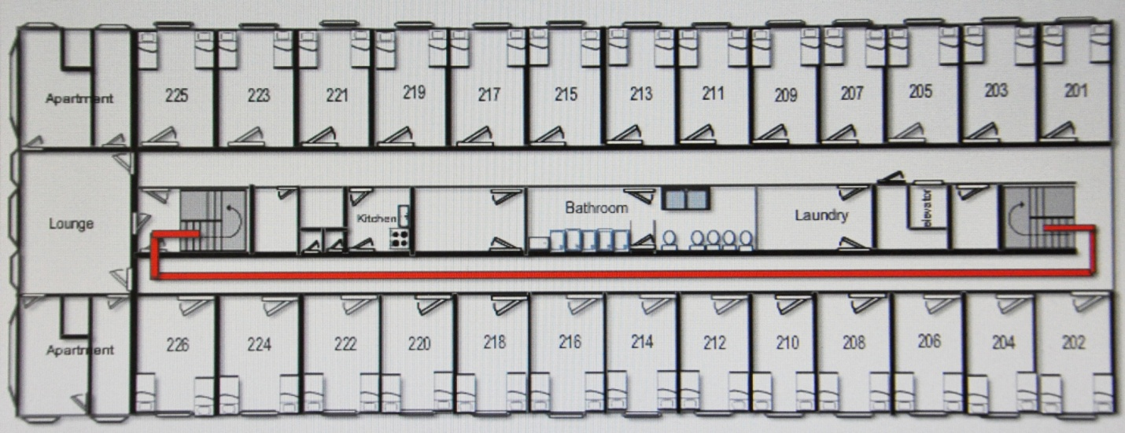
Fire Safety Evacuation Procedures
- Leave towel on the outside doorknob of your room to signal that everyone is out of the room. Leave door closed, but unlocked
- Exit through assigned door. (DO NOT USE ELEVATORS).
- Check door to see if it is hot before opening. DO NOT open if hot or warm.
- If there is smoke in the hallway, crawl to the exits
- Assemble with the members of your hall in grassy area beyond parking lots
- DO NOT re-enter the building for any reason until told to do so by the fire dept. or a member of the staff.
IF TRAPPED IN YOUR ROOM
- Close door and place a wet towel across the bottom of the door.
- Hang a sheet out of the window and yell for help
IF YOU CATCH ON FIRE STOP, DROP, AND ROLL.
FIRE EVACUATIOIN PLAN IS LOCATED IN THE HALLWAY and on the back of each residence door.

FIRE SAFETY REPORTING
FOR CAMPUS HOUSING
2010

Location | Fires | Cause | Deaths | Injuries | Property Damage
Pearl A. Presley Hall | 0 | N/A | 0 | 0 | 0
Herald C. Turner Hall | 0 | N/A | 0 | 0 | 0
Myers Village | 0 | N/A | 0 | 0 | 0
Old Presley | 0 | N/A | 0 | 0 | 0
Walnut St. | 0 | N/A | 0 | 0 | 0

