
Designed with Love - HandMade in America builds lasting connections
by Mackensy Lunsford in Vol. 16 / Iss. 48 on 06/23/2010
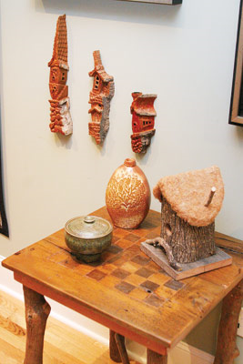
Craft, architecture and design enthusiasts take note: On Friday, June 25 and Saturday, June 26, the N.C. Arboretum is hosting an event you likely won't want to miss. Handmade in America presents the Western North Carolina Craft, Architecture and Design Expo, a two-day event that project manager Barbara Benisch says is an opportunity to bring the public face to face with local artisans and their handiwork — facilitating what she hopes will be fruitful connections.
Hand in hand: Expect to see a showcase of interiors to spark the imagination at the HandMade in America expo at the NC Arboretum this weekend Photo by Jonathan Welch
"One of the goals of Handmade in America is to help build economic opportunities for artists and craftspeople who live in Western North Carolina," says Benisch.
This isn't your typical expo, with poorly lit rows of salespeople hawking mass-produced trinkets. Expect to see a showcase of interiors to spark the imagination —all the elements handcrafted locally, and displayed with rather unprecedented attention to detail.
Experts have professionally designed 23 different intimate spaces, furnishing them entirely with local handiwork, allowing each space to reflect the "integration of the craft," says Benisch. Five of these designs are outdoor spaces, and six are created by teams led by local architects.
These well-planned environments include dining rooms, an outdoor living room, a library, and others. "There's a huge diversity of the types of things that are available to see," says Benisch. "We're talking about architectural elements like tile back splashes, iron railings, metal light fixtures, et cetera, as well as the design elements that people would think of ... textiles, ceramics, floor coverings, that sort of thing." The idea, she says, is to show that decorating with handcrafted items can create both meaningful detail, and transform a space into a unique environment.
More than 250 artists and designers are involved in making the design expo a reality, says Benisch. "People will have a lot of opportunity to see a lot of different work from a lot of different artists. We're asking all the participants — the architects, artists, landscape architects — to be on site. Part of what we want people to do is to meet them and talk about the process and make those connections."
Facilitating the connection between the customer and the craftsperson, after all, helps drive home the intrinsic value of that handmade object — one of the goals of HandMade in America. "We're interested in bringing people together — people who are actually working in the field, bringing them together with the general public to help people understand the value and potential impact of using handcrafted objects in your home," says Benisch.
She adds that those connections help foster economic sustainability. "The artists live and work in this region, so the money that you spend on objects that are made by an artist that lives here stays in the community. It also is sustainable in terms of having lasting value. Handcrafted objects last longer and have more meaning ... and they tend to be passed down through families."
Benisch adds that all of the contributors to the project are working on a volunteer basis, and all materials used are donated. "There's a huge amount of generosity that's going into this. People have just exceeded our expectations in terms of the quality of the work and the extent to which they're creating amazing spaces."
The HandMade in America Western North Carolina Craft, Architecture and Design Expo takes place on Friday, June 25 and Saturday June 26 at the North Carolina Arboretum. The expo will include a variety of workshops and presentations, both for the consumer and craftsperson. Visit designexpo.handmadeinamerica.org for more information.
Mackensy Lunsford can be reached at mlunsford@mountainx.com.

