♦Audience♦

This program is for all health professionals.

♦Objectives♦

At the completion of this program, the participant will be able to:
- Discuss new approaches in the treatment of colorectal and breast cancers.
- Identify palliative care resources available to Alaska Native patients
- Discuss management of psychiatric concerns of cancer patients
- Discuss evaluation and management of thyroid nodules
- Discuss new approaches in management of thyroid disease

♦Speakers♦
Mayo Clinic Staff:
Steven Alberts, MD, Medical Oncology
Joleen Hubbard, MD, Medical Oncology
Randy Marks, MD, Medical Oncology
Sandhya Pruthi, MD, Internal Medicine
Myra Wick, MD, Gynecology
Bruce Sutor, MD, Psychiatry
Matthew Clark, PhD, LP, Psychiatry
Michael Bostwick, MD, Psychiatry
Mark Frye, MD, Psychiatry
Keith Swetz, MD, Internal Medicine
Rajiv Pruthi, MD, Hematology
Gerald Malagrino, Center for Innovation
Bryan McIver, ChB, PhD, Endocrinology
Melanie Richards, MD, General Surgery
Keith Bible, MD, PhD, Medical Oncology
Robert Foote, MD, Radiation Oncology

Anchorage Presenters:
Matthew Olnes, MD, ANMC, Oncology Clinic
Janet Kelly, MS, MPH, ANTHC Alaska Native Epidemiology Center
Christine DeCourtney, MPA, ANTHC Cancer Program
Molly Southworth, MD, SCF, Internal Medicine
Cynthia Roleff, RN, BSN, ANTHC, AFHCAN

♦Program Schedule♦

Monday – July 23, 2012
7:30-8:00 | Registration and continental breakfast
8:00-8:10 | Introductions and Overview of Program
8:10-8:30 | Colorectal Cancer in Alaska Native People
8:30-9:00  9:00-9:30 | Management of High Risk Stage II Colon Cancer  Later-lines of Therapy for Metastatic Colorectal Cancer
9:30-10:00 | Medical Therapies for Advanced Stage Nonsmall Cell Lung Cancer
10:00-10:15 | Break
10:15-10:45 | Management of Women at Increased Risk of Breast Cancer
10:45-11:15 | Familial Breast Cancer
11:15-11:45 | Medical management of Psychiatric Complaints
11:45-12:45  12:45- 1:45 | Lunch provided  Management of Mental Health Issues in Cancer Patients –  An open Discussion Session
1:45-2:15 | Management of Addiction /Mood Disorders in Patients with Cancer
2:15-2:45 | Recent Advances in Palliative Care
2:45-3:15 | Prevention and Management of Venous Thromboembolism
3:15-3:45  3:45-4:15  4:15-4:45  4:45 | Palliative programs for Alaska Native People  Remote Approaches to management of Patients in Alaska  Remote Approaches to Management of Patients at Mayo  Adjourn

Tuesday – July 24, 2012
7:30-8:00  8:00-8:05  8:05-8:35 |  | Registration and continental breakfast  Introduction and Overview of Program  Evaluation of Thyroid Nodule: Ultrasound, Biopsy & Markers
8:35-9:00  9:00-9:15  9:15-9:30 |  | Management of “Indeterminate” Thyroid Nodule  Panel Q & A  Thyroid Cancer 101: Origins and Histologies  Surgery for Differentiated Thyroid Cancer
9:30-9:45  9:45 -10:15 |  | Adjuvant Therapy for Differentiated Thyroid Cancer  Surveillance and Monitoring Strategies
10:15-10:30 |  | Panel Q & A  Break
10:30 -10:45 |  | Surgical Management of Invasive and Recurrent Disease
10:45-11:00 |  | Radiotherapy for Residual, Recurrent and Metastatic Disease
11:00-11:15  11:15-12:00 |  | Advances in Systemic Therapy for Thyroid Cancers  Case presentation and Q & A
12:00 |  | Adjourn
♦Registration♦

Early Registration (by June 30):

ANTHC & SCF Employees: No charge

All others: $75

Late Registration (after June 30): $100

Please complete this form and mail or fax to:
Edna Hull
Alaska Native Medical Center / ANC-HED
4315 Diplomacy Drive
Anchorage, AK 99508
Phone: (907) 729-2930
FAX: (907) 729-2938

Name

Address

City Zip ________

Daytime Phone (_____)

Work affiliation

♦ACCREDITATION♦
Physicians:
Alaska Native Medical Center is accredited as a sponsor and provider of continuing medical education for physicians by the Alaska State Medical Association.
ANMC designates this live activity for a maximum of 11 AMA PRA Category 1 Credit(s) ™. Physicians should only claim credit commensurate with the extent of participation in the activity.

Nurses:
Alaska Native Medical Center is an approved provider of continuing nursing education by the Montana Nurses Association, an accredited approver by the American Nurses Credentialing Center’s Commission on Accreditation.
ANMC designates this activity as meeting the criteria for one nursing contact hour credit for each hour of participation up to a maximum of 11 hour(s). Each participant should only claim credit commensurate with the extent of participation in the activity.

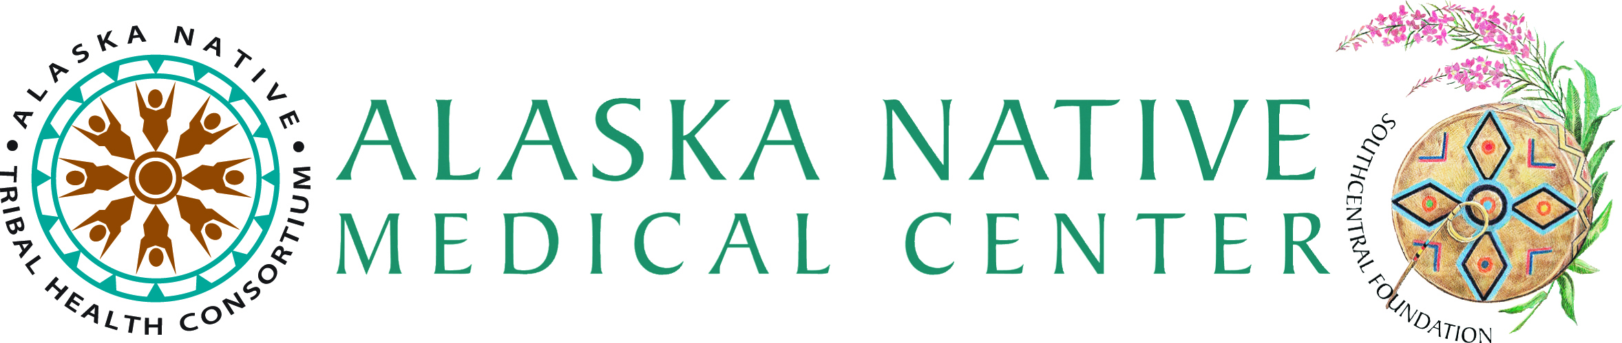

2012 Mayo Clinic

& ANMC Cancer Conference

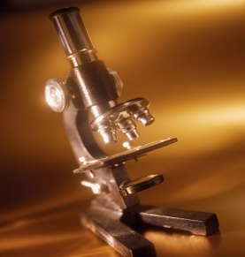

July 23-24, 2012

Alaska Native Medical Center
Hospital Conference Rooms 1 and 2
4315 Diplomacy Drive
Anchorage, AK 99508

