|  |  |
| --- | --- |
| ADP black logo (No Taglines).eps |  |
| Dealer Services | User Guide |
|  | ADP CRM Integration for CTWizard e |
|  |  |

These materials are the property of The Dealer Services Group of ADP, Inc. and are licensed to you for the sole purpose of giving necessary instructions in proper operation of the system. All these materials must be returned to ADP at its request. Any other use or application of these materials and the information contained herein is unauthorized and not endorsed by The Dealer Services Group of ADP, Inc. Printed material is registered by individual customer. There will be a $50 charge for every such assigned copy that cannot be recovered from the customer in its entirety originally as issued, and returned to The Dealer Services Group of ADP, Inc. upon request.

© 2013 The Dealer Services Group of ADP, Inc. All rights reserved, including translation in the United States of America, as well as in Canada and other countries of the International Copyright Union. All rights reserved under Pan-American Copyright Conventions and under the Universal Copyright Convention. No part of these materials may be reproduced, translated, or appropriated in any form or by any means (including electronic, mechanical, or other, such as photocopying, recording, or any information storage and retrieval system) without permission in writing from the publisher. Inquiries should be addressed to:

|  |  |
| --- | --- |
| ADP, Inc.  Dealer Services Group  1950 Hassell Rd.  Hoffman Estates, Illinois, USA 60169-6308  847.397.1700 | ADP Dealer Service Deutschland GmbH  ADP Strasse 1  D - 42489 Wülfrath  Tel: +49 (0) 20 58 902 00 |
| ADP Dealer Services Ontario  1210 Sheppard Ave E  6th Floor  North York, (ON) Canada  M2K 1E3  416.498.3700 | ADP Dealer Service UK  Charnham Park  Hungerford  Berkshire  RG17 0YL  Tel: +44 (0)1488 662662 |

Toll-free orders:

Guides and quick-reference cards 877.646.8282

Bulletins 800.669.7706 option #1

Forms and Supplies 800.ADP.ADP.ADP in U.S.A.

877.847.9276 in Canada

The ADP logo is a registered trademark of ADP, Inc.

Printed in Canada

Table of Contents

Chapter 1 Introduction 1

Minimum Requirements 1

Chapter 2 Using ADP CRM in CTWe 3

Send a New/Updated Lead to ADP CRM 3

Assign a Lead to a Salesperson 5

Open a New ADP CRM Lead in CTWe 7

Lead Updates from ADP CRM in CTWe 9

Access ADP CRM Settings 10

Appendix A Frequently Asked Questions 11

Appendix B ADP CRM 4.7B 13

ADP CRM 4.7B Release Notes 13

Appendix C Client Documentation 14

New DealerSuite Users 15

To Register by Telephone 15

To Register Online 15

If You Need Help with DealerSuite 15

Chapter 1 Introduction

ADP is pleased to offer CTWe ADP CRM Integration to our CTWe clients.

This integration provides the following features:

* CTWe users can send new leads, updates, and sold deal information to ADP CRM for follow-up purposes
* CTWe can receive new leads and updates from ADP CRM for quote creation
* CTWe will automatically assign an ADP CRM lead to the appropriate salesperson and create a quote in CTWe when the employee ID/number is the same in both systems
* CTWe managers can assign unassigned leads to the appropriate salespeople
* If CTWe receives an ADP CRM lead that contains a vehicle with a stock number, CTWe will select it when the user opens the lead
* If CTWe receives an ADP CRM lead that contains a vehicle without a stock number, CTWe will display the information so that the user knows which vehicle to select in the inventory module
* When CTWe receives an ADP CRM lead that contains vehicle trade-in information, CTWe will populate the “trade-in” window with that information when the user opens the quote

## Minimum Requirements

In order for the CTWe ADP CRM add-on to work at your dealership, your CTWe server needs to meet the following requirements.

* Windows 2003 or higher (Pro, Business, Ultimate) must be installed. If your server does not meet this minimum requirement AND you wish to send leads and updates between CTWe and ADP CRM, you need to contact your dealership system administrator and request a Windows upgrade.
* CTWe version 1.0 (or higher)
* ADP CRM version 4.7b
* ADP CRM needs to be activated in the CTWe Setting Explorer

Chapter 2 Using ADP CRM in CTWe

This chapter explains how to send leads to ADP CRM from CTWe, and also how to accept leads from CRM into CTWe.

## Send a New/Updated Lead to ADP CRM

To send a quote from CTWe to ADP CRM, follow the steps below:

1. In the Showroom Explorer, select the lead you wish to send to ADP CRM.
2. In the Showroom Explorer's ribbon, click the **CRM** tab. Then click the **Send Quote** button to send the lead to ADP CRM.
3. When ADP CRM successfully receives the new CTWe lead, their system sends an acknowledgment to CTWe. As a result, "CRM:" followed by a reference number, displays in the ADP CRM column for that lead. See screenshot below.

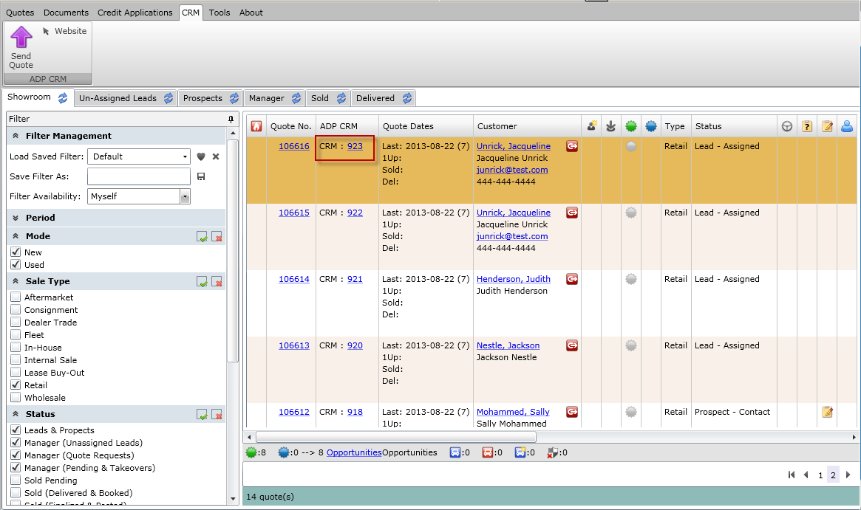

**Note.** A "CRM: ERROR" link in the ADP CRM column means there was a problem with the quote. This ERROR message is clickable and will show more detail about the error.

1. You can also click the **Website** button in the CRM tab. This will bring you directly to the ADP CRM website.
2. To **update a lead**, you can simply make changes to the lead, highlight it in Showroom Explorer, and click the **Send Quote** button in the CRM tab again. This will update the lead in ADP CRM.

**Note.** If your ADP CRM interface **isn't activated**, you will see an error message like the one below:

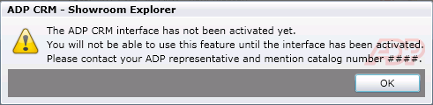

**Note.** You cannot send a converted deal to CRM. If you do try to do this, you will see an error message like the one below:

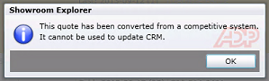

### Assign a Lead to a Salesperson

As a manager, if you find unassigned leads in the Showroom Explorer, you can assign each one to a salesperson.

1. Open the Showroom Explorer.
2. Click the **Un-Assigned Leads** tab.
3. Click the **Refresh** icon on the Un-Assigned Leads tab to view the leads that have not been assigned to a salesperson.
4. Select a lead or multiple leads, and then click the **Sales Team** button. The Sales Team window will display:

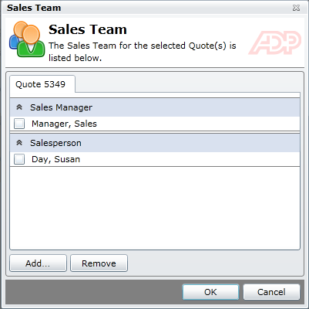

Figure 1: Sales Team window – single quote tab

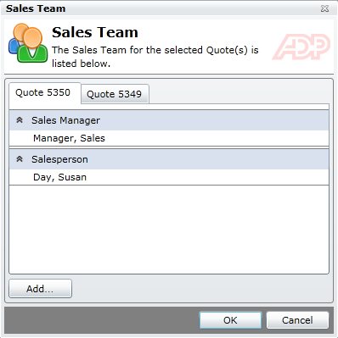

Figure 2: Figure 1: Sales Team window – multiple quote tabs

**Note.** You can also remove salesperson(s) from the Sales Team, but only if you select a single lead (not multiple leads).

1. To assign a salesperson to the Sales Team, click **Add** to open the Employee Selection window.
2. To add a salesperson to the Sales Team, select the check mark next to their name. You need to select an employee that has a role of Salesperson. You may need to open the Role drop-down to view the secondary roles assigned to an employee.
3. Click **OK** twice to save the changes to the Sales Team.

## Open a New ADP CRM Lead in CTWe

Leads from ADP CRM will automatically appear in the Showroom Explorer with a "CRM" label in the ADP CRM column.

Each NEW lead that ADP CRM sends to CTWe should contain an employee number. CTWe will try to match the employee number from ADP CRM with an existing employee ID in CTWe. If a match is found, CTWe automatically creates a quote and assigns it to the appropriate salesperson. If a match is not found, CTWe creates a quote and labels it as "Unassigned".

1. Refresh Showroom Explorer to check for a CRM lead. You will recognize a lead from CRM with a "CRM" label in the ADP CRM column (see screenshot below).



Figure 3

1. Click the Quote No. to open the lead and make the appropriate changes to it that will turn the lead into a prospect.

At this point, one of the following things will occur:

#### If a Stock # is Received

1. If a stock # is received, CTWe opens the Quote Card with the vehicle already selected.
2. Check the status of the vehicle. If the vehicle status is not *available*, pick a different vehicle. Proceed to Step 3.

#### If a Stock # is not Received

If a stock # is not received, a label displays at the top of Inventory Explorer with a vehicle description from ADP CRM.



Figure 4.

1. Open the quote and click **Replace Vehicle** (see screenshot below).

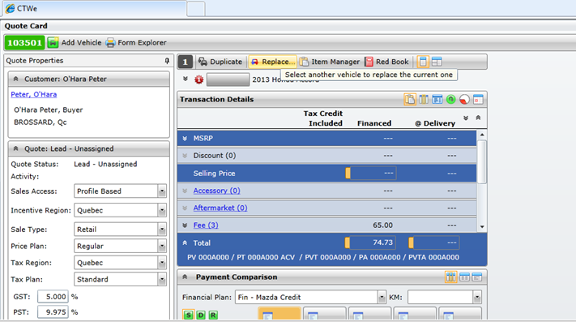

Figure 5: Click Replace Vehicle to add a vehicle that closely resembles the lead received from CRM

1. Select a vehicle that closely resembles the one included in the lead received from ADP CRM. You can either choose an existing vehicle from your inventory or add a new vehicle if necessary. Proceed to Step 3.
2. Click **OK** to add the vehicle to the quote. The quote opens automatically.
3. Continue working with the deal as you normally would.

### Lead Updates from ADP CRM in CTWe

**Note:** Updates in CRM coming over into CTWe will not take effect automatically. They will need to be triggered manually using the Lead Update Card.

1. To update a lead from CRM to CTWe, click the **CRM ID** hyperlink of the lead you want to update.
2. The Lead Update Card will display (see screenshot below):

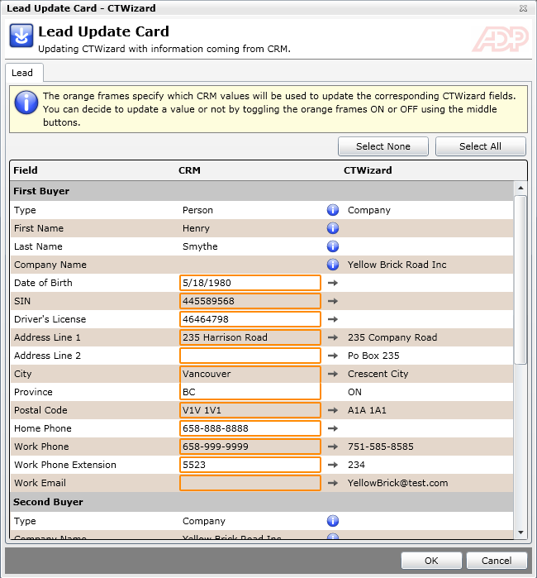

1. From this screen you can decide what information you want to update. The data inside the orange frames is what will be retained by CTWe. If there are fields that you do not want to update in CTWe, you can click the arrow button. This will remove the orange frame off that particular field.
2. When you are done, click **OK** to save your changes.

## Access ADP CRM Settings

To adjust the ADP CRM settings, the dealer administrator should follow the steps below:

1. From the CTWe Main Menu, click the **Setting Explorer** link.
2. The Setting Explorer will display. From the folder tree on the left-hand side, go to System – Integrated Systems – CRM – ADP CRM. You will see a screen similar to the one below:

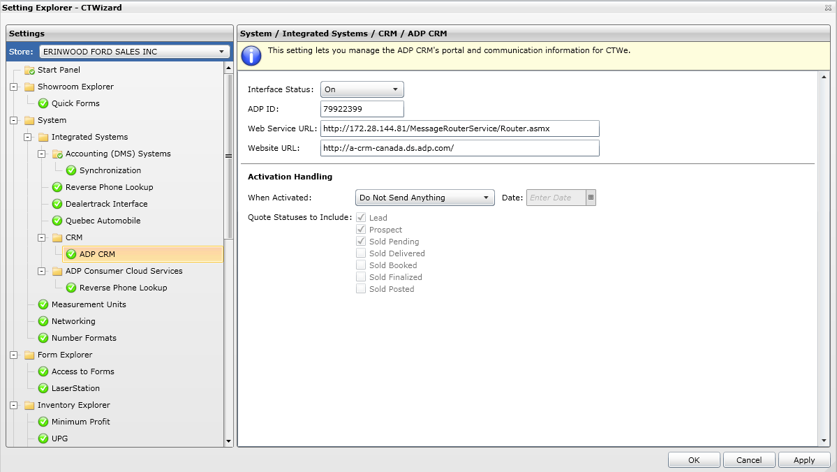

Figure 6. ADP CRM Settings

1. Do not touch the first section ("Interface Status" etc.,) – just ensure that the Interface Status is **On** so that ADP CRM is activated.
2. Click **OK** to save your changes in the Setting Explorer.

Appendix A Frequently Asked Questions

This appendix answers some frequently asked questions for ADP CRM integration with CTWe.

Occasionally, the sold follow-up information that appears in ADP CRM may not match what you see in CTWe. This can be caused by a variety of conditions.

#### How Soon After the Install Can the Dealer Expect to See CTWe Sold Deal Information in ADP CRM?

Since the CTWe ADP CRM Integration program is installed during dealership business hours, and ADP CRM runs a nightly maintenance routine that pulls CTWe sold deal data, the dealer can expect to see sold deal information in ADP CRM the day after the integration program is installed.

#### What Type of Information Shows up in ADP CRM?

The CTWe deal data that shows up in ADP CRM includes customer, vehicle, deal, trade, and profit type information that IS CONTAINED IN A SOLD DEAL.

#### What Are Some of the Common Reasons for CTWe Information Not Appearing in the ADP CRM Application?

* The deal was booked AFTER ADP CRM ran their most recent nightly maintenance routine. The deal should appear in ADP CRM the following day.
* The deal was not booked
* The deal does not have a delivery date
* The deal was not marked as delivered (the Delivered button was not selected)
* The system encountered an error message when the deal was booked
* The user cancelled the customer update
* The user cancelled the vehicle update

Appendix B ADP CRM 4.7B

You need to have ADP CRM 4.7B or higher running for ADP CRM integration to work on CTWe.

If you are responsible for ADP CRM setups, see the *ADP CRM 4.7B Release Notes* for details on how to set up this feature.

You will find the information you require on the Client Document Library on the *adpdealerservices.ca* web site. See Appendix C for instructions on how to access the Client Document Library.

## ADP CRM 4.7B Release Notes

In addition to the online help that is available from the Help menu in the ADP CRM application, you can also access a variety of how-to cheat sheets that show you how to use the new 4.7 enhancements from the ADP CRM Release Notes window. You’ll see this window the very first time you log in to ADP CRM 4.7. Later, you can access it from the Help menu:

1. On the Menu bar in ADP CRM, select **Help > About > Release Notes** link.
2. When the Release Notes window opens, click **Learn More** beneath any heading to open a cheat sheet or other job aide for that heading.

For example, look for the heading, **New CTWizard Integration for Canadian Dealerships** for more information on how the integration works between ADP CRM and CTWe.

Appendix C Client Documentation

To ensure that all of the information you need to run ADP applications is readily available, ADP provides print-format documents in the searchable Client Document Library at adpdealerservices.ca in Canada.

To access the Client Document Library:

1. Visit us at adpdealerservices.ca in Canada.
2. Click on **Support** and then click **Documentation** on the left.
3. Click **Access Documentation**.
4. Enter your DealerSuite ID and password, and click **Login**.
5. When the Client Document Library page displays, use the ADP Document Search or the Client Document Library list to locate the documents you need.

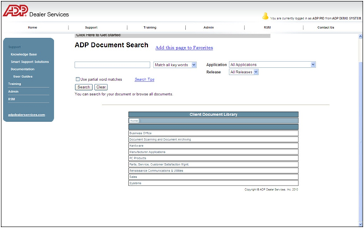

Figure 7.

## New DealerSuite Users

If you do not have an ID and password, you will need to create a new account. You can do this by telephone or online.

### To Register by Telephone

Call DealerSuite Support at 877.483.9171, option 3.

### To Register Online

1. If you do not know the CMF number for your dealership, obtain it from your dealership system administrator or contact ADP at 1.877.483.9171, option 3.
2. Go to [www.adpdealerservices.com](http://www.adpdealerservices.com).
3. In the upper-right corner of the page, click the **Member Login** button.
4. Under New Users, click the **Register Now** button.
5. Read the Disclosure Statement, and click **I accept**.
6. Follow the on-screen prompts and instructions to complete and submit your registration.

When you submit your registration, access to DealerSuite is effective immediately. This login provides access to your approved applications and to the Training/Learning Management System. If you also need access to Support Solutions, contact your dealership system administrator for authorization.

## If You Need Help with DealerSuite

Call DealerSuite Support at 1.877.483.9171, option 3.