20th Annual Dry Heat Classic ▪ July 20,, 21, & 22, 2017 Point Hilton Tapatio Cliffs Resort | All proceeds from the Dry Heat Classic go directly to support various at-need Phoenix Valley charities.  Every member of the executive staff proudly serve uncompensated, furthering an 20 year tradition of selfless funding raising and service to our community.  We thank you for your donation and provide our steadfast promise to ensure ALL funds raised are placed where they are needed most.  Please visit: www.DryHeatClassic.com, for details.
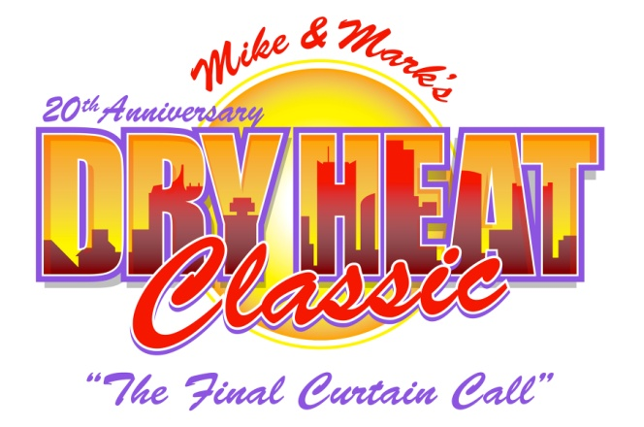
Auction Donation Form
Yes! We want to contribute the following auction item(s)

This donor form must accompany all donations. Accompanying brochures and other collateral welcome. All donations must have a minimum value of $25.00 and include a value and expiration date. (Note: Please make sure your expiration date coincides with the date of our auction, i.e. good from 7/22/2017 to 7/22/2018). Deadline for receipt of gifts is June 19, 2017.

Item: Value $ Exp:
Item: Value $ Exp:
Item: Value $ Exp:
Item: Value $ Exp:
Please Check One:
Certificate or voucher is included or in the mail.
Item CANNOT be mailed. A member of the Auction Committee may contact me for pick-up arrangements - Phone: .
I would like to make a cash donation in the amount of $ to be used to purchase gift cards or enhance packages (choose a method below):
A check is enclosed (Please make checks payable to Michael Finney Foundation)
Please charge $ to MasterCard ∙ VISA ∙ AMEX
Account # Exp. Date: V Code:
Address: City: State: Zip:
Phone: Name on Card (please print):
Signature: Date:

Please Return This Form and Certificate(s) to: Annual Dry Heat Classic ▪ 7220 W. Melinda Lane ▪ Glendale AZ 85308
P (623) 581-2537 ▪ F (623)-376-6547 ▪ email: FinneyGolf@aol.com ▪ website: www.dryheatclassic.org
The Michael Finney Foundation is a 501c3 #86-0954575 Organization
Thank You For Your Generosity and Support!

