About Dr. Ritamarie Loscalzo, MS, DC, CCN, DACBN
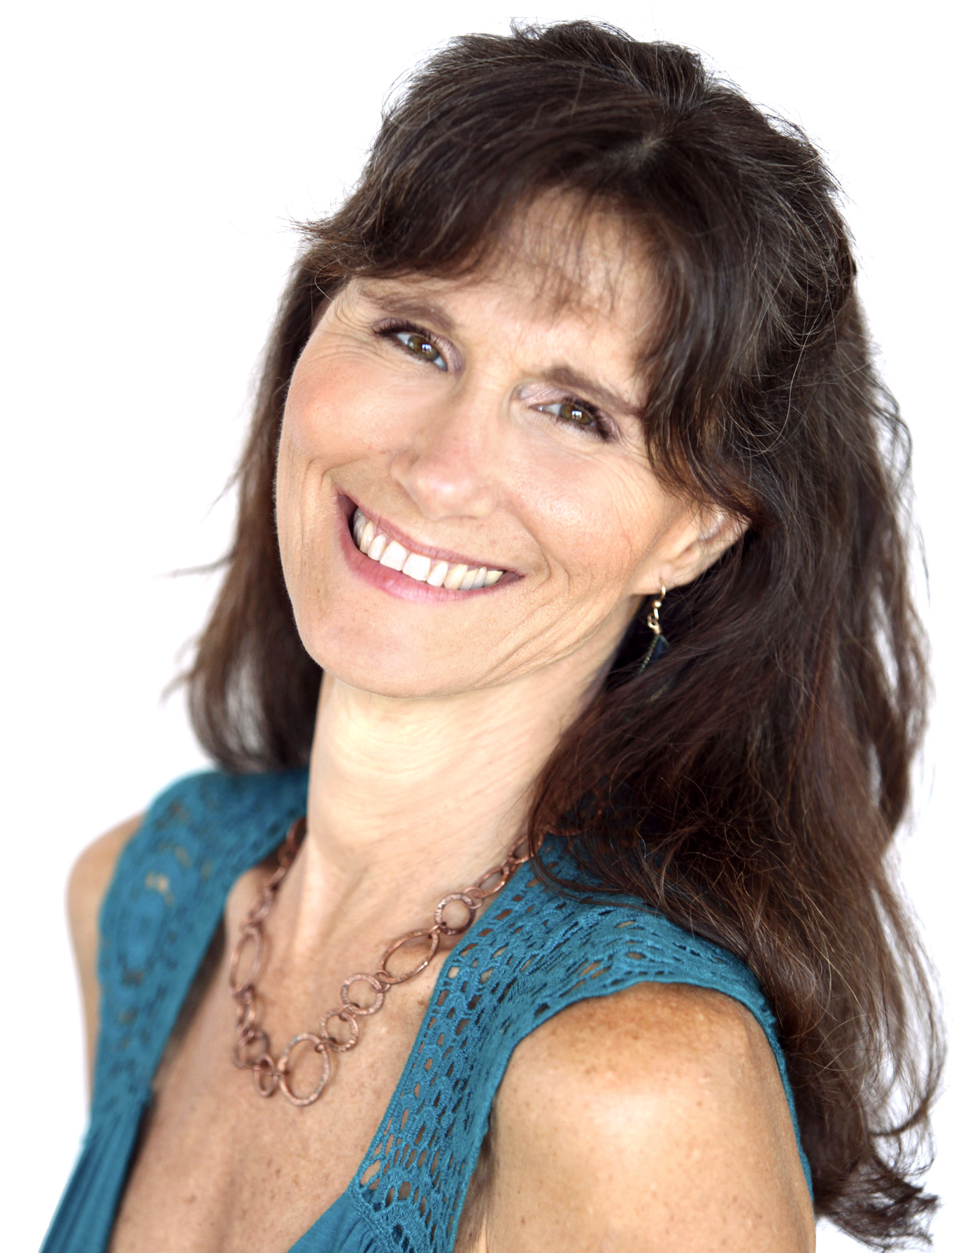
Dr. Ritamarie Loscalzo is fiercely committed to transforming exhausted high achievers all over the globe into high energy people who love their lives and live to their full potential.
A bestselling author, speaker, and internationally recognized nutrition and women’s health authority, Dr. Ritamarie combines the ancient healing wisdom of whole fresh foods and herbs with modern scientific research to inspire people everywhere to recharge their energy and reclaim their lives.
To learn more and get started on 7 Simple Strategies to Jumpstart Your Energy Practically Overnight, visit www.JumpstartYourEnergy.com or access Dr. Ritamarie’s extensive collection of vibrant living health resources at www.DrRitamarie.com.

