Building community spirit through recreation. 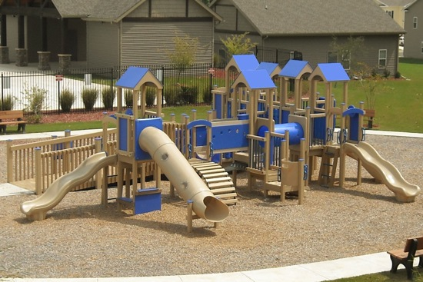 (proposed large playground area)

Sponsorship Levels
Sponsorship Amount | Recognition Example
$25,000 +  (limit 2) | Logo on, trailhead, large tot lot, pavilion
$10,000+  (limit 2) | Logo on small tot lot or swings
$5,000  (limit 5) | Logo banner on the baseball field
$2,500  (limit 6) | Logo on dugout/bleacher/  Other equipment
$1,000  Unlimited | Listing on recognition sign level 1 or picnic bench
$500  Unlimited | Listing on recognition sign level 2 or park bench
$250  30 available | Sponsor a tree
$100  Unlimited | Listing on recognition sign level 3

We are also accepting in-kind donations of labor from qualified professionals. Please contact the borough office to arrange for your donation of labor.

Please make checks payable to Richlandtown Parks and Recreation and they will be gratefully accepted at the Richlandtown Borough Office or remit your form with donation to:
Richlandtown Borough
PO Box 455
Richlandtown, PA 18955

I would like make a contribution to the Benner Hall Playground Fund. Please accept my donation of:
$____________
Name____________________________________
Address__________________________________ _________________________________________
E-mail_____________________
Telephone__________________
Name as you wish it to appear on the plaque or equipment _________________________________
Sponsored equipment Preference (not guaranteed until discussed)______________________________
Or I prefer to remain anonymous________

Signature______________________________
Date____________

Richlandtown Borough
Tel: 215-538-9290

Benner Hall

Playground Fund
Benner Hall Playground Fund

What is the Fund?
The Benner Hall Playground Fund began in the fall of 2009. The fund is a subset of the Richlandtown Parks and Recreation Board, an all volunteer group that has been working tirelessly for the past three years to restore and improve the community center Benner Hall and the park grounds that surround it.
The group is being given the opportunity to use a grant from Bucks County towards improving the park and is raising funds to supplement that grant. Current plans include improved and extended parking, a new ADA accessible playground, complete rehabilitation of the baseball field, basketball courts, and construction of a walking trail through the open acres of land. This trail would ultimately connect Union Street to Cherry Street and create areas for passive recreation, nature watching, and picnicking.
We are offering the opportunity for local businesses and individuals to sponsor the playground, with various levels of recognition available. Please see the enclosed form for your opportunity to give to this recreational facility that will benefit all ages and people in our area.

1260 Cherry Rd
PO Box 455
Richlandtown, PA 18955
Phone: Richlandtown Borough 215-538-9290
fundraising@bennerhall.com
www.bennerhall.com
http://projects.kaboom.org/projects/1487

What Are You Building?
Below is a conceptual site drawing showing the current draft plan. 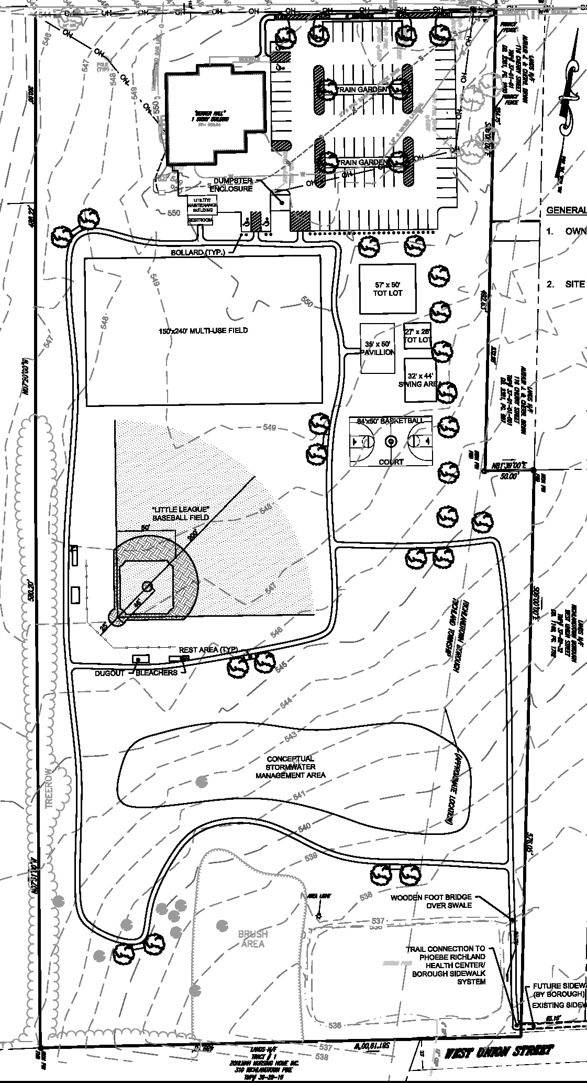

What is the Cost?
The cost of the entire project is estimated to be about $700,000.
It will be funded partially by grants that the Borough has obtained, and partially by grassroots fundraising and in-kind labor. Volunteers have been planning events to benefit the fund and the Parks and Recreation Board is seeking private sponsorships as well.
For your opportunity to sponsor the park as an individual or business, see the form located on the back of this paper.

