Mayfair Memorial Playground

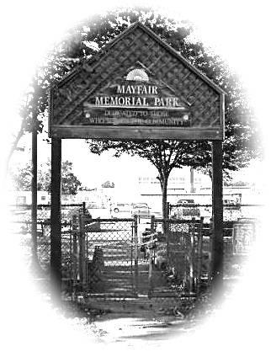

Vista St. & Rowland Ave. (at Lincoln High School )

The Friends of Mayfair Memorial Playground in conjunction with the Mayfair Civic Association, Mayfair Business Association and the Mayfair CDC are trying to rebuild the Mayfair Memorial Playground.
This Playground was previously dedicated to fallen
Fire Fighter John J Redmond

EVERY PENNY HELPS !!

Please give what you can so that OUR kids will have a fun and safe place to play.

Thank You !!

