Rebuild Mayfair Memorial Playground
At Vista & Rowland Avenues (Lincoln High School)

Phone: 267-331-4334
Mailing Address: c/o Mayfair CDC, The Perzel Community Center2990 St. Vincent St.,

Philadelphia, PA 19149
Email: MayfairMemorialPlayground@yahoo.com

December 4, 2009

Dear Mayfair Business:

Please accept this letter as the official request from the Friends of Mayfair Memorial Playground honoring Firefighter John J. Redmond and others that served our community for donations to help us rebuild the Playground. The old equipment was removed by the School District due to deterioration. Our goal is to have brand new equipment in place by the Spring of 2010, including a section for special needs children. We are actively looking for contributions to raise a minimum of $50,000. Please help the children by donating towards this goal. Donations can be sent to Friends of Mayfair Memorial Playground, c/o Mayfair CDC, The Perzel Community Center, 2990 St. Vincent Street, Philadelphia, PA 19149. Make checks payable to Mayfair CDC and write with “Playground” on the memo line.

Mayfair is great place to work and to raise a family and we feel that adding a playground back into the fabric of our community will only strengthen the civic and business communities in our neighborhood. Any help you give is greatly appreciated. Please consider giving in any of the following categories:

Patron $1-$99
Bronze Member $100-$249
Silver Member $250-$499
Gold Member $500 and above

Bronze Members will be included in the program during opening ceremonies of the dedication of the Playground. Silver members will be included in the program and memorialized on the Civic Association Website. Gold Members will be included in the opening program, memorialized on the Civic Association Website and have their names included on the outdoor promotional items used at the opening. Please consider this gift as a gift for neighborhood children and for the future of your community.

Sincerely,

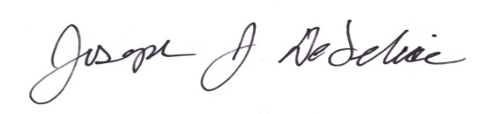
_______________________
Joseph J. DeFelice, Esq.
President, Mayfair Civic Association
Board Member, Mayfair Business Association

