Tiny Tots Development Center
An Early Learning
and Child Care Agency
Seattle, WA
FOR IMMEDIATE RELEASE

Contact information (press only):
Tiny Tots: info@tinytotsdc.org

TINY TOTS DEVELOPMENT CENTER EXPANDS TO NEW BUILDING IN SOUTH SEATTLE
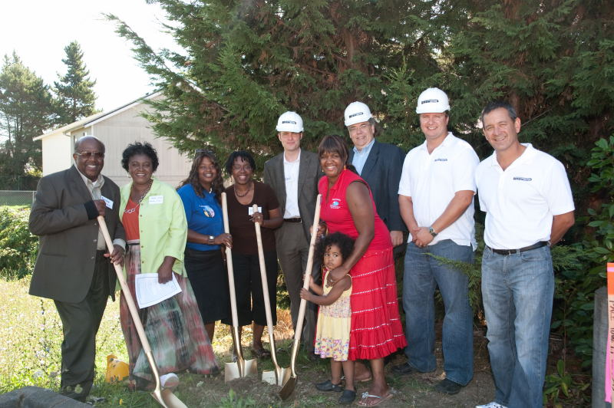

On September 18, 2009, Tiny Tots Development Center (TTDC), a nonprofit organization that provides childcare, after school programs, and early childhood education to South Seattle communities, held a festive groundbreaking ceremony, near its Tiny Tots Main site at 8302 ½ Renton Avenue South, making way for a new, larger education and child care facility.

The new construction effort is the result of a seven-year-long planning and fundraising effort by the TTDC Board of Directors and Mrs. Hicks. Representatives of community organizations, parents, architects, and TTDC staff and supporters attended the groundbreaking ceremony. The address of the new facility will be 8318 Renton Avenue South. Financing for the new Tiny Tots Main building and playground was made possible with assistance from the Rainier Valley Community Development Fund.

Other guests and supporters at the groundbreaking included:
- Bank of America
- City of Seattle Department of Human Services
- Donna Jean Brown, DJB Architects
- Dave Essig, Rainier Valley Community Development Fund
- Superintendent James Hicks, Unity Church of God in Christ
- Charlotte Jahn, State of Washington Department of Early Learning
- Michael Look, Community Development Block Grant Administrator, City of Seattle Human Services
- Eric Pettigrew, State Representative, District 37
- SEACON Construction (Everett, WA)
- State of Washington Early Learning
- Tiny Tots Development Center Board of Directors:
- Tiny Tots Development Center parents and children
- Bishop T. L. Westbrook, and Superintendent Leo C. Brown, Jr., New Jerusalem Church of God in Christ (Tacoma)
- Sandria Woods-Pollard, ECEAP Program, City of Seattle Human Services
…and many other valued friends and supporters of Tiny Tots Development Center.
One of the highlights of the groundbreaking ceremony was a vocal performance by TTDC Health and Family Services Director, Jacqualine Hicks Lenard. Singing an altered version of the Sam Cooke classic A Change is Gonna Come, she saluted Mrs. Hicks’ legacy by opening with revised lyrics: “Mrs. Hicks was born by a river/in a little town in Mississippi/but thanks to the Bank of America and the Rainier Valley Community Development Fund/I know a change is going to come”.

Since 1969, TTDC has provided licensed childcare, after school care, and education services for children from birth to age 12. We serve children and families from a variety of ethnic and economic backgrounds at four sites in South Seattle. Staff & children speak English, Spanish, Somali, Tagalog, Vietnamese, and other languages. TTDC is licensed by the State of Washington and is a City of Seattle Contracted site, an authorized provider of the State’s Early Childhood Education and Assistance Program (ECEAP) and one of the sites selected to provide free pre-school in the City of Seattle’s Step Ahead Preschool Program. These programs deliver comprehensive services to 4 year old children whose families meet income guidelines. In addition, TTDC provides after school learning opportunities through our after school Community Learning Center (CLC) program.

The grand opening date for the new facility has not yet been set, but it is expected to take place in March or April 2010. Print and online announcements about the grand opening are forthcoming. The administration and staff of Tiny Tots look forward to welcoming the community to the opening celebration.

# # #

