EN
ENGLISH 204-001 MODERN WESTERN LITERATURE
Spring 2012, Monday and Wednesday, 12:00-1:15 PM Robinson A245 Lathbury

TEXT
You must use the translations in the Norton anthology or read in the original.

• Lawall, Sarah, general editor. The Norton Anthology of Western Literature, 8th ed. Volume 2. (Be sure you buy the right volume—#2, which contains modern works, the ones that we read in English 204; you can recognize it because it features a self-portrait of Van Gogh on the cover.) New York: W. W. Norton, 2005.

RULES, REMARKS, CROTCHETS

T
his section of English 204 will try to make you a more precise, more imaginative reader and writer; to give you a sense of modern Western culture by having you read some of its texts; to increase your skills as a critical writer about imaginative literature and to intensify your æsthetic appreciation, thus increasing your pleasure in reading.
Each of you will have three five-page essays to write in the course of the semester. These will be staggered, so that not everyone's essay is due on the same subject on the same day. This arrangement is meant to be mutually beneficial: it sometimes takes me a half hour to read and comment on an essay, and I can do a better job if I have only a few to read at once. Moreover, such an arrangement permits more reading to be done through-out the course of a semester, a necessity in a course that meets only twice a week and still attempts to represent as much of history as this one does. Still three days are devoted to discussion of writing; I exhort you not to miss those sessions.
To have the chance of being awarded a passing grade for English 204, you must do all the assignments; you cannot “skip” a written assignment. You must turn in all work and take all in-class writing tests, if any are given, including the final. (2) I exact penalties for late papers; I reduce grades one increment per class missed—e. g., B becomes B- then C+. Please note that the grading system includes pluses and minuses. (3) Under no circumstances will I accept written work after the date for the succeeding written assignment; that is to say, you may not give me two or more papers at once; doing so means that you fail the class. Also you must have picked up your previous essay before giving me the next one. I have more than my convenience in mind; you cannot benefit from comments if you cannot apply them on the next assignment.
You or your parents or spouse are paying $1983 for this course—more if you are an out-of-state student; that means each class costs $73. If you bought an Ipod and found when you arrived home that it did not work, you would demand satisfaction. Get your money's worth by participating and by asking for the aid you need. Read my comments. Argue if you disagree; request an explanation if you don’t understand.
Before class, from 11:00 to 12:00, I will be in my office, A467, upstairs in the main English Department office suite. I have a phone, and you may call me there at 993-1189. Please do not use the general English Department number, as the secretaries are overworked. It is against department rules to fax papers. I have a pigeonhole in the English Department, where you may leave messages for me. Please do not call me at home. My e-mail address is <lathbury@gmu.edu>. E-mail has become an essential part of our lives, but it is easy to spend too much time on it. I will respond to e-mail messages politely, I hope, but not loquaciously, nor will I bother about formatting.
Please turn your cell phone off. I don’t think it’s fair to fail anyone whose cell phone goes off in class, but I will send my boys from the factory around to visit you and your family if it happens.
This course serves a variety of students with a variety of needs. Please tell me if you feel that you are not getting from the class what you need.

SCHEDULE OF ASSIGNMENTS

23 January 2012
First class.
Lecture explaining what constitutes plagiarism—handout.
A history of Western Civilization, from the Sumerians to the Renaissance. This treatment will be somewhat broad.
Some ideas on how to write about literary works; the kinds of essays this course demands.

25 January 2012
Read Tartuffe, Acts I and II.

30 January 2012
Read Tartuffe, Acts III, IV and V.

1 February 2012
Read The Princess of Clèves, Parts I-III.

6 February 2012
Read The Princess of Clèves, Parts IV and V.
Essays due from ______, ______, and ______.

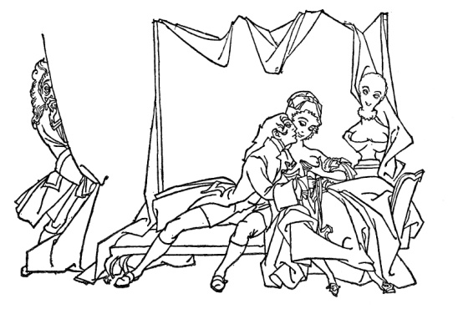
8 February 2012
Read Candide, Chapters 1-15.
Essays due from ______, ______, and ______.

13 February 2012
Read Candide, Chapters 16-30.
Essays due from ______, ______, and ______.

15 February 2012
No reading assignment We will discuss a sample essay in class.

20 February 2012
Read Faust, p. 522-563.
Essays due from _____, _____, and _____.
22 February 2012
Read Faust, p. 563-596.
Essays due from _____, _____, and _____.

27 February 2012
Read Faust, p. 596-623.
Essays due from _____, _____, and _____.

29 February 2012
You will meet without me. I will be in Chicago at a conference.
Read “The Queen of Spades,” p. 801-820.

5 March 2012
Read “The Overcoat,” p. 1008-1033.
Essays due from _____, _____, and _____.

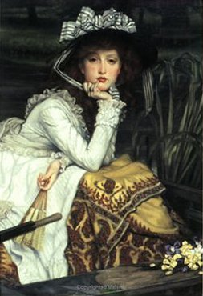

7 March 2012
Read Madame Bovary, Part One. QUIZ.
Essays due from _____, _____, and _____.

19 March 2012
Read Madame Bovary, Part Two. QUIZ.
Essays due from _____, _____, and _____.

21 March 2012
Read Madame Bovary, Part Three. QUIZ.
Essays due from _____, _____, and _____.

26 March 2012
Read “The Death of Ivan Ilych,” I-XII, p. 1330-1368.
Essays due from _____, _____, and _____.

28 March 2012
Read the selections from the writing of Baudelaire, p. 1542-1558.
Essays due from _____, _____, and _____.

2 April 2012
Read Hedda Gabler, Acts One and Two.
Essays due from _____, _____, and _____.

4 April 2012
Read Hedda Gabler, Acts Three and Four.
Essays due from _____, _____, and _____.

9 April 2012
Read The Cherry Orchard, p. 1503-1538.
Essays due from _____, _____, and _____.

11 April 2012
Read “Death in Venice,” Chapters 1-3.
Essays due from _____, _____, and _____.

16 April 2012
Read “Death in Venice,” Chapters 4-5.
Essays due from _____, _____, and _____.

18 April 2012
Read from Remembrance of Things Past, p. 1785-1815.
Essays due from _____, _____, and _____.

23 April 2012
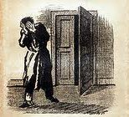
Read “The Metamorphosis,” p. 1966-1999.
Essays due from _____, _____, and _____.

25 April 2012
Read The Good Woman of Setzuan, p. 2116-2169.
Essays due from _____, _____, and _____.

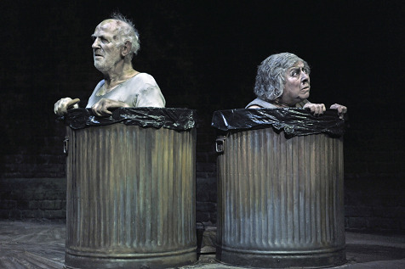

2 May 2012
Read Endgame, p. 2210-2238.
Note final exam.
Essays due from _____, _____, and _____.

14 May 2012
10:30-1:15 PM
FINAL EXAMINATION.
The final exam will consist of two sections:
a. (worth 20 points) 10 objective questions designed to test your recall of the works we have read this session. No books or notes permitted. When you turn that in you will receive part
b. (worth 80 points)—2 essays. One will be a brief explanation of some point or points on one text from the last third of the course. The second essay will be longer and comparative. In both sections of part b, there will be several questions so that you can choose which to answer. On part b, you may use your own books and notes, but not those of a friend. One question will ask you to deal with Endgame.
I will not change the time of the final Don’t ask.

