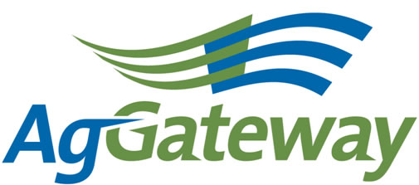

2013 Annual AgGateway Conference

Panel Speaker Application

_____________________________________________________________________

Company Name

____________________________________ _______________ _____ ______

Address City State ZIP

_____________________________________________________________________

Contact person for Company

__________________________ ___________________________________

Phone Email Address

Describe the issue/problem, the solution, and people impacted. Please include why you think this involves collaboration and how this solution facilitated business success.

_____________________________________________________________________

_______________________________________________________________________________________________________________________________________________________________________________________________________________

__________________________________________________________________________________________________________________________________________

_____________________________________________________________________

__________________________________________________________________________________________________________________________________________

_______________________________________________________________________________________________________________________________________________________________________________________________________________

__________________________________________________________________________________________________________________________________________

_____________________________________________________________________

_____________________________________________________________________

Email completed form to sdenty@xsinc.com by May 10, 2013.

