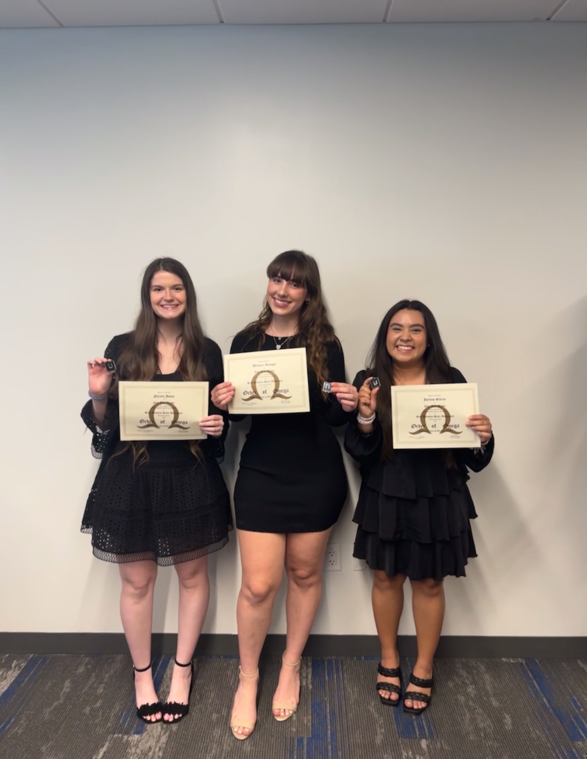

Orb of nega

Orba

Jerine Cas