ACTION PRINCIPLES
Treasure the Earth
We are obligated to
future generations to
protect our world. Clean
air; clean water; green,
open spaces; national
parks; and preservation
of our natural resources are
everyone’s business.
Human beings are dependent creatures.
Each of us must accept responsibility and do our part. Tread softly.
Be mindful of the fragility of our planet.
Bill FitzPatrick is a 5th-Degree Black Belt, holds a Master's Degree in Education and runs the non-profit American Success Institute


Continued on page 3
The only one way to build self-confidence is to experience success, and then being continually challenged to overcome more substantial obstacles.
Your school’s belt or ranking system is one of the unique ways martial arts is able to help you build self-confidence. Being recognized for your advancement with a new belt color makes it easy to track your progress. It also challenges you to expand and perfect your skills, including your physical and character development.
Each rank you earn presents you with new challenges that must be overcome to accomplish the specific requirements of your next rank. Your instructor makes a major contribution to your self-confidence. He or she has the knowledge and skills to help you face challenges that you may think are insurmountable.
He or she will help you set long-term goals to overcome those challenges, and then separate those long-term goals into intermediate and short-term goals. You’ll find it much easier to focus on those smaller goals, until you’ve accomplished the long-term goal.
This is unique to martial arts training and doesn’t exist in virtually any other activity, such as seasonal athletics: baseball, soccer, football, etc. They all have values, such as teamwork and cooperation; however, they also have static sets of skills that team members learn, and then must practice regularly to become more efficient and effective.
In your martial arts class, you develop similar physical skills: kicks, punches, etc., but there is also a constant opportunity to overcome new challenges that not only help perfect the skills you’ve learned, but also teach you new skills. You’ll become more motivated because you’re always learning something new. You’ll also build your self-confidence faster because when you are faced with new challenges, you’ll have the self-confidence to overcome them because you’ve done it before!
Subject Number One Is Self-Confidence
Continued on page 3

Our School is a Proud Member of the National Association of Professional Martial Artists
1
PUBLISHED FOR THE STUDENTS, FRIENDS AND FAMILIES OF THIS MARTIAL ARTS SCHOOL.

September

Welcome to Kickin’ Kid’s Corner, the mind-boggling, brain-teasing section of Kid’s Zone. If you solve this puzzle in one minute or less, you’re a Grandmaster; two minutes, a Master; three minutes, an Advanced Student; four minutes, an Intermediate Student; five minutes, a Beginner Student; six minutes, do 10 sit-ups; seven minutes, do 10 push-ups; or eight or more minutes, do 10 sit-ups and 10 push-ups.

Kid’s
Corner
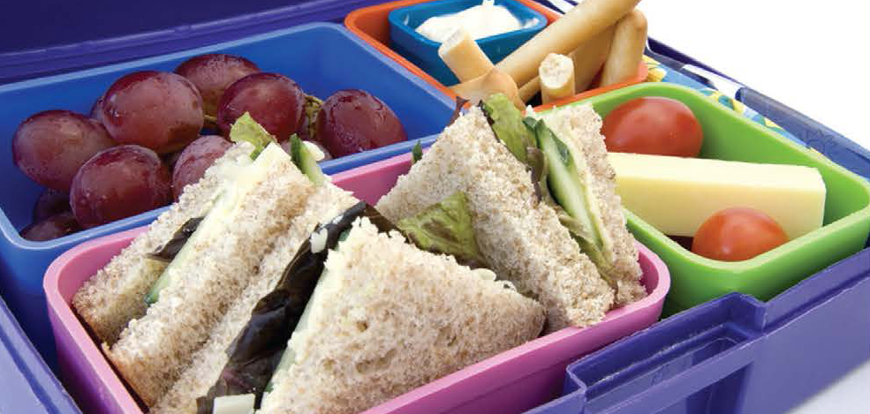
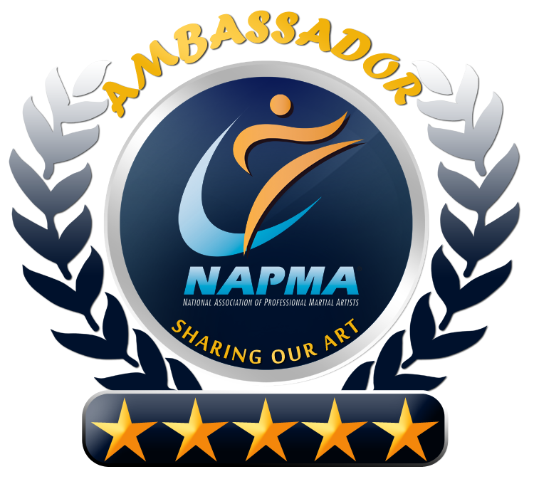
Martial Arts Word Scramble: Here’s how it works. Unscramble the letters to create a word that describes a martial arts training weapon. Write your answer to the immediate right.

Example: A T I A L M R T R A S
Solution: M A R T I A L A R T S

1. K A A M __ __ __ __
2. B T O F A F __ __ __ __ __ __ __
3. C N H U N K U A __ __ __ __ __ __ __ __
4. I S A __ __ __
5. N C A E __ __ __ __
6. F N T O A __ __ __ __ __
7. S T S C I K I R C M A E __ __ __ __ __ __ __ __ __ __ __
8. H R R A G S W T O N I T __ __ __ __ __ __ __ __ __ __ __ __
9. K K B O E N __ __ __ __ __ __
10. W R O D S __ __ __ __ __
Answers: 1.Kama; 2. Bo Staff; 3. Nunchaku; 4. Sai; 5. Cane; 6. Tonfa; 7. Escrima Stick; 8. Throwing Star; 9. Bokken; 10. Sword
Nikki Goeddeke
Age 11
Eating right provides the nutrients to energize children, build strong bones and fight diseases and other conditions. Pay attention to what and how much your kids eat.
Unfortunately, nearly one-fourth of kids’ daily energy intake comes from nibbling on mostly prepackaged snack foods, which are high in calories and low in nutrients.
Young children actually need snacks, since their stomachs are small. They often can’t obtain all the nutrients they need from daily meals. It’s not always easy to persuade your kids to eat healthy snacks and their snacking habits won’t change overnight, but here are a few snack-time tips:
Snacks: Plan Them; Don’t Ban Them!
• Offer your child frozen yogurt or soda crackers instead of ice cream or pretzels.
• Select snacks from a variety of food groups, so your kids won’t be bored.
• “Disguise” fruits and vegetables, such as celery with peanut butter, or carrots with a low-fat dip.
Food Allergies
According to the Food and Drug Administration, as many as six-percent of American children younger than age three have food allergies. For some kids, food allergies can cause only minor discomfort, but for others they can be severe. Try to work with your child’s school to find ways your child can be supervised to prevent contact with allergenic foods. Ask who would treat your child and discuss your child’s allergies with that person, making sure that he or she has the necessary medications and medical information.
Fruit Juice: Friend or Foe?
Although juice does contain some healthy nutrients, it’s high in calories and it may contribute to weight gain and tooth decay if consumed in excess. Some juice drinks, even those with 100% juice, have more calories than sugary carbonated beverages do. Juice also lacks the healthy fiber of whole fruit.
Back-to-School Nutritional Tips
Healthkick


How Martial Arts Has Helped Me I was taught to be a leader, not a follower. Being a leader means to be your own person. You have to be able to stand for what you believe is best for you. Being a leader is also being a strong person and saying “No” to temptations.
I also learned about discipline in karate class. I think with discipline your mind becomes stronger as well as your body. Your mind has to tell your body that you’re able to push a little harder and make that one last kick or that one last punch.
I have also learned about confidence being on the demo team and performing in front of a whole bunch of people that I don’t know.
I was able to complete my performance and, with each demo, my confidence grew too! It was really cool!

Nikki Goeddeke is a student at Tri-Star Martial Arts.

2
Kickin’ Newsletter — for Students, Friends and Families of this Martial Arts School

Results in Their Own Words!

Become an Ambassador!
We are sincerely grateful,
and deeply honored that you
have choose our school and
our program to help you
achieve your personal goals
that those of your family.
Undoubtedly you’ve already
found that our program is SO
much more than just a “sport”
or activity. The character lessons and values we focus on will change your life in such a positive, meaningful and permanent way!
Lots of our students tell us that they have friends, colleagues, co-workers, relatives or the like that they would LOVE to share the benefits of this program with, but aren’t really sure how.
This is where our “Ambassador Program” can help! Just speak to your instructor, and ask them for a couple “Ambassador VIP Passes” that you can share with anyone you think might benefit from our program!
Help us “spread the word” about our program and you can become an “Ambassador” for our school.
Ask Your Instructor for Details About our “Ambassador” Program!

LESSON 2
“He who asks a question is a fool for five minutes; he who does not ask a question remains a fool forever.”

Chinese Proverb
LESSON 3
“Look at all the sentences which seem true and question them.”

David Reisman,
20th-century American social scientist
LESSON 1
“Judge a man by his questions rather than by his answers.”

Francois Voltaire, 18th-century French author
continued from page 1
Questioning
LESSON 4
“The important thing is not to stop questioning.”
Albert Einstein, 20th-century German-Swiss-American mathematical physicist
3
Our School is a Proud Members of the National Association of Professional Martial Artists
Words of the Week
555-555-5555
www.YourSite.com
Caption
Your Logo
Your Photo
«recipient_first_name» «recipient_last_name»
«recipient_street»
«recipient_city», «recipient_state» «recipient_zip»
«sender_school_name»»
«sender_street_address»
«sender_city», «sender_state» «sender_zip»
PLACE
POSTAGE
HERE
4
Kickin’ Newsletter — for Students, Friends and Families of this Martial Arts School

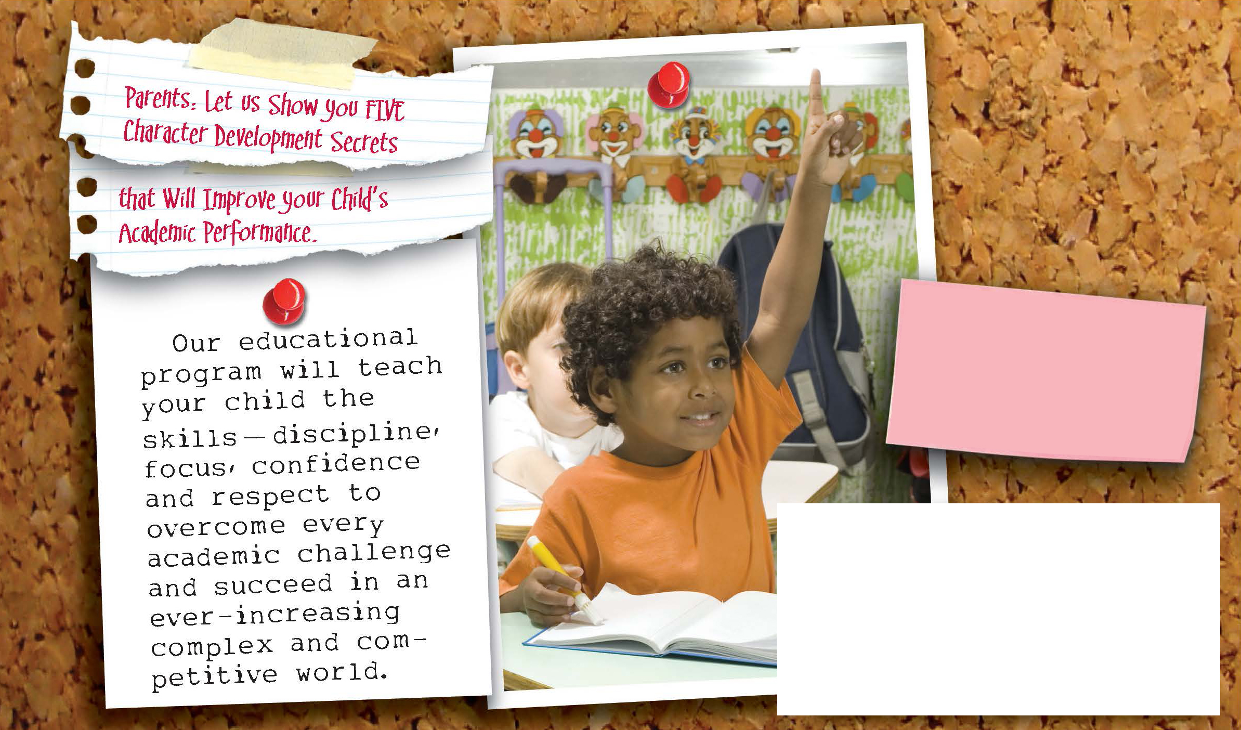

Call our school today to make an appointment for our free beginner’s course
-a$100 value!

Your Logo
See the Results for Yourself, FREE!
- FREE – Introductory Program ($149.00 Value)
- FREE – 1 on 1 Orientation Lessons ($39.00 Value)
- FREE – Official Martial Arts Uniform ($69.00 Value)
- FREE – Information DVD and CD ($29.97 Value)

Call 555-555-5555
Or Visit: www.YourSite.com
Valid for New Enrollments Only, Not in Combination With Any Other Offer. See School Staff for All the Details!

Alternate 3rd Page
You Can Insert Your Calendar of Events, Student(s) of the Month…Whatever!
Go Nuts…..Student’s LOVE to see their “name in lights”!
NAPMA SCHOOL UPDATE

