ACTION PRINCIPLES
Observe and Be Aware
Observation and awareness require conscious effort on your part.
Eventually, they will become
instinctive and valuable skills.
Know where the exits are
when you enter a movie
theater or other public place.
Be aware of your surroundings when you are walking on an unfamiliar street.
Be relaxed, but always ready to protect yourself.
Bill FitzPatrick is a 5th-degree Black Belt, holds a Master’s Degree in Education and runs the non-profit American Success Institute

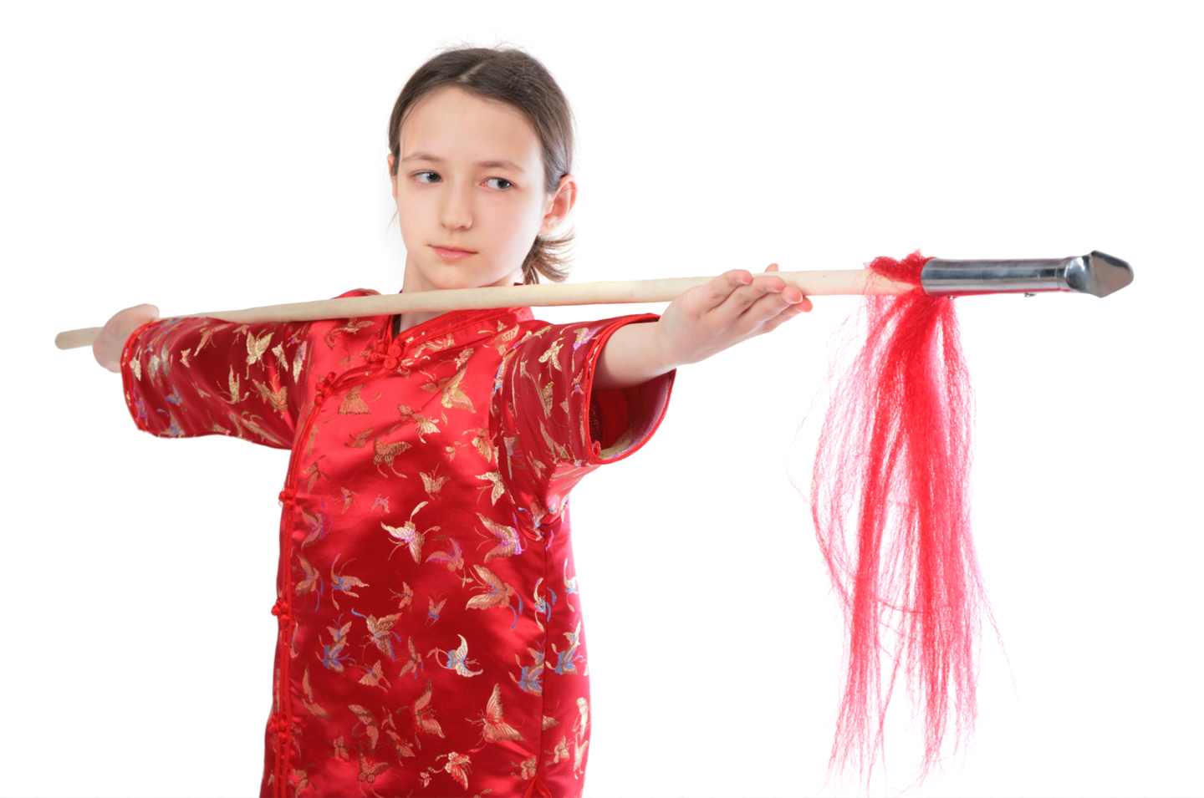
Focus is a skill just like any other, such as writing your name or solving arithmetic problems. Focus is a set of behaviors that you can improve with the right coaching and motivation. As a martial arts student, you’re able to participate in a process that will develop your focus.
The biggest misunderstanding about focus is that it’s a “natural” skill, much like athletic or musical skills. The mistaken thinking is that if you weren’t born with it, you will never be a focused person.
Millions of other martial arts students around the world have proven that to be a false assumption. The ability to focus in your academic and martial arts classrooms, on your homework, chores and martial arts practice can be developed. In other words, you can progress from poor focus to excellent focus skills.
As you grow older, the average attention span for your age group changes. For example, seven minutes is the average attention span of most 6 and 7 year olds. Your martial arts classes are divided into small increments of time that match with your attention span, so you can learn how to focus on the skills specifically for your age group. Your instructor can then reward you and other students as your focus skills improve, one step at a time.
As you become more excited and enthusiastic about your martial arts training and learn to focus on your instructor, using the four skills of concentration, you’ll develop a more positive attitude about the importance of being very focused on all your tasks and responsibilities.
Concentrate on developing your focus skills and you’ll feel great about your progress as a student and a person. You’ll be able to face the biggest challenges and experience greater success today and when you grow to become an adult.
Martial Arts Will Develop Your Focus
Continued on page 3

Our School is a Proud Member of the National Association of Professional Martial Artists
1
PUBLISHED FOR THE STUDENTS, FRIENDS AND FAMILIES OF THIS MARTIAL ARTS SCHOOL.

August

Welcome to Kickin’ Kid’s Corner, the mind-boggling, brain-teasing section of Kid’s Zone. If you solve this puzzle in one minute or less, you’re a Grandmaster; two minutes, a Master; three minutes, an Advanced Student; four minutes, an Intermediate Student; five minutes, a Beginner Student; six minutes, do 10 sit-ups; seven minutes, do 10 push-ups; or eight or more minutes, do 10 sit-ups and 10 push-ups.
Kid’s
Corner

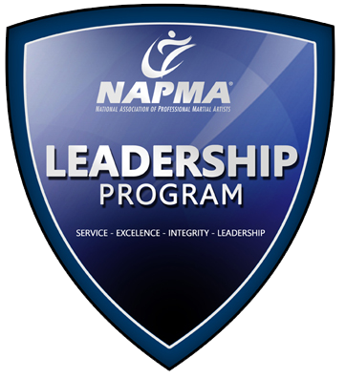
Some Answers: BLAB, BELL, BET, BALL, BACK, ALL, ACT, LACK, LET, LAB, TACK, CALL, CELL, TELL, TALL
Bonus Words: TABLE, CABLE, BLEAT, CLEAT
10…………………………..
11…………………………..
12…………………………..
13…………………………..
14…………………………..
15…………………………..
16…………………………..
17…………………………..
18…………………………..

1…………………………..
2…………………………..
3…………………………..
4…………………………..
5…………………………..
6…………………………..
7…………………………..
8…………………………..
9…………………………..

YOUR WORD IS: BLACK BELT
Martial Arts Word Create: Here’s how it works. Use all the letters in the words B-L-A-C-K B-E-L-T to create as many new words as you’re able. Words that count towards your score must consist of three letters or more. Each word is worth one-half point. You are allowed to use each letter only once in each new word. BONUS: Give yourself a full point for any word created using at least five letters! Example:
MARTIAL ARTS creates words...SMART...RATS...TART.
People throughout the world spend billions of dollars every year on bottled water. It’s the fastest growing drink choice in the United States, according to the Beverage Marketing Corporation. As a martial arts athlete, water is an important component of healthy training—and it’s likely you drink bottled water during class and when you practice at home. That’s why it’s important that you understand the basics about the water you are consuming.
Some people drink bottled water as an alternative to other beverages; others prefer its taste or think it is safer than their tap water. Whether it travels through a pipe to your home or comes packaged in a bottle, safe drinking water is essential to good health.
In the same way that tap water’s taste and quality may vary from place to place, so too does bottled water’s taste and quality vary among, and even within brands.
The taste and quality of both bottled water and tap water depend on the source and quality of the water, including its natural mineral content and how, or if, the water is treated.
To make sure that all water is safe to drink, the U.S. Environmental Protection Agency (EPA) sets standards for tap water provided by public water suppliers, while the U.S. Food and Drug Administration (FDA) sets standards for bottled water, based on EPA standards.
Bottled water and tap water are both safe to drink if they meet these standards, although people with severely weakened immune systems or other specific health conditions may wish to further treat their water at home or purchase high quality bottled water.
Be a smart consumer and read the label on your bottled water. While there is currently no standardized label for bottled water, the label may tell you how the bottled water is treated. Check the label for a toll-free number or Web page address of the company that bottled the water. This may be a source of further information.

Anthony Fulginit
Age 16
Know the Basics of Commercially Bottled Water
Healthkick


How Martial Arts Has Helped Me
To me, martial arts is more than a word or a sport; it's a way of life. I feel the martial arts has made me a better person, physically and mentally.
Most importantly, it gave me respect for myself and for others. Martial arts keeps me alert and aware of my environment.
It has also improved me, physically.
I have more stamina, and I’ve also become more responsive and agile.
I try to set goals for myself to become an even better martial artist and person. Then I rate them on a scale of 1 to 10 and try my hardest and push myself to achieve them. Martial arts has now become a part of me and what I am. I am proud and honored to call myself a martial artist.
Anthony Fulginit is a student at John McGonigle & Johanna Grassia’s Martial Arts Lifestyle Center.
2
Kickin’ Newsletter — for Students, Friends and Families of this Martial Arts School

Results in Their Own Words!

Leadership Skills and More
The value of our
program goes FAR beyond
just “kicking and punching”.
The skills we teach impact
our students lives on a
MUCH deeper level.
Greater confidence, higher
self-esteem and laser sharp focus
are the skills we value in ourselves
and in our leaders.
We specialize in creating the next generation of our communities’ leaders through the National Association of Professional Martial Artists LEADERSHIP Program. This program will teach you the fundamental leadership and communication you’ll need in your career, your school life and in your future.
If you’re interested in exploring the LEADERSHIP program for yourself or member of your family, speak to your instructor in class or call us at the school to see how to qualify!

Humility

LESSON 2
“I have often wished I had time to cultivate modesty...but I am too busy thinking about myself.”
Dame Edith Sitwell, English poet
LESSON 3
“Humility does not mean thinking less of yourself than of other people, nor does it mean having a low opinion of your own gifts. It means freedom from thinking about yourself at all.”
William Temple, a former Archbishop of Canterbury
LESSON 1
“The superior man is modest in his speech, but exceeds in his actions.”

Confucius, 5th Century BCE philosopher
LESSON 4
“It is always the secure who are humble.”
Gilbert Keith Chesterton
English critic, novelist and poet
3
Our School is a Proud Members of the National Association of Professional Martial Artists
Words of the Week
555-555-5555
www.YourSite.com
Caption
Your Logo
Your Photo
«recipient_first_name» «recipient_last_name»
«recipient_street»
«recipient_city», «recipient_state» «recipient_zip»
«sender_school_name»»
«sender_street_address»
«sender_city», «sender_state» «sender_zip»
PLACE
POSTAGE
HERE
4
Kickin’ Newsletter — for Students, Friends and Families of this Martial Arts School

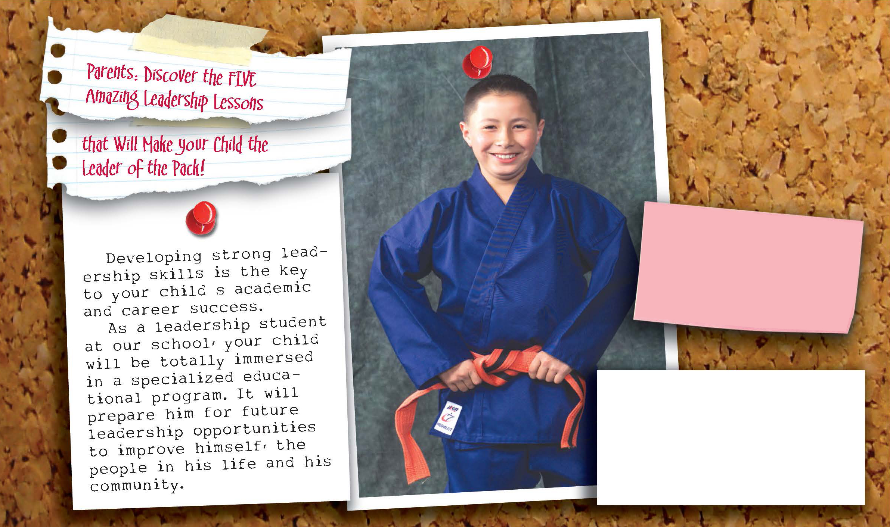

Call our school today to make an appointment for our free beginner’s course-a $100 value!
See the Results for Yourself, FREE!
- FREE – Introductory Program ($149.00 Value)
- FREE – 1 on 1 Orientation Lessons ($39.00 Value)
- FREE – Official Martial Arts Uniform ($69.00 Value)
- FREE – Information DVD and CD ($29.97 Value)

Call 555-555-5555
Or Visit: www.YourSite.com
Valid for New Enrollments Only, Not in Combination With Any Other Offer. See School Staff for All the Details!

Alternate 3rd Page
You Can Insert Your Calendar of Events, Student(s) of the Month…Whatever!
Go Nuts…..Student’s LOVE to see their “name in lights”!
NAPMA SCHOOL UPDATE

