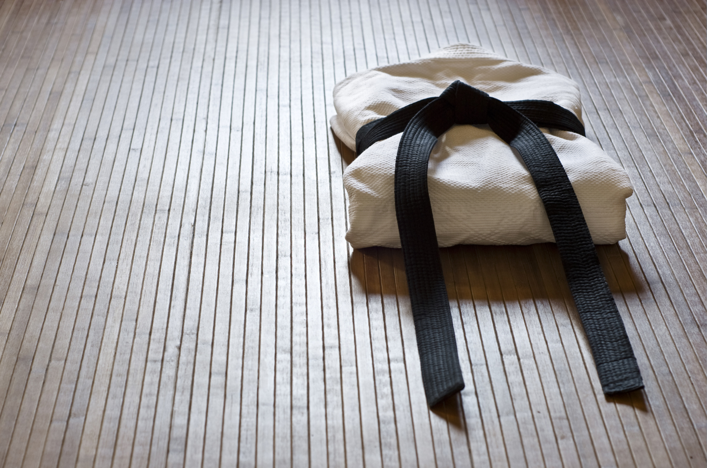
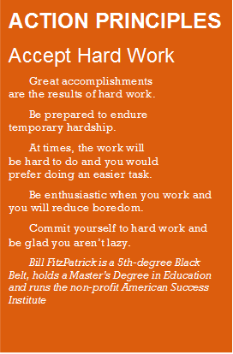
Continued on page 3
ACTION PRINCIPLES
Practice Forgiveness
Anger, hatred,
bitterness, resentment and
revenge are negative
thoughts and reveal
someone unable to forgive.
Allowed to fester, these
bad feelings can consume
too much of your time and energy and become difficult obstacles to overcome.
Liberate yourself.
The forgiving person is always stronger, has a positive attitude and would rather spend their energy to move forward with their lives.
Bill FitzPatrick is a 5th-Degree Black Belt, holds a Master's Degree in Education and runs the non-profit American Success Institute

AII martial arts have two important features: self-defense and, more important, the perfection of character.
The simple fact is that anyone can fight, once he or she is angry enough.
To use your body effectively as a weapon, however, takes training and time. Yes, everyone can learn a few simple techniques that may help him or her to evade or survive an assault.
Correct martial arts training prepares the mind and body to respond to unexpected situations. A good martial artist tends to be as much an expert at avoiding confrontations as dealing with them.
Part of this effect relates to what martial artists call centering. Most martial artists are not looking for a fight, nor do they adopt habits that make them easy targets. It's bit like a "predator" effect. In nature, most predatory animals do not hunt other predators. It is not safe or easy.
Human criminals and violence-prone individuals realize that other predators are not easy pickings, so they seek easier targets (most of the time).
The martial arts are valuable to self-defense, if you train properly. You don’t have to be a super-skilled martial artist to defend yourself effectively. You do need to know the arts of detection, evasion and survival.
A good self-defense course includes instruction on how to use the fight-flight response to your advantage, and "go-to" techniques that work when you're under the intense pressure of attack.
While the exciting moves of a Jean Claude Van Damme are fun to watch and practice, they are just that—fun. In reality, the moves you'll need for practical self-defense are much simpler and easier to execute effectively, with training and practice. Often, the most effective weapon of martial artists is their minds and mental development and the confidence they've developed to avoid problems before they begin.

Why Martial Artists Don’t Find Themselves in Trouble
Continued on page 3

Our School is a Proud Member of the National Association of Professional Martial Artists
1
PUBLISHED FOR THE STUDENTS, FRIENDS AND FAMILIES OF THIS MARTIAL ARTS SCHOOL.

July



“Do not follow where the path may lead. Go instead where there is no path and leave a trail.”– Muriel
Strode (KEY: The code letter is the fourth letter AFTER the decoded letter.)
Martial Arts Code Breaking: Each code letter below represents another letter. Guess them all and you break the code! Each time the code letter appears in the text it will represent the same decoded letter.
Hints: Each code has a key (the relationship between the code and decoded letters). Observe punctuation. Work on short words first.
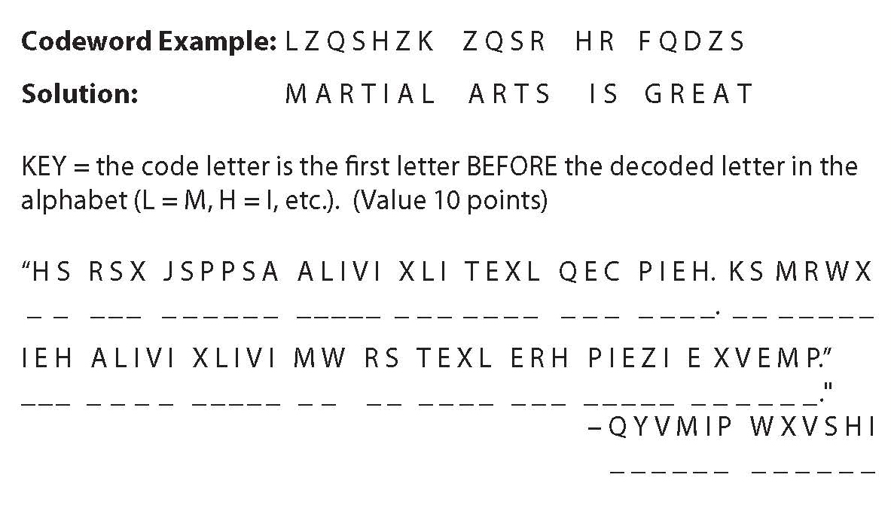
Welcome to Kickin’ Kids‘ Corner, the mind-boggling, brain-teasing section of Kid’s Zone. If you solve this puzzle in one minute or less, you’re a Grandmaster; two minutes, a Master; three minutes, an Advanced Student; four minutes, an Intermediate Student; five minutes, a Beginner Student; six minutes, do 10 sit-ups; seven minutes, do 10 push-ups; or eight or more minutes, do 10 sit-ups and 10 push-ups.
Ignite your Celebrations, Not Yourself!
Kendra Klonowski
Age 12
Many cultures have traditions that include fireworks, including the American Fourth of July. A joyful celebration can become a painful memory when children and adults are injured while using fireworks. To be safe, you should consider all fireworks to be dangerous.
The U.S. Consumer Products Safety Commission estimates that approximately 9,800 people were treated in hospital emergency rooms for injuries associated with fireworks during 2007. Children 10 to 14 years old had the highest per capita injury rate among all age groups.
Follow these tips, so you and your family can enjoy fireworks safely.
• Do not allow young children to play with fireworks under any circumstances. Sparklers, considered by many the ideal "safe" firework for the young, burn at very high temperatures and can easily ignite clothing. Children cannot understand the danger involved and cannot act appropriately in case of emergency.
• Older children should only be permitted to use fireworks under close adult supervision. Do not allow any running or horseplay.
• Light fireworks outdoors in a clear area away from houses, dry leaves or grass and flammable materials.
• Keep a bucket of water nearby for emergencies, and for dousing lit fireworks that don’t fire.
• Do not try to relight or handle malfunctioning fireworks. Douse and soak them with water and discard them.
• Be sure other people are not in range before lighting fireworks.
• Never ignite fireworks in a container, especially made of glass or metal.
• Keep unused fireworks away from firing areas.
• Store fireworks in a dry, cool place. Check instructions for special storage directions.
• Observe state and local laws.
• Never have any
portion of your body
directly over a
firework while
lighting it.
• Don't make or
experiment with
homemade fireworks.

Kid’s
Corner
Healthkick

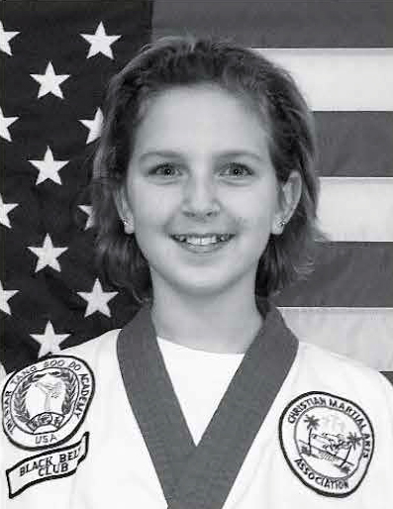
How Martial Arts Has Helped Me
Martial arts has helped me in many ways. Being confident, disciplined and able to know how to defend myself are the three reasons I think and know why
I’m in Karate. Trying Karate the first time was kind of weird. I was scared, but that didn’t stop me because I overcame my fear. Karate has taught me discipline for both inside and outside the studio. Inside the studio, we say, “Yes, sir” and “No, sir.” Outside the studio we use our manners.
Learning to defend myself was another major part of my Karate and school life. In school, if someone is bothering me, then I tell him or her to back off. Some people respect me more than they did before.
Martial arts has made my life better.
Kendra Klonowski is a student of Duane Brumitt at Tri-Star Martial Arts in Bradley, Illinois.

2
Kickin’ Newsletter — for Students, Friends and Families of this Martial Arts School

Results in Their Own Words!

LESSON 4
“Anger is a signal, and one worth
listening to.”
Harriet Lerner
clinical psychologist and author
LESSON 2
“Anger makes you smaller, while forgiveness forces you to grow beyond what you were.”

Cherie Carter-Scott
author life coach and motivational speaker
C.A.N.I.
Our school is
dedicated to the concept
of “C.A.N.I.”.
Constant and Never-ending Improvement. Not only for our students, but for our school, our instructors, our classes and our programs.
As a proud member of the National Association of Professional Martial Artists, the world’s leading professional martial arts organization, we require that our instructors (and staff) continue their education, not only in their martial arts skills, but ALSO their teaching skills, communication skills and leadership ability.
Our instructors attend regular “teacher training” sessions, “in service” training days, and through the NAPMA GOLD Program learn from some of the best martial artists in the world!
If you’re interested in exploring the GOLD Team program for yourself or member of your family, speak to your instructor in class or call us at the school to see how to qualify!

LESSON 3
“When anger rises, think of the consequences.”
Confucius, ancient Chinese thinker
political figure and educator
LESSON 1
“Speak when you are angry—and you will make the best speech you’ll ever regret.”
Laurence J. Peter
educator and best known for The Peter Principle
continued from page 1
Anger

3
Our School is a Proud Members of the National Association of Professional Martial Artists
Words of the Week
555-555-5555
www.YourSite.com
Caption
Your Logo
Your Photo
«recipient_first_name» «recipient_last_name»
«recipient_street»
«recipient_city», «recipient_state» «recipient_zip»
«sender_school_name»»
«sender_street_address»
«sender_city», «sender_state» «sender_zip»
PLACE
POSTAGE
HERE
4
Kickin’ Newsletter — for Students, Friends and Families of this Martial Arts School



See the Results for Yourself, FREE!
- FREE – Introductory Program ($149.00 Value)
- FREE – 1 on 1 Orientation Lessons ($39.00 Value)
- FREE – Official Martial Arts Uniform ($69.00 Value)
- FREE – Information DVD and CD ($29.97 Value)

Call 555-555-5555
Or Visit: www.YourSite.com
Valid for New Enrollments Only, Not in Combination With Any Other Offer. See School Staff for All the Details!

Alternate 3rd Page
You Can Insert Your Calendar of Events, Student(s) of the Month…Whatever!
Go Nuts…..Student’s LOVE to see their “name in lights”!
NAPMA SCHOOL UPDATE

