ACTION PRINCIPLES
Develop Your Special Talent
You were born with a
special talent. It may be to
sing, write, teach, paint,
mentor, preach, defend or
befriend.
You have something
special to offer the world. You must continue to learn and try new things to find your special talent.
The world needs your gift.
Be aware that even a special talent can go stale if you don’t continue to use it and hone it.
Bill FitzPatrick is a 5th-degree Black Belt, holds a Master's Degree in Education and runs the non-profit American Success Institute.

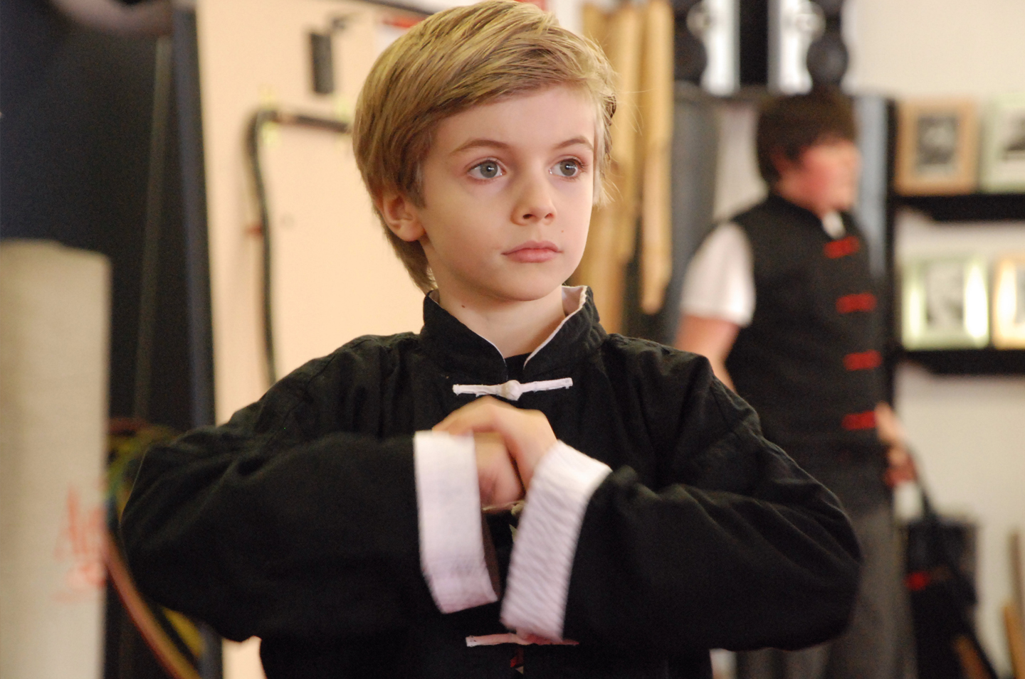
When the Teacher is Ready, the Student Will Appear
Continued on page 3
When the student is ready, the teacher will appear!” is an old saying that describes the student’s perspective in any learning environment, including the martial arts classroom. Of course, your instructor is very visible when you walk in the school, and join him on the mat. It will also be obvious to you when your instructor “appears” to teach you the easy lessons: block down, turn to the left, fix your hand, etc.
What you may not notice, until later in life, however, are the life lessons that your instructor has also “appeared” to teach you. As you mature, you realize how the character development and leadership lessons you learned benefit your everyday life. This is what makes a martial arts teacher so special: He or she is helping you learn lessons that will change your life forever.
You can recognize and benefit from those life lessons now, and not have to wait until you’re older, if you develop your listening skills, and really listen to what your teacher has to say. Your ears may hear what your instructor (or parents) are saying, but your mind is not really listening and understanding, and then using that understanding to act correctly.
For example, your parents may have told you when you were younger not to touch the hot stove. You heard them and responded, “OK,” but you might have touched the stove anyway because you didn’t listen carefully to what they said.
Your instructor is always striving to help you grow, and is excited when you invite your friends to join you in class, so you and your instructor can pass the same knowledge to them. Listen to your instructors consistently, and take those lessons and make them your own.
Log your learning experiences in a personal journal, and call it your
“Book of Knowledge.” In it, write your struggles, aches and pains, injuries, successes and failures, and learn from each of them. Then, take the time to share what you’ve learned, and you’ll become the best martial artist ever.

Continued on page 3

Our School is a Proud Member of the National Association of Professional Martial Artists
1
PUBLISHED FOR THE STUDENTS, FRIENDS AND FAMILIES OF THIS MARTIAL ARTS SCHOOL.

March

Welcome to Kickin’ Kid’s Corner, the mind-boggling, brain-teasing section of Kid’s Zone. If you score: 12, 11, or 10, you’re a Grand Master; 9 or 8, an Advanced Student; 7, an Intermediate Student; 6 or 5, a Beginner Student; 4, do 10 sit-ups; 3, do 10 push-ups; 2 or 1, do 10 sit-ups and 10 push-ups.
Good luck!
Kid’s
Corner

Answers: 1. H, Cyber-bullying; 2. J, Confidence; 3. F, Verbal Boundary; 4. G, Eye Contact; 5. A, Bully; 6. E, Buddy
System; 7. D, Self-respect; 8. C, Victim; 9. I, Inform Bonus: B, Mediation
Martial Arts Match Game. Match each word or phrase about bullying and bully prevention with the appropriate definition or explanation below. Answer the bonus correctly and add one point to your score.
Good luck!
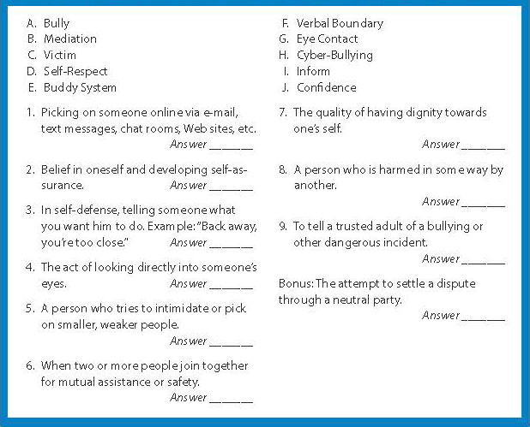

I Travel and Compete in Martial Arts
I joined martial arts because David, my older brother, is a martial arts student. I thought it would be a great idea to try it with David. I really enjoyed the first class, so I continued training.
In September 2006, David and I went to Melbourne, Australia with our family and other students to compete at the World Championships. I competed as an individual and also as the captain of the Canadian Junior Girls Team.
The team received a gold medal in team patterns, a silver medal in team power breaking and a bronze medal in team special technique. I won an individual gold medal in Junior Girls Micro Weight Sparring.
I am now an instructor as well as a student at our school. I am now preparing to compete in Italy for another international competition.
Lisa Wilcox is a student at Lightning Family Martial Arts in Calgary, AB Canada, where Chris and Sonya Howes are her instructors.
Lisa Wilcox
Age 15
Multi-Vitamins: No Magic Pill
Many people think they can eat anything and subject their bodies to stresses (both internal and external), and then take a vitamin or other “magic pill” to negate the effects. They’ll skip the veggies and choose the chips, thinking they’ll obtain their daily vitamin requirements from a pill. Even if your weight doesn’t increase because of unhealthy eating habits, your body and health will suffer.
Research strongly suggests that there is no magic pill, but you can benefit from the “magic” of whole foods. They contain known nutrients, such as fiber, that are necessary for a healthy body. You’d have to take many “fiber pills” to obtain the soluble and insoluble fiber in real food. Whole foods contain potentially thousands of as yet unidentified nutrients and a natural blend of nutrients that interact in both known and unknown ways. Even the scientific experts don’t fully understand how the components of whole foods interact.
Vitamin/mineral pills will not help you “make sure” your diet is complete. They may contain excessive, even toxic, quantities of nutrients, which is almost never an issue with foods. In other words, it is very difficult to overdose on the vitamins and minerals found naturally in foods. Recent studies have definitively shown that taking nutrients in supplement form doesn’t have the same health benefits as eating whole foods…and some seemingly innocuous supplements may actually cause harm.
Some groups of people should take a basic vitamin/ mineral supplement because they aren’t able to obtain adequate quantities of nutrients from their diets. These groups include dieters or picky eaters who avoid whole food groups; strict vegetarians; those older than 50 (who may need vitamin B12 and D); pregnant/breastfeeding women; people with chronic gastrointestinal disorder that inhibits absorption; and those with a chronic illness that depletes nutrients. Keep in mind that the supplement should be in addition to an otherwise healthy, balanced diet, not in place of it.
To care for your body, you must consistently eat a balanced diet. You can’t correct a nutrient-devoid meal with a pill. Just as there is no 10-minute workout that will give you the body of a model, there’s no magic pill that will allow you to fuel your body with junk food, and still look and feel great.

Healthkick

2
Kickin’ Newsletter — for Students, Friends and Families of this Martial Arts School

Results in Their Own Words!

Black Belt – A Family Journey
We’ve discovered over the years that a students that train at our school WITH the rest of their family, can accomplish much better results.
It makes sense, you have someone to practice with at home, someone to help motivate and support you when things get “tough”, and someone to celebrate your accomplishments with (and believe me, earning your Black Belt is an amazing accomplishment)!
Have you considered taking the journey to Black Belt as a whole family?
Not only will you enjoy greater results from your physical training, but you’ll be carrying the discipline, structure, and values we teach in our school with the entire family, home.
Like we say:
“A Family that Kicks Together, Sticks Together!”
Speak to Your Instructor Today About Our “Family” Plans, and Specials for Families that Train Together!

Risk

LESSON 2
“You'll always miss 100% of the shots you don't take.”
Wayne Gretzky
Hockey superstar
LESSON 3
“The important thing is this: To be able at any moment to sacrifice what we are for what we could become.”
Charles DuBois
LESSON 1
“Only those who dare to fail greatly can ever achieve greatly.”
Robert F. Kennedy
U.S. Attorney General during
Kennedy administration
continued from page 1
LESSON 4
“You've got to jump off cliffs all the time and build your wings on the way down.”

Annie Dillard, contemporary
American author
3
Our School is a Proud Members of the National Association of Professional Martial Artists
Words of the Week
555-555-5555
www.YourSite.com
Caption
Your Logo
Your Photo
«recipient_first_name» «recipient_last_name»
«recipient_street»
«recipient_city», «recipient_state» «recipient_zip»
«sender_school_name»»
«sender_street_address»
«sender_city», «sender_state» «sender_zip»
PLACE
POSTAGE
HERE
4
Kickin’ Newsletter — for Students, Friends and Families of this Martial Arts School


Hey Moms!
Ready to Get Fit, and Knock Out Stress?

See the Results for Yourself, FREE!
- FREE – Introductory Program ($149.00 Value)
- FREE – 1 on 1 Orientation Lessons ($39.00 Value)
- FREE – Official Martial Arts Uniform ($69.00 Value)
- FREE – Information DVD and CD ($29.97 Value)

Call 555-555-5555
Or Visit: www.YourSite.com
Valid for New Enrollments Only, Not in Combination With Any Other Offer. See School Staff for All the Details!
Your Logo

Alternate 3rd Page
You Can Insert Your Calendar of Events, Student(s) of the Month…Whatever!
Go Nuts…..Student’s LOVE to see their “name in lights”!
NAPMA SCHOOL UPDATE

