ACTION PRINCIPLES
Allow Your Opponent to Save Face
In business, sports or
everyday relationships,
always allow your
opponent to save face.
You won. That should
be enough. Bragging is
counterproductive.
Winning provides you with the opportunity to show both mercy and humility. You won’t always win, but you can always do what you believe to be righ to win or lose.
Bill FitzPatrick is a 5th-degree Black Belt, holds a Master’s Degree in Education and runs the non-profit American Success Institute

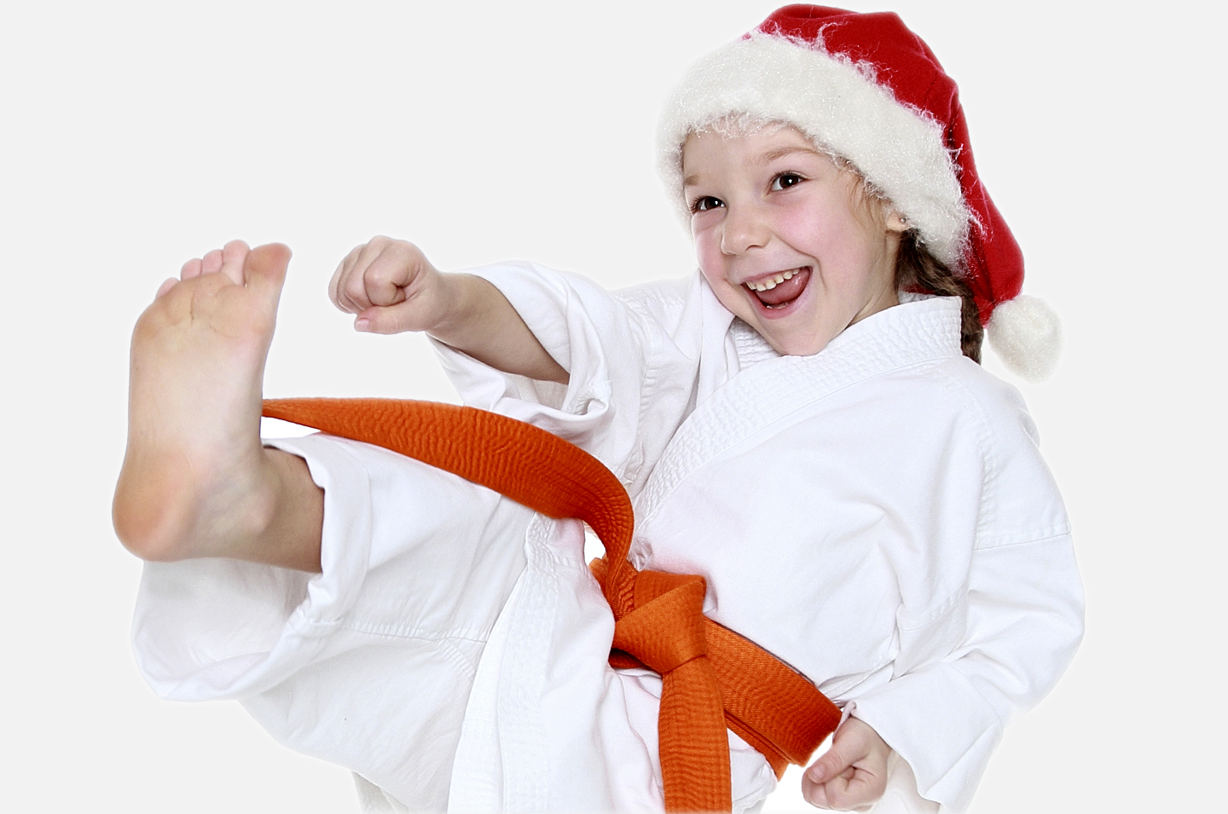
Continued on page 3
The mission is set: a Ninja must first develop his plans, determine his route, decide on his methods, wear the proper clothing, fill his pack with the proper tools and then infiltrate the fortress. Once inside, the Ninja must be mindful of many things: first of all, the Ninja must tread lightly, since Samurai castle floors are specifically designed to creak with weight to alert the Samurai; next the Ninja must be conscious of his surroundings, since there may be low light, sleeping dogs and possibly, even guards; and, most importantly, the Ninja must be very aware of where the cookies and the milk are stored, so he may have a midnight snack.
If anyone is a Ninja, then it is most certainly Santa. Maybe, he was trained in the ancient art of Ninjutsu. You never know!
The holidays are an amazing time for imagination, but, most importantly, they are a great time to exercise the heart. The heart becomes stronger through exercise, but it also becomes stronger through the art of giving. Give your heart a workout during the holidays, with exercise and proper diet and the sharing of goodwill with others. Build your Ninja heart muscles with these ideas:
1. Adopt a family that may not be as fortunate as yours.
2. Help organize a food drive or a fundraiser for a deserving charity.
3. Continue to share the holiday cheer by sharing a smile with all the people in your daily life.
4. Send holiday cards to everyone you know.
5. In your holiday cards to old friends, tell them you miss them.
6. Send a note or card to people who have helped change your life. This little gesture will make their day.
7. Do not be a stranger to your sensei help him at your school or, at least, tell your instructors what they have done for you.
8. Spend time helping the people you love.
Santa is a Ninja!
Continued on page 3

Our School is a Proud Member of the National Association of Professional Martial Artists
1
PUBLISHED FOR THE STUDENTS, FRIENDS AND FAMILIES OF THIS MARTIAL ARTS SCHOOL.

December

Welcome to Kickin Kids, the mind-boggling, brain-teasing section of Kid's Zone. If you score: 9 or more, you are a Grandmaster; 7 or 8, a Master; 6, an Advanced Student; 5, an Intermediate Student; 4, a Beginner Student; 3, do 10 sit-ups; 2, do 10 push-ups.
Positive Characteristic Word Maker: Below is a positive character word. Using the letters in the word, make as many other words (four letters or more). You may use only the letters found in the word the same number of times as they appear in the word (for example, if the character word was HONOR, you would not be permitted to make the word NOON because there is only one letter N in HONOR). Good luck!
Kid’s
Corner
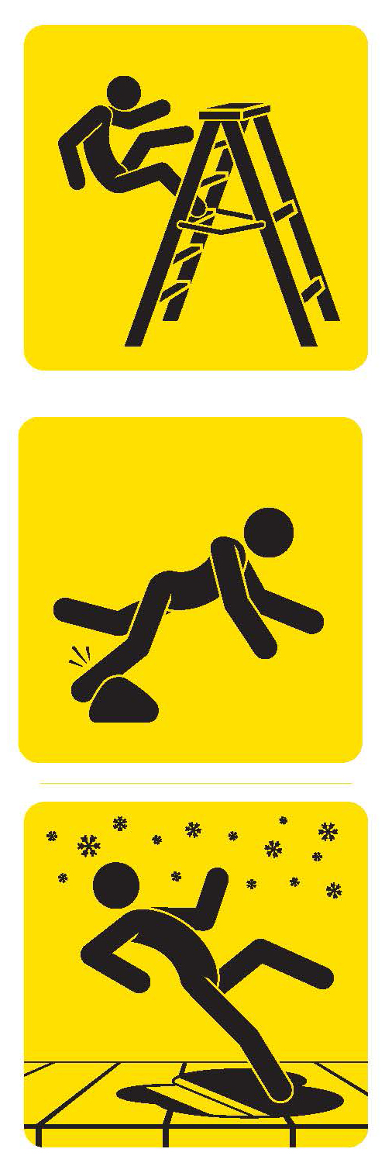
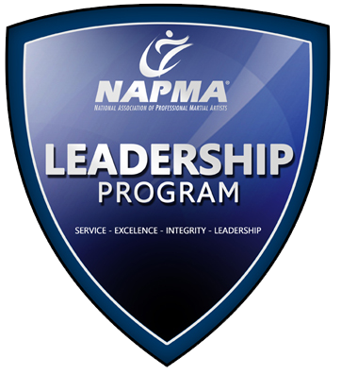
Possible answers include: KISS, STOCK, VETO, NOISE, TOKEN, KNOT, OINK, COIN,
TICKS, EVICT, EVEN and STOVE
6…………………………..
7…………………………..
8…………………………..
9…………………………..
10..………….…….……….
1…………………………..
2…………………………..
3…………………………..
4…………………………..
5…………………………..
Bonus ……………………………………………………………….
See how many words you can make from: STICKTOITIVENESS
Example: STICK
The Reality
We all want to keep our children safe and secure and help them live to their full potential. Knowing how to prevent leading causes of child injury, like falls, is a step toward this goal.
Falls are the leading cause of non-fatal injuries for all children ages 0 to 19. Every day, approximately 8,000 children are treated in U.S. emergency rooms for fall related injuries. This adds up to almost 2.8 million children each year.
Thankfully, many falls can be prevented, and parents and caregivers can play a key role in protecting children.
Prevention Tips
The following are tips that can be used to prevent children from sustaining injuries related to falls:
Play safely.
Check to make sure playground equipment your child uses is properly designed and maintained and there’s a safe, soft landing surface below.
Make home safety improvements.
Use home safety devices, such as guards on windows that are above ground level, stair gates, and guard rails. These devices can help keep a busy, active child from taking a dangerous tumble.
Keep sports safe.
Make sure your child wears protective gear when playing active sports, such as wrist guards, knee and elbow pads, and a helmet when in-line skating.
Supervision is key.
Supervise young children at all times around fall hazards, such as stairs and playground equipment, whether you’re at home or out to play.

Ian Gopie
Age 7
Falls
Healthkick

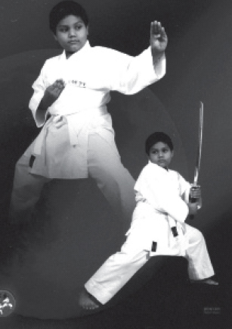
Martial Arts Teaches
Me To Work Hard
My name is Ian and I have been a martial arts student for 10 months. My sensei has taught me that hard work makes you a good student in martial arts class and life. I practice my moves and skills at home, so when I go to martial arts class I know how to do them properly.
By paying attention to my sensei, I learned never to hurt anyone in class and to use my skills should the moment come when I need to defend myself. Although martial arts is hard work, it’s also fun. It has taught me much about life, such as to achieve greatness you must work hard and never give up, no matter what color belt you are. I must thank my sensei for the respect and self-discipline I have learned, which I will always look back on, as I grow older
Ian Gopie is a student at Robert William’s Shotokan Karate Studio of Self Defense in Queens Village, New York.
2
Kickin’ Newsletter — for Students, Friends and Families of this Martial Arts School

Results in Their Own Words!

Leadership Skills and More
The value of our
program goes FAR beyond
just “kicking and punching”.
The skills we teach impact
our students lives on a
MUCH deeper level.
Greater confidence, higher
self-esteem and laser sharp focus
are the skills we value in ourselves
and in our leaders.
We specialize in creating the next generation of our communities’ leaders through the National Association of Professional Martial Artists LEADERSHIP Program. This program will teach you the fundamental leadership and communication you’ll need in your career, your school life and in your future.
If you’re interested in exploring the LEADERSHIP program for yourself or member of your family, speak to your instructor in class or call us at the school to see how to qualify!

Potential

LESSON 2
“I am only one, but still I am one. I cannot do everything, but still I can do something; and because I cannot do everything, I will not refuse to do something that I can do.”
Helen Keller,
American writer
LESSON 3
“Continuous effort—not strength or intelligence—is the key to unlocking our potential.”
Winston Churchill,
British statesman, prime minister during World War II
LESSON 1
“Focus on your potential instead of your limitations.”
Alan Loy McGinnis, Ph.D,
author and family therapist
continued from page 1
LESSON 4
“You see things; and you say, 'Why?' But I dream things that never were; and I say, 'Why not?”
George Bernard Shaw,
British playwright, essayist
essayist
3
Our School is a Proud Members of the National Association of Professional Martial Artists
Words of the Week
555-555-5555
www.YourSite.com
Caption
Your Logo
Your Photo
«recipient_first_name» «recipient_last_name»
«recipient_street»
«recipient_city», «recipient_state» «recipient_zip»
«sender_school_name»»
«sender_street_address»
«sender_city», «sender_state» «sender_zip»
PLACE
POSTAGE
HERE
4
Kickin’ Newsletter — for Students, Friends and Families of this Martial Arts School


Give a
Gift Certificate
this Holiday Season!

Martial Arts Gift Certificates are the perfect gift idea for:

• Adults will appreciate a fitness activity that is fun, exciting and reduces weight and stress.

• Children will benefit from physical activity, character building lessons and a motivating environment.

• Teens will learn self-defense, build confidence and gain greater self-respect for themselves and others.
Ask your Instructor for details.
See the Results for Yourself, FREE!
- FREE – Introductory Program ($149.00 Value)
- FREE – 1 on 1 Orientation Lessons ($39.00 Value)
- FREE – Official Martial Arts Uniform ($69.00 Value)
- FREE – Information DVD and CD ($29.97 Value)

Call 555-555-5555
Or Visit: www.YourSite.com
Valid for New Enrollments Only, Not in Combination With Any Other Offer. See School Staff for All the Details!

Alternate 3rd Page
You Can Insert Your Calendar of Events, Student(s) of the Month…Whatever!
Go Nuts…..Student’s LOVE to see their “name in lights”!
NAPMA SCHOOL UPDATE

