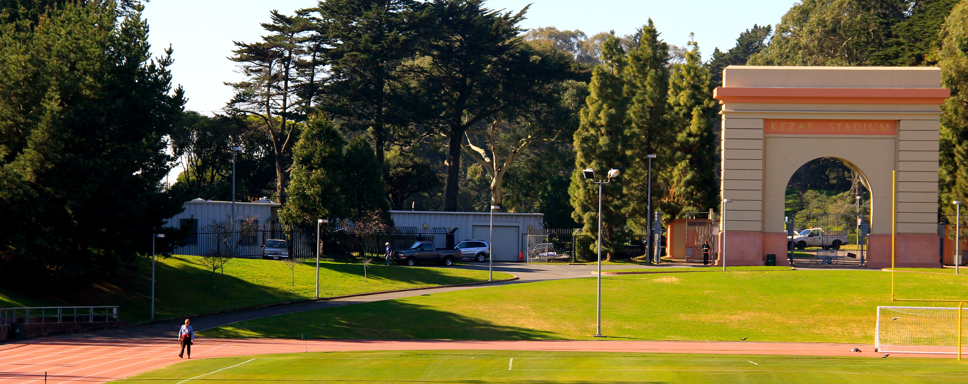
PUBLIC NOTICE
Kezar Track Renovation

The Recreation and Park Department invites you to attend an informational meeting on upcoming improvements for the track, inside Kezar stadium. Kezar stadium is located in Golden Gate Park adjacent to Kezar Triangle along Stanyan Street.

DATE: November 13, 2013 (Wednesday)
TIME: 5:30 P.M. to 7:00 P.M.
PLACE: County Fair Building Auditorium– Golden Gate Park

For more information, please contact:
Toks Ajike, Project Manager
Toks.ajike@sfgov.org or (415) 581-2543

* * * * * *
The #71, #6 and Muni Train N Judah stop in the vicinity of Kezar Track
To request translation services please call 415-581-2579 Monday through Friday between 9am and 5 pm, at least 72 hours (3 days) before this meeting.
In order to assist the City’s efforts to accommodate persons with severe allergies, environmental illnesses, multiple chemical sensitivity or related disabilities, attendees at public meetings are reminded that other attendees may be sensitive to various chemical-based products. Please help the City to accommodate these individuals.
If you would like to request accommodations, please contact our Inclusion Center at 415-206-1546 or vicky.pitner@sfgov.org. Please note that requesting accommodations at least 72 hours prior to an event will help ensure availability.

